WEST MIDLANDS INTEGRATED TRANSPORT AUTHORITY

TRANSPORT ACT 1985

Child Travel (Bus) Concession Scheme

To be valid

From 1st August 2016

WEST MIDLANDS INTEGRATED TRANSPORT AUTHORITY

1985 ACT CHILD TRAVEL (BUS) CONCESSION SCHEME

1ST August 2016

The Scheme

1. This Child Travel (Bus) Concession Scheme subsequently referred to as “the Scheme” has been established by the West Midlands Integrated Transport Authority (“ITA”) , in pursuance of its powers under:-

- the Transport Act 1985 (as amended) (“1985 Act”);

- Travel Concession Scheme Regulations 1986 (“TCSR”);

- and all other relevant legislation.

2. The Scheme will be administered by Centro, the West Midlands Passenger Transport Executive (“the Executive”).

3. The Scheme covers the discretionary concessions to be provided by operators under the 1985 Act as detailed in clause 7 below;

4. Unless otherwise defined in this Scheme words or terms used in the Scheme shall have the same meaning as given to such words or terms in the 1985 Act, and TCSR.

Operative Date

5. The Scheme shall come into operation in its entirety on 1st August 2016 and be in operation until 31st July 2017 (inclusive).

Scheme Area

6. The area covered by the Scheme (“Scheme Area”) is the principal area of the Passenger Transport Area of the West Midlands, which consists of the administrative areas of Birmingham City Council, Coventry City Council, Wolverhampton City Council and the Metropolitan District Councils of Dudley, Sandwell, Solihull and Walsall, plus additional areas included in the Network West Midlands bus travel (‘n’Bus) area as defined in the ‘n’Bus Ticket Scheme (April 2013). A map of the Scheme Area is provided in Appendix A.

Scheme Applicability

7. The Scheme shall apply:

(a) to eligible persons listed in Schedule 1 who tender to the operator on a Scheme Service (as defined below) the applicable permit or pass and any applicable concessionary fare for that category of concessionary passenger referred to in Schedule 1;

- when travelling on eligible services (as defined in section 94 (4) of the 1985 Act and as further defined in the Travel Concession (Eligible Services) Order 2002 which have been admitted or required to participate in the Scheme (“Scheme Services”); but

(c) only on journeys wholly within the Scheme Area.

Eligible Persons and Nature of Concession

8. Operators participating in the Scheme will be required on all Scheme Services to allow the concessions detailed in Schedule 1 to persons who satisfy the requirements set out in paragraph 7 above. Only journeys that meet all of these requirements will be eligible for concessionary reimbursement under this Scheme.

9. The ITA or Executive (as appropriate) may from time to time by giving a minimum of 28 days’ notice in writing vary the class of eligible person or nature of the concessions to be provided or the reimbursement arrangements by notice and where relevant such notice shall comply with the provisions of section 97(6) of the 1985 Act.

Entry of Operators to the Scheme

- An operator shall be admitted into the Scheme from the next admissions date with at least 28 days prior notice in writing from the operator to the Executive that it wishes to participate in the Scheme (the admission dates being 1 August, 1 November, 1 February and 1 May after expiry of such notices). At the Executive’s discretion, operators may be admitted into the Scheme in advance of these admission dates.

Fares Including a Special Amenity Element

11. In accordance with Sections 96(4) and (5) of the 1985 Act, where it appears to the Executive that an operator’s current or proposed fares for relevant journeys on any Scheme Service include a "special amenity element", the Executive may make admission to or continuation by the operator in the Scheme in respect of the relevant Scheme Service conditional on the operator agreeing appropriate modifications to the reimbursement arrangements that would otherwise apply.

12. For the purposes of paragraph 11 and in accordance with Section 96(6) of the 1985 Act, fares for relevant journeys on a Scheme Service are to be regarded as including a special amenity element if they are significantly high in relation to the general level of fares for comparable journeys in the Passenger Transport Area of the West Midlands.

Removal or Withdrawal of Operators from the Scheme

13. An operator who is participating in the Scheme, in respect of any of its Scheme Services, other than pursuant to a participation notice, must give the Executive at least 42 days’ notice in writing of withdrawal from the Scheme in respect of all or any of such Scheme Services.

14. The ITA may terminate the Scheme by giving the all participating operators not less than 3 months’ notice in writing.

Reimbursement Arrangements

15. The reimbursement arrangements are as set out in the West Midlands Passenger Transport Executive Transport Act 1985 Child Travel (Bus) Reimbursement Arrangements (“Reimbursement Arrangements”).

Data

16. All data requirements are as set out in the Reimbursement Arrangements.

Other Requirements of the Scheme

17. All operators participating in the Scheme shall display on their vehicle any sign, supplied by the Executive, for the purpose of showing that concessions are available on those vehicles.

18. Operators shall not discriminate against eligible persons or any class of eligible persons in the provision of Scheme Services or associated services and facilities.

Contact for Communications

- All notices, data and other information required to be given to the Executive under the Scheme shall be provided to the following contact point (or such other contact point as may be nominated by the Executive to operators in writing from time to time):

Taryn Taylor
Concessionary Payments Manager
Centro
Centro House
16 Summer Lane
Birmingham
B19 3SD

telephone 0121 214 7433
fax 0121 214 7426
e-mail taryntaylor@centro.org.uk

20. When an operator first applies or becomes obligated to participate in the Scheme, they shall provide to the Executive details of the name, address, telephone number and fax number of its official contact for communications in relation to this Scheme, and shall by notice in writing inform the Executive of any changes to the same.

21. Any notice or communication sent to the last such address, e-mail address or fax number as is referred to above shall be deemed to be duly served on the recipient. If an operator has failed to give notice in writing to the Executive of such an official contact, then the Executive may send any notice or other communication to any address set out in the most recent correspondence from the operator concerned, which shall be deemed to be its address for service.
Schedule 1

Eligible Person and Nature of Concession under 1985 Act

Class of Eligible Persons |  | Nature of Concession to be Provided  On Scheme Services Provided by Bus
(i) | Children  Residents of the Metropolitan Boroughs of the West Midlands whose age is 5 years or greater but does not exceed 15 years. | Cash fare at time of travel:  Approximately half adult cash fare on  Monday to Friday from start of daytime services to before 0930, and from 1500 to before 1800  ‘n’Bus and ’n’Network multi-operator tickets:  Approximately half adult fare on  Monday to Friday from start of daytime services to before 0930, and from 1500 to before 1800  Centro Scholar’s pass:  Valid Monday to Friday term time only and journeys to and from the school or college only  from 0600 to before 0930 and from 1500 to before 1800 and, if in connection with the school or college curriculum, any time up to 2215  Any other ticket and fare types:  including but not limited to other pre-paid season tickets may be included under this Scheme subject to prior written agreement between the Executive and the operator  In all the above cases time of travel is determined by actual time of boarding as recorded on the ticket machine
(ii) | Students aged 16-18  Residents of the Metropolitan Boroughs of the West Midlands who are in full-time education as defined by Section 14 of the Education Act 2002, not in receipt of direct income and aged under 18 on the 31 August immediately before the Academic Year concerned. The concession then applies to the end of that Academic Year. | 16-18 photocard and cash fare at the time of travel  Approximately half adult cash fare on Monday to Friday term time only and journeys to and from the school or college only  from 0600 to before 0930 and from 1500 to before 1800 and only if in connection with the school or college curriculum, outside these times  16-18 photocard and ‘n’Bus and ’n’Network multi-operator tickets:  Approximately half adult fare on  on Monday to Friday term time only and journeys to and from the school or college only  from 0600 to before 0930 and from 1500 to before 1800 and only if in connection with the school or college curriculum, outside these times  16-18 photocard and Centro Scholar’s pass:  Monday to Friday term time only and journeys to and from the school or college only  from 0600 to before 0930 and from 1500 to before 1800 and, if in connection with the school or college curriculum, any time up to 2215  16-18 photocard and any other ticket and fare types:  including but not limited to other pre-paid season tickets may be included under this Scheme subject to prior written agreement between the Executive and the operator  In all the above cases time of travel is determined by actual time of boarding as recorded on the ticket machine
(iii) | Children and Students (as defined above) who are Disabled (as defined in section 146 Transport Act 2000) | On production of a statutory travel concession permit carrying a logo identifying it as being issued by the West Midlands Passenger Transport Executive (Centro), or any other permit as agreed by the PTE, a person shall be carried without charge on Scheme Services, provided that the actual time of travel falls between the following hours:  Valid Monday to Friday term time only from 0600 to before 0930 and only if in connection with the school or college curriculum  In all the above cases time of travel is determined by actual time of boarding as recorded on the ticket machine

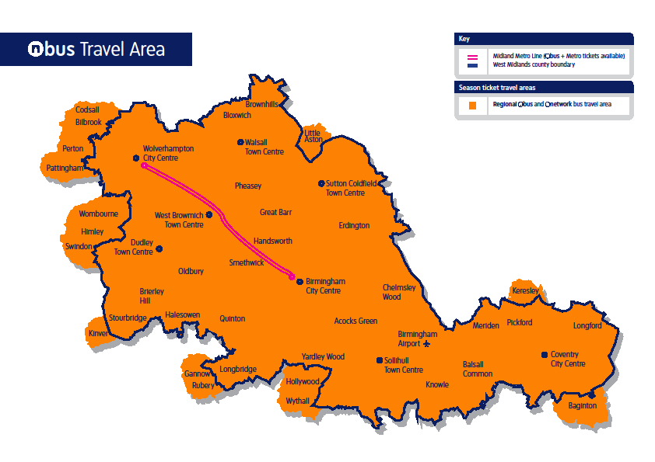
Appendix A

