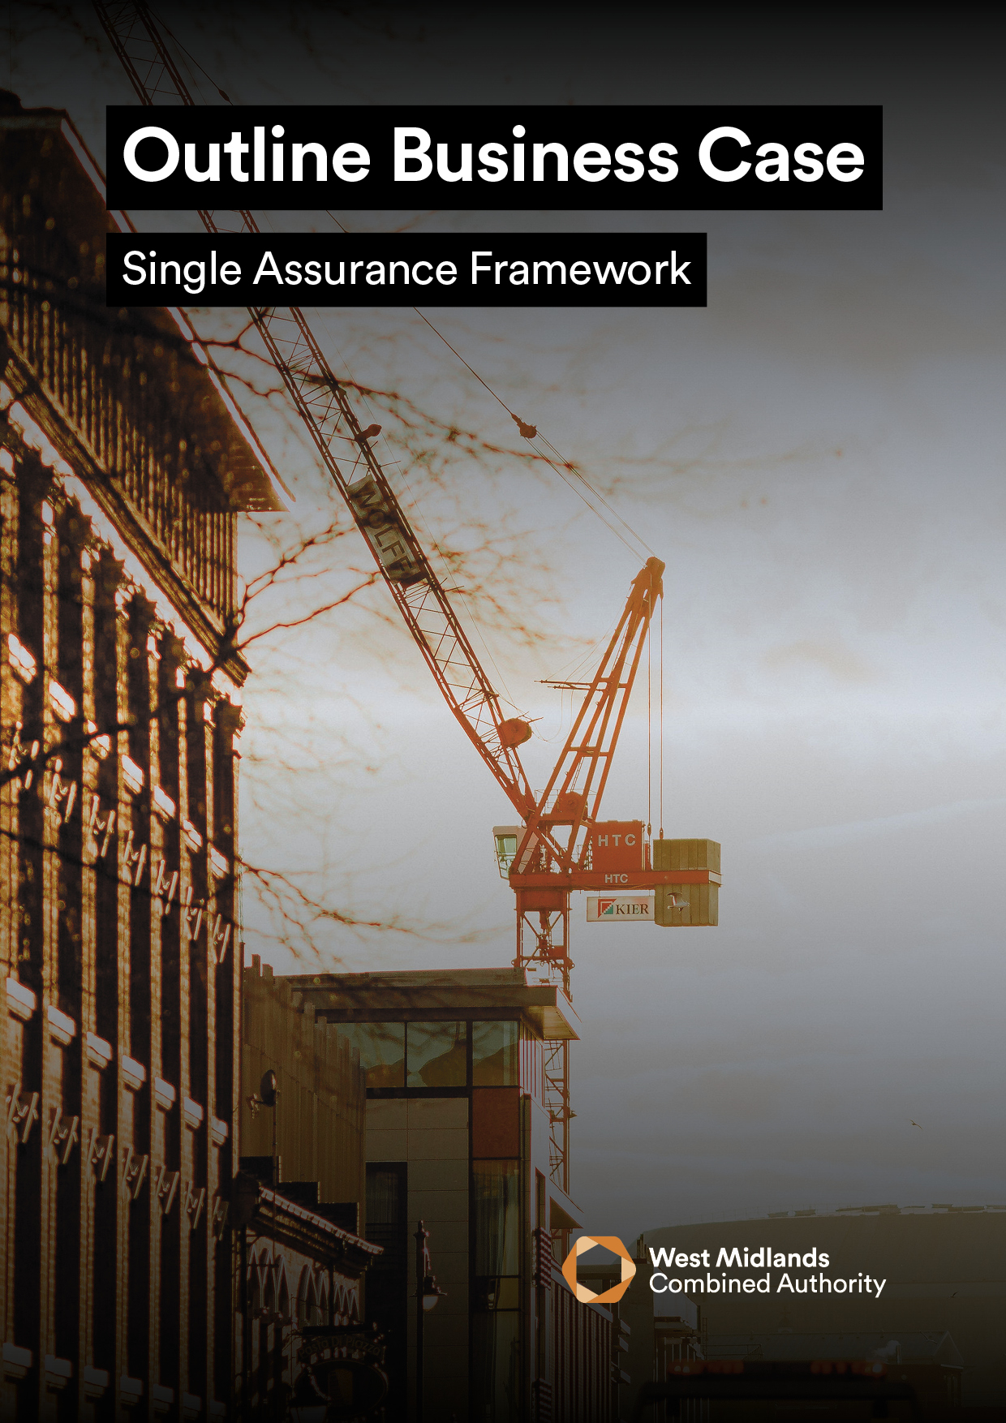
<INSERT PROJECT NAME>

<INSERT PROJECT NAME>

OUTLINE BUSINESS CASE VERSION 4.0
The purpose of the Outline Business Case (OBC) is to:
- Revisit the Strategic Outline Case (SOC) in more detail to identify a Preferred Option which demonstrably optimises Value for Money (VfM).
- Prepare the project for procurement.
- Put in place the necessary funding and management arrangements for the successful delivery of the project.
It is a requirement that all OBC’s submitted to the West Midlands Combined Authority (WMCA) for public funds must:
- Revisit the options identified in the Strategic Outline Case (SOC) and outline the detailed plans associated.
- Complete the Economic Case according to the HM Treasury’s Green Book.
- Set out the likely deal, affordability, supporting procurement strategy and management arrangements for successful roll out of the project. Key contractual clauses (Heads of Terms) and payment mechanisms should be demonstrated within the Commercial Case.
- Contain a detailed analysis of affordability and any funding gaps within the Financial Case.
- Outline the project management plan and methodology within the Management Case.

GUIDANCE
- To support better spending, investment decisions and better procurement, this Outline Business Case should be written using supplementary WMCA guidance, which can be found here.
- In addition, it is a requirement that all proposals for public funds submitted to WMCA are guided and based around the HM Treasury Green Book and supporting information, which can be found here.
- The input of key stakeholders must be detailed within Table 2, otherwise the business case will be rejected until this information is provided.
- Mandatory appendices as listed in Section 6.0 of this business case must be submitted as supplementary documents
Table 1
PROJECT DETAIL
Project Name:
WMCA Directorate:
Delivery Team (if WMCA internal):
Organisation (if WMCA external):
WMCA Project Code:
GOVERNANCE
If external to WMCA, when was this project approved by your internal governance?
VERSION CONTROL
Version: |  |  | Date:
OBC Prepared by: |  |  | Job Title:

Table 2
STAKEHOLDER INVOLVEMENT
Please provide the names and level of input of the stakeholders listed below. Note that some are mandatory and others are optional / dependent on the source of funding / nature of the project, this is made clear on the left of the table below and further explained in the supplementary guidance.
 | Role | Name | Input | Date
Mandatory | Senior Responsible Owner (SRO): |  | Choose an item.
 | WMCA Executive Director: |  | Choose an item.
 | Governance Services: |  | Acknowledged
 | Finance Lead: |  | Choose an item.
 | Legal Representative: |  | Choose an item.
 | Procurement Lead: |  | Choose an item.
 | Monitoring and Evaluation: |  | Choose an item.
Optional | Programme SRO:  (if applicable) |  | Choose an item.
 | Digital and Data Engagement and Delivery:  (if WMCA internal) |  | Choose an item.
 | WMCA Finance:  e.g., Major Programme Returns (if CRSTS/ Investment Programme funded) : |  | Choose an item.
 | Human Resources: |  | Choose an item.
 | Transport Planning Assurance:  (if CRSTS funded) |  | Choose an item.
 | Cycling Team: |  | Choose an item.
 | Network Mitigations Forum: |  | Choose an item.
 | Inclusive Growth Team: |  | Choose an item.

EXECUTIVE SUMMARY

PLEASE PROVIDE A ONE-PAGE STAND-ALONE SUMMARY OF THE PROPOSED PROJECT WHICH INCLUDES (MAX 500 WORDS):

• A BRIEF PROJECT DESCRIPTION AND WHY IT IS necessary

• TARGET OBJECTIVES

• ASSOCIATED OUTPUTs

FINANCE SUMMARY
Table 3
Finance Summary | OBC (£)
Total Project Cost:
WMCA Funding Requested (within this business case):
Development Funding Requested:
WMCA Funding Stream:
Funds Secured:
Funds Not Secured:

1 - STRATEGIC CASE

PROVIDING STRATEGIC FIT SUPPORTED BY A COMPELLING CASE FOR CHANGE

1.1 PROJECT SPENDING OBJECTIVES AND ALIGNMENT TO WMCA AIMS
Objectives should be; bound by strategic context for project; focus on needs, not the solution; facilitate realistic options for appraisal and SMART (Specific, Measurable, Achievable, Realistic and Time-Dependent). They will address at least one of the generic drivers for spend - improved effectiveness, efficiency, economy, compliance, replacement. Include objective(s) to reach the next business case stage e.g., FBC and entire project. Note, all projects need to consider Inclusive Growth and its contribution to Net Zero.
Table 4
# | Objective | Baseline  (Quantitative) | Target | Specific actions and when, to achieve objective | How will the customer be impacted?  (i.e. Outcomes) | Alignment to WMCA Aims and Objectives
1. |  |  |  |  |  | Choose an item.
2. |  |  |  |  |  | Choose an item.
3. |  |  |  |  |  | Choose an item.
4. |  |  |  |  |  | Choose an item.
5. |  |  |  |  |  | Choose an item.
6. |  |  |  |  |  | Choose an item.

1.2 INCLUSIVE GROWTH AND EQUALITIES
Explain how this project will contribute to inclusive growth and equality within the West Midlands. If WMCA internal, the WMCA’s Inclusive Growth Framework can be found here. To add, state how health inequalities and equalities (protected characteristics as defined by the Equality Act) have been considered in the production of this business case, this can be done using the WMCA Health and Equity Impact Assessment (HEQIA) Tool found here for internal staff, or other tools available within Local Authorities. If you are external to WMCA but wish to use our HWQIA Tool, contact equalitiesteam@wmca.org.uk.

1.3 KEY RISKS
Specify the key risks associated with the achievement of the project’s objectives, along with the key activity aimed at either managing the cause or mitigating the effects of each risk. The information provided should be an extract from the Risk Register and Issue Log attached with this OBC.
Table 5
ID | Risk | Impact  (1-5) | Probability  (1-5) | RAG  Rating | Risk  Owner | Mitigation

1.4 CONSTRAINTS
Specify any constraints that have been placed on the project.

1.5 DEPENDENCIES
Specify any dependencies outside the scope of the project upon which the success of the project is dependent.

2 - ECONOMIC CASE

MAXIMISE PUBLIC VALUE TO SOCIETY THROUGH THE SELECTION OF THE OPTIMAL COMBINATION OF SCOPE, COSTS AND OUTCOMES

2.1 CRITICAL SUCCESS FACTORS
List the critical success factors i.e. what must this project achieve to be successful?
These are not outcomes or objectives; they are the attributes essential for successful delivery of the project.
Table 6
# | Critical Success Factor (CSF) | Alignment to Project Objectives
1.
2.
3.
4.
5.

2.2 ECONOMIC APPRAISAL OF THE SHORT-LISTED OPTIONS
Prepare the economic appraisals for the short-listed options in the table below.
Table 7
Option Label | Business as  Usual  (baseline) | Do-minimum  Option | Preferred  Option  (If not Do-  Minimum) | Option 3  (More ambitious) | Option 4
Description of Option

NPSV for CBA or Net Present Unit Cost, NPUC for CEA
Relevant present value public sector cost
Appropriate BCR or NPUC
Significant Quantified but unmonetizable benefits
Significant unquantifiable benefits
Residual risk and optimism bias allowances
Switching values of key variables
Life span of the option

2.3 VALUE FOR MONEY (VFM) JUDGEMENT
Explain why the identified Preferred Option is being chosen over other options.

2.4 BENEFITS APPRAISAL
Specify the main benefits associated with the achievements of the project’s spending objectives by beneficiary. Distinguish benefits from outcomes.
This should be aligned with the Outline Benefits Realisation Plan / MEP appended to this OBC.
Table 8
# | Benefit | Benefit Classification | Beneficiary(s)
1. |  | Choose an item.
2. |  | Choose an item.
3. |  | Choose an item.
4. |  | Choose an item.
5. |  | Choose an item.

Provide quantified benefits for the following items. Note that inclusion here is independent of the social benefits and BCR calculation, and not all items should be included in a Green Book appraisal.
Table 9
Item | Quantified benefit | Social benefit included in BCR
GVA | £m increase in WM GVA over x years | N/A
Jobs created | Number created in WM over x years | N/A
Houses built | Number built in WM over x years | N/A
Carbon emissions | X tonnes saved over x years | Valued using latest HMT values

2.5 PREFERRED OPTION SENSITIVITY ANALYSIS
Using the Preferred Option, undertake a sensitivity analysis as outlined below.
Table 10
Category | Assumptions and Estimates
Costs and Benefits (£) | Capital Costs
 | Lifecycle Costs
 | Costs of Core Services
 | Costs of Non-core Services
 | Benefits Valued in Monetary Terms
Non-monetisable Benefits | Quantifiable and Qualitative
Timing | Delays in Project

3 - COMMERCIAL CASE
COMMERCIALLY VIABLE AND ATTRACTIVE TO THE SUPPLY SIDE

3.1 PROCUREMENT STRATEGY AND ROUTE
Determine the procurement strategy and explain how the project’s key outputs and activities will be procured in accordance with relevant procurement rules and regulations.

3.2 SERVICE REQUIREMENTS AND OUTPUTS
Identify the project’s service streams and required outputs and the scope and content of a potential Deal to be made between public and private sector service providers. Attach a copy of the advertisement, if applicable.

3.3 SUPPLIER CAPACITY AND CAPABILITY
Confirm the capacity and capability of the suppliers to meet the needs of this project

3.4 RISK APPORTIONMENT
Outline potential risk apportionment and identify how the service risks in the design, build, funding and operational (DBFO) phases of the project may be apportioned between the public and private sectors.
This should align to the Risk Register and Risk Management Strategy appended to this OBC.

3.5 CHARGING MECHANISM
Identify how the project intends to make payment for its key services and outputs over the expected lifespan of the contract(s) and to tie down risks in the charging mechanism.

3.6 KEY CONTRACTUAL ARRANGEMENTS
Outline the contractual arrangements for the project, contract to be used, and the key contractual issues for the Deal and its accountancy and personnel implications (i.e., legal or personnel/HR implications) and how these will be managed.

4 - FINANCIAL CASE

AFFORDABLE AND FUNDABLE OVER TIME
Unrounded figures should be used throughout the Financial Case. State how project costs have been ratified and by whom.

4.1 CAPITAL AND REVENUE FUNDING STATEMENT
A summary of the overall affordability of the project and the funding that has been secured to date must be provided.
All secured funding identified below should be verified by a written confirmation attached to this OBC with details of any conditions etc.
Table 11
 | Status  (Secured / Not Secured) | £M
Revenue
Capital
Total
Development Funding within the above (funding required to reach the next stage)

Table 12
Funder | Amount | % of Total | Status  (Secured / Not Secured) | Details of Funding Status / Timing / Conditions etc.
Total | £ | 100%

4.2 OVERVIEW OF FUNDING AND AFFORDABILITY SUMMARY
A summary of the overall affordability of the project and the funding that has been secured to date must be provided. Where there is a shortfall in available funding, provide details of how this will be addressed and the level of contingency included.

Complete the table below to provide an overview of the WMCA funding:
Table 13
Funding Type
Grant / Cashflow (repayable) / Underwrite
Funding Commencement Date | DD/MM/YY
Funding Completion Date | DD/MM/YY
Basis of Reimbursement
Quarterly in arrears of expenditure incurred (WMCA Standard)
Any Conditions Precedent?

e.g., securing DfT funding. Include any spend deadline/s, eligible spend outputs and high priority items likely to be included in any Conditional Grant offers or development agreements in principle (Heads of Terms)
Order in which WMCA Funding is to be drawn
1st/2nd/3rd

Work streams for which WMCA Funding is available to be drawn against

e.g., all / workstream 1, 3 and 4 etc.

4.3 COST BREAKDOWN
Complete the table below detailing the breakdown of project expenditure to date and forecasted costs. Include the costs to develop to the next Business Case stage e.g., FBC.
Table 14
Project Spend to date
Expense Item | Cost/Budget (£) | Capital/Revenue
(Example – Personnel)
(Example - Consultancy Fees)
(Example - Design)
(Example - Construction)
(Example - Marketing)
Development costs for next stage business case [OBC]
Include further line items as required
Budget Forecast
Expense Item | Cost/Budget (£) | Capital/Revenue
(Example – Personnel)
(Example - Consultancy Fees)
(Example - Design)
(Example - Construction)
(Example - Marketing)
M&E budget
Include further line items as required
Spend to Date | £ | Revenue
 | £ | Capital
Forecast | £ | Revenue
 | £ | Capital

4.4 BORROWING SUMMARY
Please state if any element of the project costs is to be financed by borrowing. (Yes/No).
If applicable please complete the following table and provide an explanation of the borrowing required to fund this project:
Table 15
Principle expected to be Borrowed | £XX
Source of Finance | (PWLB, Private, LA to LA, etc.)
Loan Type | (Annuity, Equality Instalment of Principal, Maturity,  Other)
Interest Rate Assumed | X.X%
Loan Term | XX Years
Expected Loan Draw Down Date | DD/MM/YYYY
Repayment Source | (E.g., Future Customer Revenues)
Other costs Associated with Borrowing | £XX

4.5 IMPACT ON ORGANISATIONAL FINANCES
The impact on the organisation’s balance sheet and income and expenditure account must be explained. This includes depreciation, impairment, and any contingent liabilities or capital changes.

4.6 STAKEHOLDER(S) SUPPORT
Evidence of stakeholder support must be provided where other public sector organisations are funding the project’s outputs and services.

5 - MANAGEMENT CASE
CAN BE DELIVERED SUCESSFULLY BY THE ORGANISATION AND ITS PARTNERS

5.1 MANAGEMENT AND GOVERNANCE
Provide an overview of the necessary management and governance arrangements both in the delivery phase and in operation. Include how the project will be managed day-to-day, the decision-making process and how project spend will be monitored and controlled.

5.2 PROJECT SCHEDULE FOR DELIVERY
The key project milestones table below is a summary of those key milestones aligned to the Project Schedule, which must be appended to this OBC. Include dates for future business case submissions (i.e., FBC) and a longstop date by which all monies for development of this OBC needs to be drawn by.
Table 16
# | Milestone | Start Date | End Date
1.
2.
3.
4.
5.
6.
7.
9.
10.

5.3 PROJECT ORGANOGRAM
Insert a Project Organogram which includes distinguishes between full-time, part-time and fixed term staff. A Senior Responsible Owner (SRO) should be appointed and identified in the organogram.

5.4 PROJECT DELIVERY ROLES AND RESPONSIBILITES
Classify the roles and tasks to determine who is Responsible (R), Accountable (A), Consulted (C) and Informed (I).
Table 17
 | <Insert Role> | <Insert Role> | <Insert Role> | <Insert Role> | <Insert Role>
<Insert Task> | Choose an item. | Choose an item. | Choose an item. | Choose an item. | Choose an item.
<Insert Task> | Choose an item. | Choose an item. | Choose an item. | Choose an item. | Choose an item.
<Insert Task> | Choose an item. | Choose an item. | Choose an item. | Choose an item. | Choose an item.
<Insert Task> | Choose an item. | Choose an item. | Choose an item. | Choose an item. | Choose an item.
<Insert Task> | Choose an item. | Choose an item. | Choose an item. | Choose an item. | Choose an item.

5.5 USE OF SPECIALIST ADVISERS
Specify what support and SME advice is required from outside the project team. Include both resources inside your organisation (e.g. legal and finance) and those outside (e.g. technical consultants).

5.6 CHANGE AND CONTRACT MANAGEMENT ARRANGEMENTS
Explain how contracts and project-level changes will be managed with references to the WMCA Change process. Include any detail on the tolerances applied.

5.7 RISK AND ISSUE MANAGMENT
Explain how project risk management is undertaken; the relevant roles and responsibilities for managing risk across the project. Think about how risks are identified, how often and by whom the risk register is reviewed. Particular focus should be applied to how and where risks will be escalated, including when a risk is out of control.
All information provided should be in line with the WMCA Risk Management Framework and should be supported by the Risk Register and Issue Log attached to this OBC.

5.8 PROJECT ASSURANCE
Set out the arrangements for project assurance, including the use of Cabinet Office Gateway Reviews. Other sources of assurance should be considered: technical, quality, security etc. Specify the probable timescales for undertaking project implementation and post evaluation reviews.

5.9 CONTINGENCY ARRANGEMENTS
Set out the contingency plans in the event of any delays or disruptions to anticipated services.

5.10 LESSONS LEARNT
Detail how Lessons Learnt have been considered during the development of this proposal and plans for capturing Lessons Learnt during this project.

5.11 MONITORING AND EVALUATION
Set out a summary of the Monitoring Evaluation arrangements for the project and milestones to progress towards completion of the final business case stage i.e., FBC and leading to Project Evaluation.
Further steer is set out within the OBC guidance document and Performance Team Intranet Page.
For additional support with completing the M&E template pleases contact the M&E team: CorporateMonitoringEvaluation@wmca.org.uk

6 - MANDATORY APPENDICES REQUIRED FOR THIS OBC
Please provide each of the mandatory appendices listed below as a separate Word/Excel document – do not embed in the Business Case or provide PDFs.
If any appendices are missing, your business case may be rejected until missing appendices are provided.
Table 18
APPENDIX |  | PROVIDED (Y/N)
A | Outline Benefits Realisation Plan / Monitoring and Evaluation Plan (MEP)
B | Benefits Register (may be contained within MEP)
C | Outline Risk Management Strategy
D | Risk Register and Issue Log
E | Stakeholder and Communications Strategy
F | Written Confirmation/s of Confirmed Funding
G | Project Schedule
H | If WMCA funding required is between £1-5 million, WMCA Individual Executive Director Decision Template
I | If WMCA funding required is over £5 million, All Board / Committee Report Template
J | If Investment Programme, Project Delivery Plan on a Page (POAP)
K | If CRSTS, Additional Appendix

