Purpose of this document

This document is intended to enable you to draft your pledge response offline with colleagues. Please do not submit this document – the best way to submit your completed pledge is using the online form. You will be able to copy / paste your responses into the form from this document.

To submit your completed pledge go to https://www.wmca.org.uk/what-we-do/environment-and-energy/west-midlands-net-zero-business-pledge/

The Pledge was established by West Midlands Combined Authority, in partnership with Sustainability West Midlands. It was developed in collaboration with:

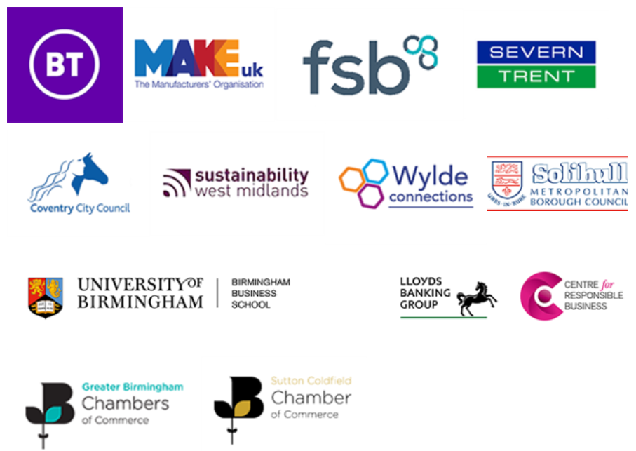

The West Midlands Net Zero Business Pledge

There are 4 parts to completing the pledge
- Become an ambassador
- Working with others
- Committing to reducing your carbon footprint
- Share your business challenges in relation to this pledge

Organisation name

What size is your organisation in terms of employees
How did you hear about the WMCA Net Zero Business Pledge
Contact name

Job title

Email address

Telephone

Registered address - Main office (West Midlands)

Postcode

Sector

Organisation website

LinkedIn handle – if applicable

Twitter handle - if applicable
Are you paying the Real Living Wage to all employees as defined by the Living Wage Foundation?
Yes. I am
No. I am not currently

1. Commitment to reducing your carbon emissions
We want to show leadership in support of the Government’s national ambitions for achieving net zero carbon in the UK by 2050 and have set the West Midlands a target to do this by 2041. Your pledge as part of this commitment will help to reduce the carbon emissions generated by your organisation and will contribute to the regional target. This can result in cost savings and give you a competitive advantage. Support and grants are also available to help make these changes easier from the WMCA supported the Sustainable Business Support Hub.

How far has your organisation progressed in terms of carbon reduction (please select one)
Beginner - this is our first step
Intermediate - we have made a few changes to reduce emissions
Advanced - we are well on our way to taking action
Please provide any web links to reports, plans or strategies, that evidence your progress to date (if available)

Please give details of any carbon reduction targets you have already committed to (if applicable)

We have provided some suggestions for how you can reduce your carbon emissions. These are intended as starting points, so you don’t need to do each one to fulfil the pledge.

Please tick all that apply and provide any details below each section.

Management
Assessing your current emissions and developing a plan to reduce them
Adopting and publishing an Environmental Policy to capture your goals
Establishing an Environmental Management System (EMS) to monitor your progress
Obtaining a formal certification for your EMS
Raising awareness of environmental business issues amongst staff, e.g. through carbon literacy training
Adopt a sustainable procurement policy
Addressing any risks of pollution across your business
Managing environmental risks
Please share more details of what you are doing in terms of management

Transport
Encouraging alternatives to car use
Promoting walking and cycling
Upgrading your transport fleet to low emission vehicles
Please share more detail of what you are doing on transport

Energy management
Consider switching to a green energy supplier
Monitor utility use to identify areas for savings
Installing lighting, heating and cooling controls to save energy
Insulation to reduce the need for heating and cooling
Please share more detail of what you are doing on energy use

Natural environment
Planting trees or hedges in your grounds or community
Harvesting rainwater or grey water to use on-site
Creating wildlife habitats on your grounds, e.g. a pond, bird feeder, wild patches of grass
Please share more detail of what you are doing on natural environment or water management

Resource use
Reviewing operations to reduce the use of raw materials
Avoiding single use items
Having an active approach to waste monitoring and reduction
Please share more detail of what you are doing on resources

If your business has specific waste materials or products that could be put to good use by others then please add these into the commentary below.

Please add any other actions your organisation is carrying out to reduce carbon emissions

Annual Review
As part of the Net Zero Business Pledge we will carry out an annual review to assess progress against your commitments. Please confirm that you are happy for us to contact you to see how you are progressing *

2. Working with others

Please tell us if you have any existing collaborations where your business is working with others to achieve better environmental outcomes.

If you're not currently working with others, there are many ways that you can start to collaborate. You can find further information about networks and support organisations from the Sustainability West Midlands Business Support Hub

Include any suppliers, networks and contacts. You can also include collaborations you would like to put in place that would help you to fulfil your pledge.

3. Become an ambassador
By acting as an ambassador you can inspire your customers, staff, and suppliers to make changes too.
Tell us about your business and what you hope to achieve from the actions you will take. If you have already started your carbon reduction journey then please tell us what benefits you’ve found to inspire others.
(Share your thoughts in 150-300 words)

Please tell us how you will champion this pledge and let us know if there is any support you need to assist you in this role.

Upload your logo here
Upload online

Upload an image reflecting your business operation
Upload online

Please confirm you are happy for your logo, image and case study to be used in connection with promoting your pledge
Yes. Happy for the logo, image and case study to be used as part of promotional activity
Please contact us to discuss the use of the logo, image and case study
No. Not happy for the logo, image and case study to be used as part of promotional activity

4. Sharing your business challenges
If you need support there is plenty available via regional and local green business networks. Tell us about your business challenges for net zero.

