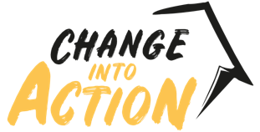
THERE’S A BETTER WAY: CHANGE INTO ACTION
COMMUNICATIONS TOOLKIT

Intro
Please use this toolkit to help you promote Change into Action (including Alternative Giving CIO) to residents and businesses in the West Midlands. Feel free to use any of the digital assets and copy and share the information with your networks. Let’s put real Change into Action!

Background
Change into Action is an alternative giving scheme that provides residents and businesses with a safe and secure way to donate money to people sleeping rough.

Originally launched in Birmingham by the West Midlands Combined Authority with Birmingham City Council, it has now been rolled out to all seven boroughs of the West Midlands, except Wolverhampton where the local Business Improvement District (BID) run an identical scheme called Alternative Giving CIO.

With alternative giving schemes, donations fund practical support for people who are, or have been, rough sleeping so that they can move away from the streets for good.

There’s a better way
The new campaign style and tagline ‘There’s a Better Way’ was first developed by Birmingham City Council for their campaign in September 2021. The aim is not to tell the public what to do, but to advise that there is a better way to help, and that Change into Action provides that. Often, people who are begging are vulnerable and at risk and there are services available to help.

We don’t want to delay people getting the support they need and escaping a cycle of begging. We are also conscious that begging sometimes occurs near busy main roads and routes through our towns and cities and this potentially places motorists’ lives at risk too.

This new campaign uses outdoor media across the region alongside social and digital media to promote the campaign and runs from 1 December 2021.

What can we do to help?
The Change into Action website provides information about homelessness and encourages support for the campaign in three ways:

- Locate – to look out for people who might be sleeping rough, or at risk of homelessness, so that they can be connected to local support services and outreach teams. Concerned residents can use StreetLink to notify local services.
- Donate – to make a donation to Change into Action that will directly help people to move away from the streets and turn their lives around.
- Share - promote and share details about the campaign.

Social media posts, hashtags, and graphics

Twitter
- Your donations to @Changein2action directly support people who need it in your local area. Just £2 could cover the cost of a warm meal for someone sleeping rough this winter. There’s a better way to help. Donate to #ChangeIntoAction now, at: http://changeintoaction.org.uk #BetterWay

- Just £10 can help someone off the streets to buy kitchen items for their move into self-catering accommodation. There’s a better way to help in your local area. Donate to @ChangeIn2Action now, at: http://changeintoaction.org.uk #BetterWay #ChangeIntoAction

- Donate £50 to @Changein2Action and you could help to smarten the appearance of someone homeless, giving them the confidence to attend job interviews. There’s a better way to help. Donate to #ChangeIntoAction today, at: http://changeintoaction.org.uk #BetterWay

- Your donations can help us to provide TV or music for people with addiction issues to keep on track with their new life and distracted from the streets. There’s a better way to help. Donate to @ChangeIn2Action at http://changeintoaction.org.uk #BetterWay #ChangeIntoAction

- #ChangeIntoAction is a partnership between organisations in your community working together to help vulnerable people move off the streets and into accommodation. We need your help to turn more lives around. There’s a #BetterWay to help. Donate, at: http://changeintoaction.org.uk

Facebook
- Your donations to @ChangeIntoAction directly support people who need it in your local area. Just £2 could cover the cost of a warm meal for someone sleeping rough this winter. There’s a better way to help. Donate to #ChangeIntoAction now, at: http://changeintoaction.org.uk #BetterWay

- Just £10 can help someone off the streets to buy kitchen items for their move into self-catering accommodation. There’s a better way to help in your local area. Donate to @ChangeIntoAction now at http://changeintoaction.org.uk #BetterWay #ChangeIntoAction

- Donate £50 to @ChangeIntoAction and you could help to smarten the appearance of someone homeless, giving them the confidence to attend job interviews. There’s a better way to help. Donate to #ChangeIntoAction today, at http://changeintoaction.org.uk #BetterWay

- Your donations can help us to provide TV or music for people with addiction issues to keep on track with their new life and distracted from the streets. There’s a better way to help. Donate to @ChangeIntoAction at http://changeintoaction.org.uk #BetterWay #ChangeIntoAction

- #ChangeIntoAction is a partnership between organisations in your local community working together to help vulnerable people move off the streets and into accommodation. We need your help to turn more lives around. There’s a #BetterWay to help. Donate, at: http://changeintoaction.org.uk

Tag in our social media channels:

Facebook: @ChangeIntoAction

Twitter: @ChangeIn2Action

Use BOTH hashtags:
- #ChangeIntoAction
- #BetterWay

Social media graphics

Download social media assets

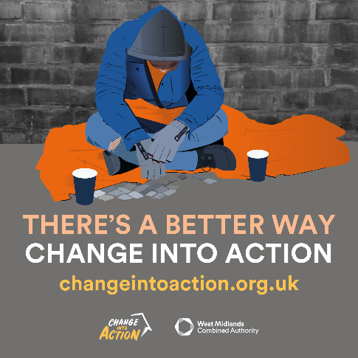
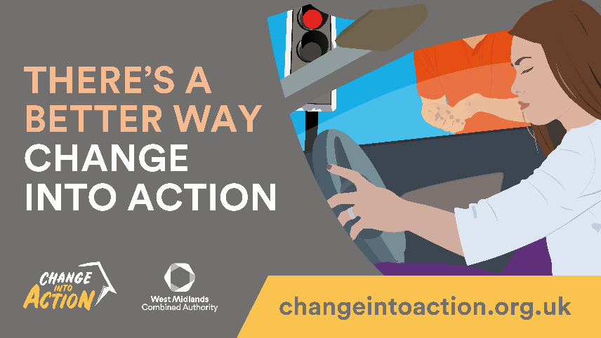
Example graphics:

