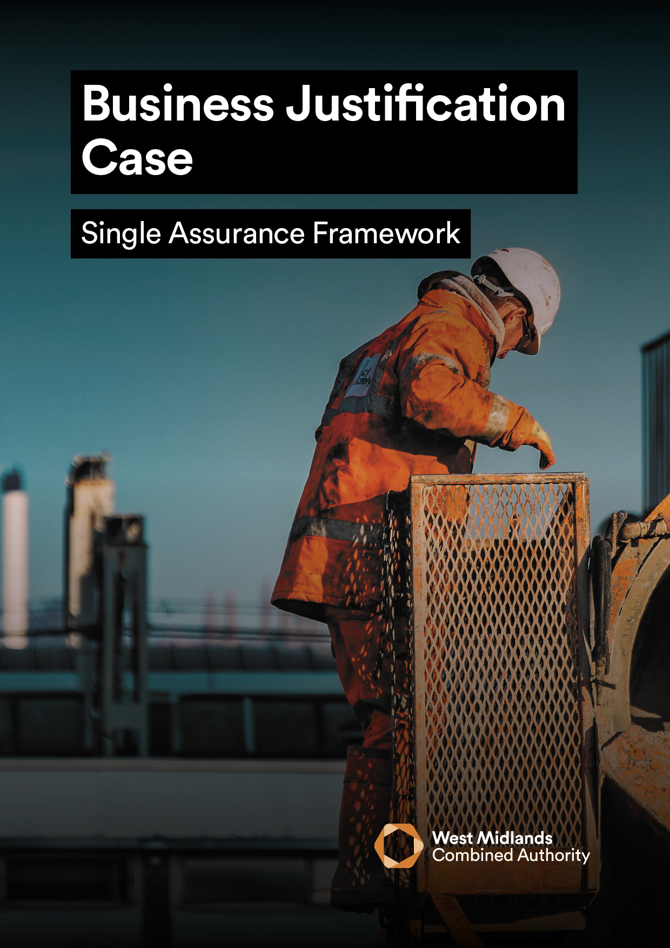

**BUSINESS JUSTIFICATION CASE**

**_____________________________________________________________________________**

[Insert Project Name]

|  |
| --- |
| The **Business Justification Case (BJC)** is a single stage business case, using the Five Case Model, for the delivery of relatively low level spend for which **firm** prices are available.  A BJC may be considered within WMCA for smaller items of spend, which:   * are **not** novel or contentious and * can be procured from an existing pre-competed arrangements. |

|  |  |  |  |
| --- | --- | --- | --- |
| **Version** |  | **Date** |  |
| **Prepared By** |  | **Job Title** |  |

|  |  |
| --- | --- |
| **Lead WMCA Directorate** |  |
| **Lead WMCA Executive Director** |  |

|  |  |  |
| --- | --- | --- |
| **Has BCAT been submitted to Assurance and Appraisal?** | **Yes** | **No** |
| **Has this been approved by Lead WMCA Executive Director?** | **Yes** | **No** |

|  |  |
| --- | --- |
| **Approved By** |  |
| **Signature** |  |
| **Date** |  |

***To support better spending, investment decisions and better procurement, this Business Justification Case should be written using WMCA guidance. In addition, it is a requirement that all bids for public funds submitted to WMCA are guided and based around the HM Treasury’s Green Book 2020 and supporting information which can be found here***

|  |  |
| --- | --- |
| **1** | **EXECUTIVE SUMMARY**  Please provide a one-page stand-alone summary of the project which includes a brief project description, details of alignment with WMCA strategic objectives, project objectives, costs and expected outputs and details of the spend for which approval is being sought. |
|  | |

|  |  |
| --- | --- |
|  |  |

|  |  |
| --- | --- |
|  |  |

|  |  |
| --- | --- |
| **2** | **STRATEGIC CASE** |
| **2.1 Strategic Objectives** | |
| Please outline how the proposed project will contribute to each of the key  policy aims that relate to the WMCAs strategic objectives:   |  |  | | --- | --- | | **Policy Aim** | **Alignment with Proposed Project** | | Promote inclusive economic growth in every corner of the region |  | | Ensure everyone has the opportunity to benefit |  | | Connect our communities by delivering transport and unlocking housing and regeneration schemes |  | | Reduce carbon emissions to net zero and enhance the environment |  | | Secure new powers and resources from central government |  | | Develop our organisation and be a good regional partner |  | | |
| **2.2 Inclusive Growth** | |
| Please outline how the proposed project will contribute towards inclusive growth of the  region in alignment with each of the key policy aims:   |  |  | | --- | --- | | **Policy Aim** | **Inclusive Growth contribution through Proposed Project** | | Promote inclusive economic growth in every corner of the region |  | | Ensure everyone has the opportunity to benefit |  | | Connect our communities by delivering transport and unlocking housing and regeneration schemes |  | | Reduce carbon emissions to net zero and enhance the environment |  | | Secure new powers and resources from central government |  | | Develop our organisation and be a good regional partner |  | | |
| **2.3 COVID-19 Recovery**  Please outline any specific measures included within the proposed project to support  COVID-19 recovery? | |
|  | |
| **2.4 Existing Arrangements**  Describe the existing arrangements in place (i.e. business as usual); set out what is currently  provided? This may include, but not be limited to costs, asset availability / utilisation and condition. | |
|  | |
| **2.5 Business Needs**  Describe deficiencies associated with the current provision and the implications if the project  does not proceed.   * Include suitable quantification of needs/demands where possible. * Provide details around the service gap – i.e. the difference between current provision and where the business wants to be in line with the spending objectives of this proposal * Why is public sector investment required? | |
|  | |
| **2.6 Project Scope and Services**  In order to deliver potential service improvements, it is useful to classify needs / requirements. For  This project please outline the requirements of the project based on the following hierarchy:   * The ‘Essential’ requirements without which the project would not be judged to be a success; * The ‘Desirable’ requirements which the project may justify extra expenditure on a value for   money basis; and   * The ‘Optimum’ or ‘Highly Desirable’ requirements, which the project may justify on a marginal   low cost and affordability basis. | |
|  | |
| **2.7 Spending Objectives**  Outline the key objectives, in the table below, of the proposal by way of what it is trying to achieve  in terms of outcomes. Some examples that may apply are detailed below:   * To improve the quality of public services by delivering better social outcomes e.g. to meet new   policies and operational targets (effectiveness);   * To improve the delivery of public services through better use of inputs and outputs (efficiency); * To reduce the costs of public services (economy); * To meet legal, regulatory or organisational requirements and accepted best-practice   (compliance and conformance);   * To re-procure services or equipment to avert service failure and provide business   continuity (replacement)  Outcomes should be developed based on three key questions:  1. How much did we do?  2. How well did we do it?  3. Is anyone better off?  These three questions will form the core of what should be measured in relation to the delivery and  impact of the project being appraised. | |
| |  |  |  |  |  |  | | --- | --- | --- | --- | --- | --- | | **#** | **Objective** | **Baseline** | **Target** | **Specific actions to achieve objective** | **How will the customer be**  **better off? (i.e. Outcomes)** | | **1.** |  |  |  |  |  | | **2.** |  |  |  |  |  | | **3.** |  |  |  |  |  | | **4.** |  |  |  |  |  |   *Objectives and associated outcomes should be based on **SMART** methodology (**S**pecific,  **M**easurable, **A**chievable, **R**ealistic and **T**ime-Dependent). Targets should be related to these  objectives, along with the current baseline measure. | |
| **2.8 Constraints**  Document the constraints that have been placed on the investment proposal which are a set of  parameters within which the project must be delivered. This may include, but not be limited to  affordability; spatial; legislative; timing; legal constraints; funding conditions etc. | |
|  | |
| **2.9 Dependencies**  Specify any dependencies outside of the scope of the investment proposal upon which successful  delivery is dependent (i.e. is the project reliant on another / external environment to be successful?). | |
|  | |

|  |  |
| --- | --- |
| **3** | **ECONOMIC CASE** |
| **3.1** **Options Analysis**  Please identify a number of options and complete a shortlisting exercise within the table  below.  The options being appraised should include:   * Business as usual (the baseline from which improvement will be measured); * The ‘Do Minimum’ (a realistic option that meets core requirements); and * Any additional options considered capable of delivering the objectives (a workshop   format with stakeholders; end-users; sponsor/SRO and other key participants may  facilitate engagement, can challenge thinking and better scope particular options) | |
| |  |  |  |  | | --- | --- | --- | --- | | **Option** | **Description** | **Shortlisted (S) / Rejected (R)** | **Meets Objectives?**  **(Y/N)** | | **1.** |  |  |  | | **2.** |  |  |  | | **3.** |  |  |  | | **4.** |  |  |  |   **3.2 Monetary Costs**  Detail the assumptions and sources used in producing the costs and benefits of the short-listed  options, taking account of additionality and potential for displacement. Evidence should be provided which should be benchmarked or market tested (if appropriate). A separate appendix can be included to  detail cost if required. | |
|  | |
| **3.3 Options Evaluation**  The following table should be completed for each of the options. More detailed calculations can be  included as an Appendix.   * All costs and benefits arising from the project (inclusive of public, private and third sectors) at * current market prices; * Any adjustments for optimism bias; * Summary of NPSV and intended benefits (Inclusive of clear assumptions underpinning NPSV calculations (within separate appendix if required); * Details of any financial savings under different options (do not double count these as benefits); * A challenge to cost assumptions where appropriate. Appraisers should consider   sensitivity analysis to illustrate how option rankings may be affected by varying key  assumptions. | |
| |  |  | | --- | --- | | **OPTION 1** | **BUSINESS AS USUAL (BAU)** | | **Description** | *<Potential scope, solution, delivery, implementation, and funding stream >* | | **Net**  **Costs** |  | | **NPSV** |  | | **Advantages\*** |  | | **Disadvantages\*** |  | | **Conclusion** | *<How well it meets the agreed spending objectives and critical success factors (CSFs) for the procurement.>* | | **OPTION 2** | **DO MINIMUM:** | | **Description** | *<Potential scope, solution, delivery, implementation, and funding stream>* | | **Net**  **Costs** |  | | **NPSV** |  | | **Advantages\*** |  | | **Disadvantages\*** |  | | **Conclusion** | *<How well it meets the agreed spending objectives and critical success factors (CSFs) for the procurement.>* | | **OPTION 3** |  | | **Description** | *<Potential scope, solution, delivery, implementation, and funding stream>* | | **Net**  **Costs** |  | | **NPSV** |  | | **Advantages\*** |  | | **Disadvantages\*** |  | | **Conclusion** | *<How well it meets the agreed spending objectives and critical success factors (CSFs) for the procurement.>* | | |

|  |  |
| --- | --- |
| **3.4 Benefits**  Describe the benefits from achieving the anticipated project outcomes, as well as any proposed beneficiaries (e.g. type of benefit, who will be better off, how will this be measured – i.e. is the benefit cash / non-cash releasing?) using the table below:   * Can it be quantified or is it a qualitative benefit? * How does each benefit impact upon the options?   Please also document:   * direct public sector benefits (to originating organisation / West Midlands region) * social impact and benefits (including reference to any non-monetisable benefits) * indirect public sector benefits (to other public sector organisations); and * wider societal benefits (households, individuals and businesses where applicable) | |
| |  |  |  |  |  |  | | --- | --- | --- | --- | --- | --- | | **Benefit** | **Benefit Type** | **Impact on Option 1** | **Impact on Option 2** | **Impact on Option 3** | **Impact on Option 4** | | **1.** |  |  |  |  |  | | **2.** |  |  |  |  |  | | **3.** |  |  |  |  |  | | **4.** |  |  |  |  |  | | |
| **3.5 Risks**  Document the risks associated with achieving the anticipated project outcomes using the table below overleaf. Include the proposed countermeasures for mitigating and managing the risk.  You should focus on the business risks (those that are retained in the organisation) and the service risks (those that may be shared with the supply side, as required, in the design, build, funding and operational phases of the investment proposal).  The probability of each risk occurring and its likely impact should be assessed, along with an overall risk rating. | |
|  | |
| **3.6 Risk Summary**  Please provide a summary of the 5 key risks associated with the proposed project? For larger more complex projects a separate risk register is expected as a separate appendix (please refer to guidance). | |
|  | |
| **3.7 Options Appraisal Summary**  A summary of each option should be completed as per below. Each option should reference the costs, benefits and risks noted within Section 2.1. | |
| |  |  |  |  |  | | --- | --- | --- | --- | --- | |  | **Option 1** | **Option 2** | **Option 3** | **Option 4** | | **Description\*** |  |  |  |  | | **Net Costs (capex and opex)** |  |  |  |  | | **Benefits (monetary and non-monetary)** |  |  |  |  | | **Risks** |  |  |  |  | | **Conclusion\*\*** |  |  |  |  |   * This may include details on the scope, solution, delivery, implementation and funding stream  ** How well it meets the agreed spending objectives | |
| **3.8 Recommended / Preferred Option**  Please confirm which Option you deem to be the preferred option. Conclusions should be drawn on each of the different options considered in terms of cost, benefit, risk and its ability to meet the spending objectives. | |
|  | |
| **4** | **COMMERCIAL CASE** |
| **In this section, please provide an outline of the proposed procurement for the preferred option – i.e. what will be procured and how.**  **Key information includes:**   * Describe the outputs – i.e. goods, services and works that will be procured in relation to the recommended / preferred option and how this will be paid for; * Outline how the goods, services and works will be paid for e.g. payment against milestones, payment against delivery of services, performance related pay (e.g. KPIs), availability or usage, the pricing strategy objectives; * Identify and explain any associated mitigation or reduction of procurement risks through the contract should be detailed; * Set out the approach / route to procurement (i.e. the strategy to undertake it), the source of procurement advice and how it fits with market place conditions; * How the proposed approach meets existing procurement rules and regulations and achieves value for money; * Market knowledge, e.g. demonstrate whether there has been any supplier engagement, any assessment of the viability of concept, the market risks and the number of potential bidders; * Explain any legal / personnel implications of the recommended / preferred option, if applicable, and how they will be managed. | |
|  | |
| **5** | **FINANCIAL CASE** |
| **Please outline how the project will be funded. Other relevant information regarding the funding of the project should be included:**   * Commitments already made to guarantee the funding, or other resources required; * Presentation of the financial implications and sources of funding for the preferred option (whole life cost inclusive of inflation, VAT, optimism bias, depreciation etc.). See table below. For investment proposals exceeding five years, the table should be expanded accordingly; * CAPEX and OPEX requirements should be detailed and an overall statement on affordability and funding should be provided; * Details should be provided to confirm if the funding is secured / applied for; * Assumptions surrounding revenue generation should be explained and justified where possible. An assessment of viability should be made. * Explain any impacts on the balance sheet (e.g. increases in assets / liabilities) of the organisation and how these will be dealt with. | |
|  | |
| **6** | **MANAGEMENT CASE** |
| **6.1 Project Management Arrangements**  Please detail the arrangements in place to successfully deliver, manage and evaluate the scheme / project.  **Project Management**  Consideration should be given to the following:   * Proposed project management arrangements including project management standards, governance arrangements (e.g. roles, responsibilities, capability and capacity of the project team, reporting lines and how the governance structure works); * Project schedule for delivery (including contingency plan / arrangements); * Project assurance (i.e. definition of monitoring and quality criteria; monitoring performance and delivery; progress reports; provision of advice, guidance, support and information e.g. potential / actual overruns) * Project reviews (peer-to-peer reviews, project implementation reviews and post- evaluation review and if applicable. Cabinet Gateway Reviews); * Risk Management Plan detailing the allocation and sharing of risk to those best placed to manage them (public / private sector). This should also include a risk register for larger / more complex projects (attached as an appendix); * Contract Management Plan (e.g. for dealing with contractual elements of the project, if required) | |
|  | |
| **6.2 Project Benefits & Evaluation**  Consideration should be given to the following:   * Benefits Realisation Plan should be included. * Post Project Evaluation (e.g. who will be responsible for completing the PPE, when it will be completed, what will be evaluated and how widely will lessons learned will be disseminated). The PPE should evaluate if the project was delivered to time, cost and specifications whilst assessing the delivery of benefits / project outcomes achieved, risk management and the overall management of the project | |
|  | |