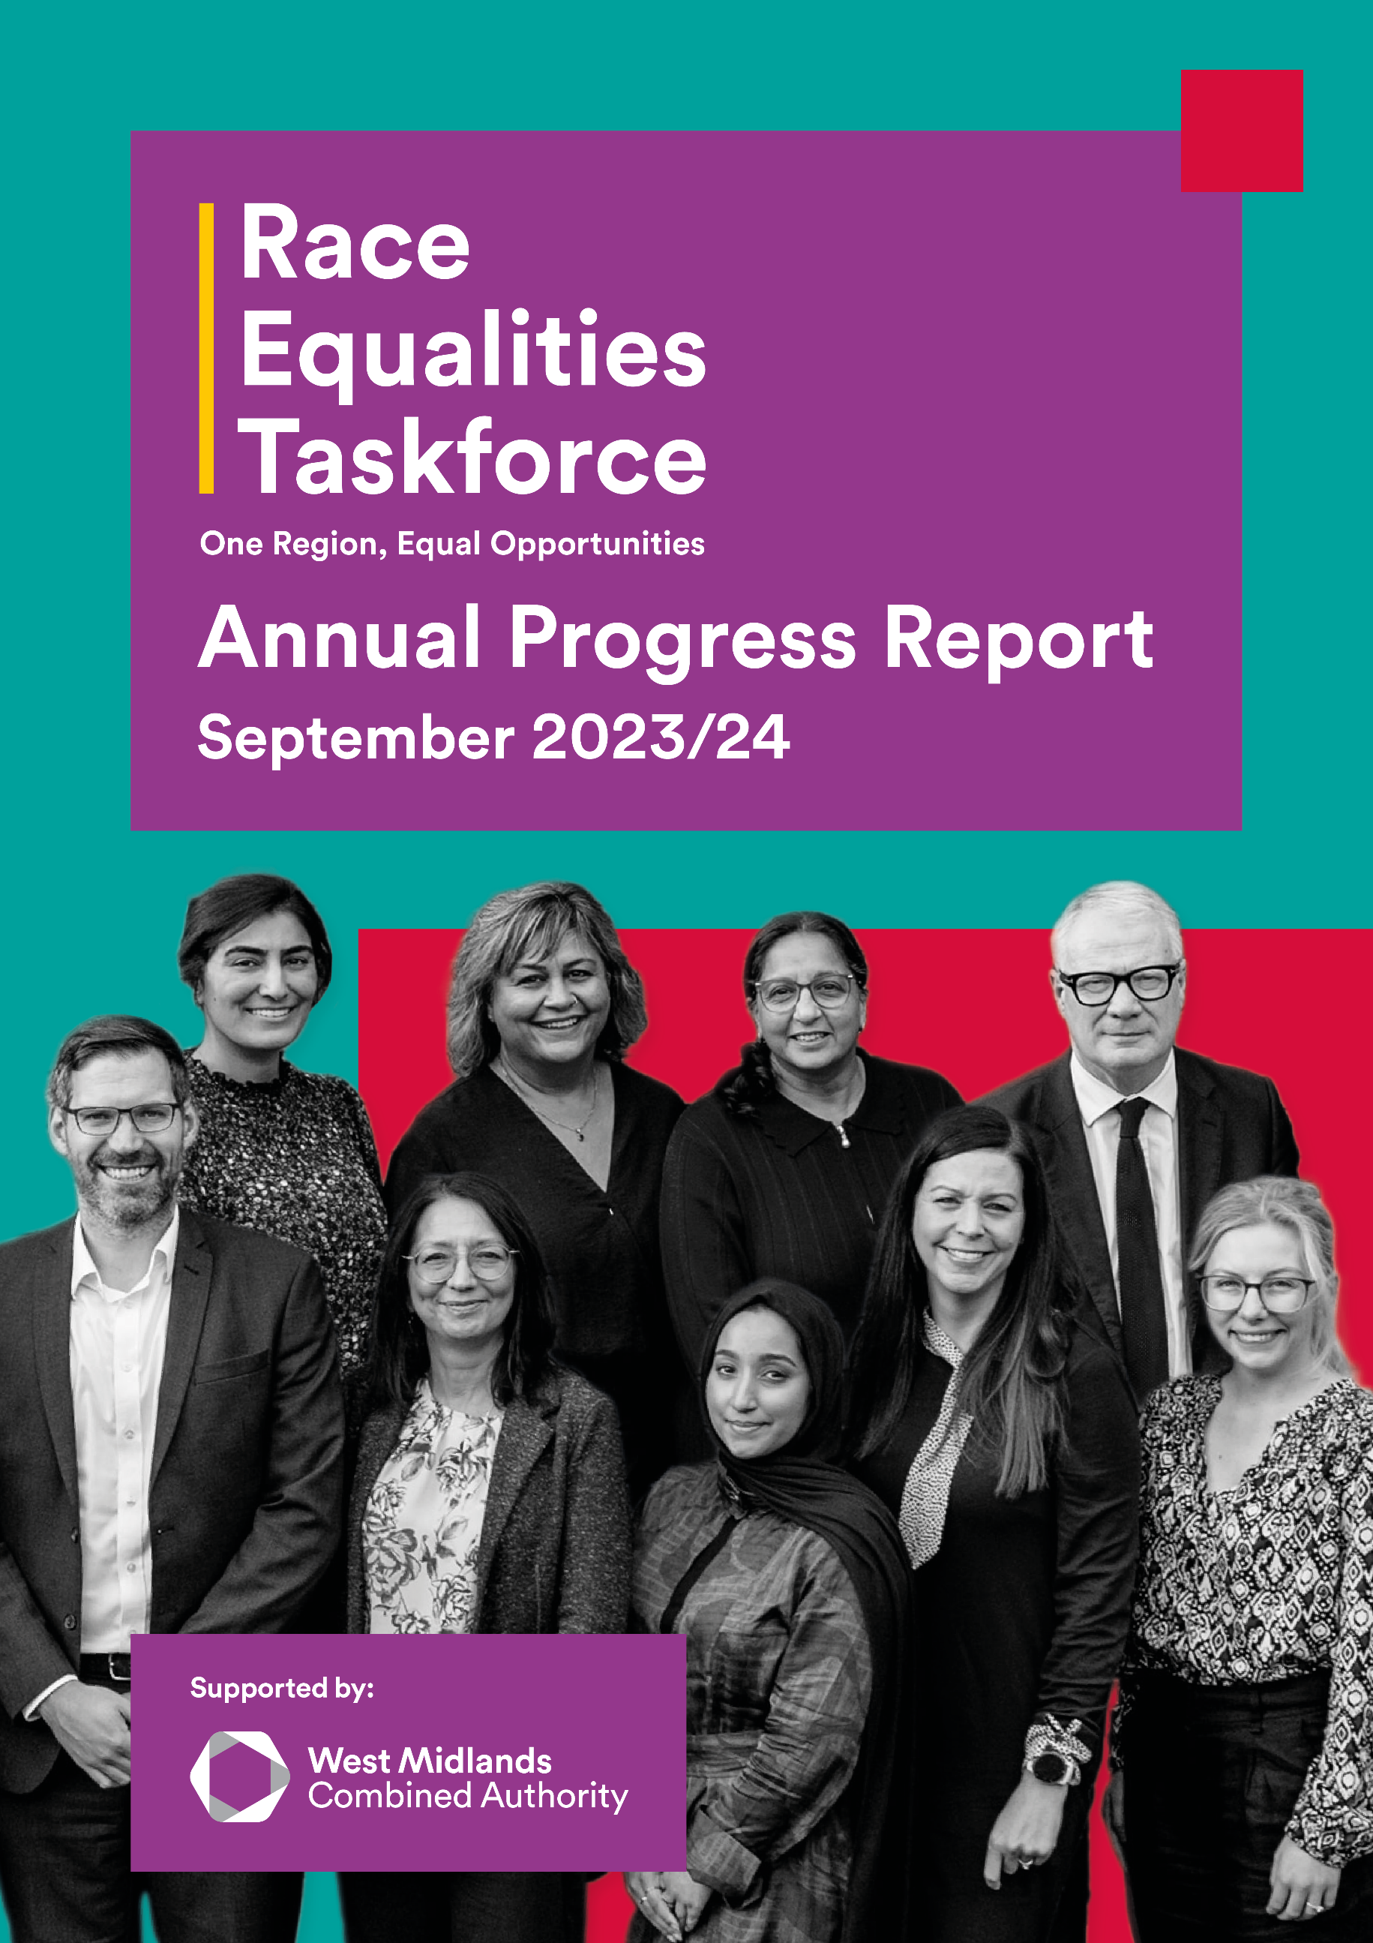

Contents
Foreword 2
Introduction 3
Enabling Change 7
Influencing Change 11
Mobilising Action 16
Unlocking Investment 21
Looking Forward 24
Appendix: summary of progress 27
Appendix: thanks to partners 42

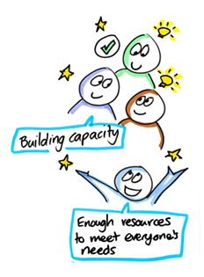
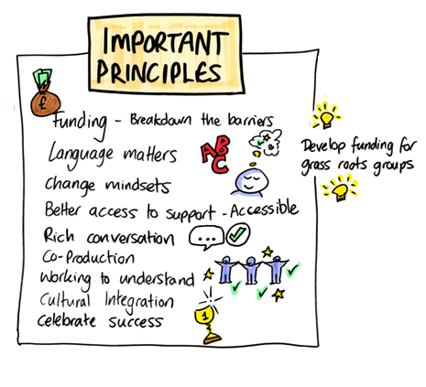


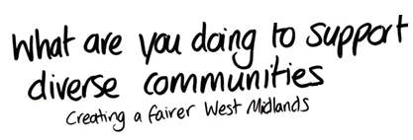


Foreword

"I became Independent Chair of the Race Equalities Taskforce ("RET") in July 2023. I did this against a backdrop of divisive identity politics, geopolitical fragmentation and no recourse to funding from government or grants. There was feedback regionally and indeed nationally that there is a lot of discussions on these issues, but implementation of the actions identified in reports like Race Forward was NOT happening.
We held a community launch for Race Forward in September 2023. The report provides the rich data and evidence that outlines why the RET exists in this region. It also offers a fluid framework for action across the various policy pillars we would focus on, vitally recognising the cross-cutting priorities that drive outcomes.
It has now been 12 months, since the RET launched into its first year of delivery moving to implementation through action and leading to impact. Crucially we have established cross-sector work groups, bringing together domain experts, to drive forward progress in various areas. We lead by inclusion and are open to critical challenge.
We have a systems change mandate, to do this, allocating resources efficiently becomes paramount hence everything achieved to date and our ongoing work stems from the following principles (lessons learnt):
- Make incremental steps (they add up)
- Learn by doing
- Build trust and credibility
- We only know what we know
- Lead by inclusion
- Web for the medium term
The impact we have made so far would not be possible without all our partners, stakeholders and challengers. We are on a journey together. Thank you for your support and insights.
In the coming 12 months our ambition is to grow the body of our work, be more intersectional, strengthen national ties and attract funding both private and public. This will be challenging - bringing fact and hard truths to the fore is not popular.
“Opinion is the medium between knowledge and ignorance” - Plato.
Do you have a growth mindset? If you would like to work with us, please email RaceEqualitiesTaskforce@wmca.org.uk.
We are stronger together. Unity."
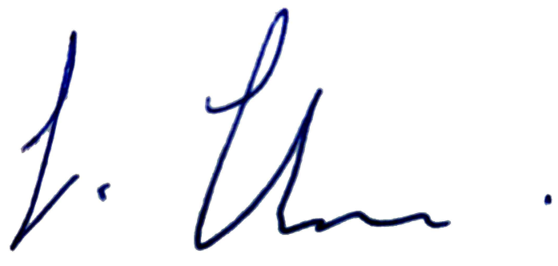
Sharonjit Clare
Independent Chair of the West Midlands Race Equalities Taskforce

Introduction

The West Midlands Race Equalities Taskforce brings together partners to tackle race inequality and make our region fairer. This report sets out the progress the Taskforce has made in our first year of delivery (September 2023 - 2024).

About the Taskforce
45% of people living in the West Midlands Combined Authority area (WMCA) do not identify as being from a White British background. This means that 1.3 million of our residents may face race inequality in their daily lives.
The Race Equalities Taskforce was set up to improve opportunity for all communities. We are an independent group that was created by the leaders of our region at the WMCA Board. Our job is to bring together a wide range of partners to tackle race inequality and make our region fairer.
The Taskforce first met in Spring 2022. We are a partnership that brings together leaders from different backgrounds and sectors, including independent members and public service officers.
We spent our first year developing Race Forward, which is our plan for change. Race Forward sets out evidence of race inequality in our region. It then outlines the changes we want to enable, influence and mobilise across our priority areas. We focus on the policy areas where the WMCA and its partners can make the most impact.
Race Forward was backed by the WMCA Board in March 2023 and launched at our community event in Sandwell, in September 2023. Community leaders at the launch shared their support. They asked us to champion their priorities too.
Our community launch marked the beginning of the Taskforce’s delivery phase. Since then, we have been working towards the ambitions set out in Race Forward as well as the priorities that community leaders asked us to focus on at the launch event.
You can find out more about the Taskforce at www.wmca.org.uk/race-forward and read our report online.
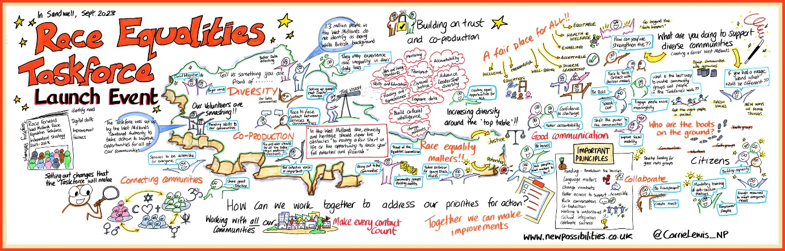
Our Race Forward priorities:
Race Forward sets out our priorities, ambitions and ideas for action. These focus on the policy areas where the WMCA and its partners can make the most impact. Race Forward also identifies some ‘cross cutting’ priorities. These are themes and guiding principles we need to make change possible.
Jobs, Living Standards, Skills and Education  Aim: remove barriers and build inclusive pathways. |  | Health and Wellbeing  Aim: champion culturally intelligent health and wellbeing services. |  | Housing and Homelessness  Aim: develop fairer access and build homes and neighbourhoods that help people to flourish.

Transport  Aim: connect lives through a sustainable and accessible transport network. |  | Criminal Justice  Aim: create a fairer criminal justice system that considers race and makes every community feel safe. |  | Cross cutting priorities  Data and evidence.  Leadership diversity.  Cultural intelligence.  Coproduction.  Intersectional approach.  Building trust.

Our community-led priorities:
We held a community launch for Race Forward on 15 September 2023 at the Bethel Convention Centre in West Bromwich. More than 70 partners joined us, representing around 50 organisations, including community, business and public service leaders. The West Midlands Mayor and Leader of Sandwell Council spoke. Lots of community organisations from Sandwell joined us.
At the event, we introduced Race Forward and asked people for their advice on our next steps. Community leaders told us that they often feel undervalued and unsupported by public services. They spoke about the need to build better and more equal partnerships to support communities to thrive.
Community leaders asked the Taskforce to:
- Improve community engagement and set up community sounding boards.
- Explore capacity building, so that public services invest and “build on what is already there.” They wanted us to help to “break down barriers” to funding and competition between groups.
- Showcase best practice. People said that the fantastic work communities do needs to be understood, valued and celebrated.
Our social innovation spiral…
The Taskforce take a ‘social innovation’ approach. We bring together a wide range of partners to find new ways to tackle race inequality. The work we do varies depending on the scenario, but we are always moving towards embedding systemic change. This framework can help us to plan and track the progress of our activity.

10
8
4
2
3
5
13
9
6
7
Enable change | 1 | Identify challenges and opportunities through better data and community engagement.
 | 2 | Generate ideas through workshops, reports and learning.
 | 3 | Enable change by bringing together partners to take action.
Influence change | 4 | Directly influence WMCA and our partners.
 | 5 | Indirectly influence wider change by encouraging other organisations, businesses, and communities.
Mobilise change | 6 | Develop and test ways to tackle issues.
 | 7 | Make a case for longer term change and demonstrate what works.
 | 8 | Deliver and implement what works.
Embed change | 9 | Grow and scale progress.
 | 10 | Embed change into the system.
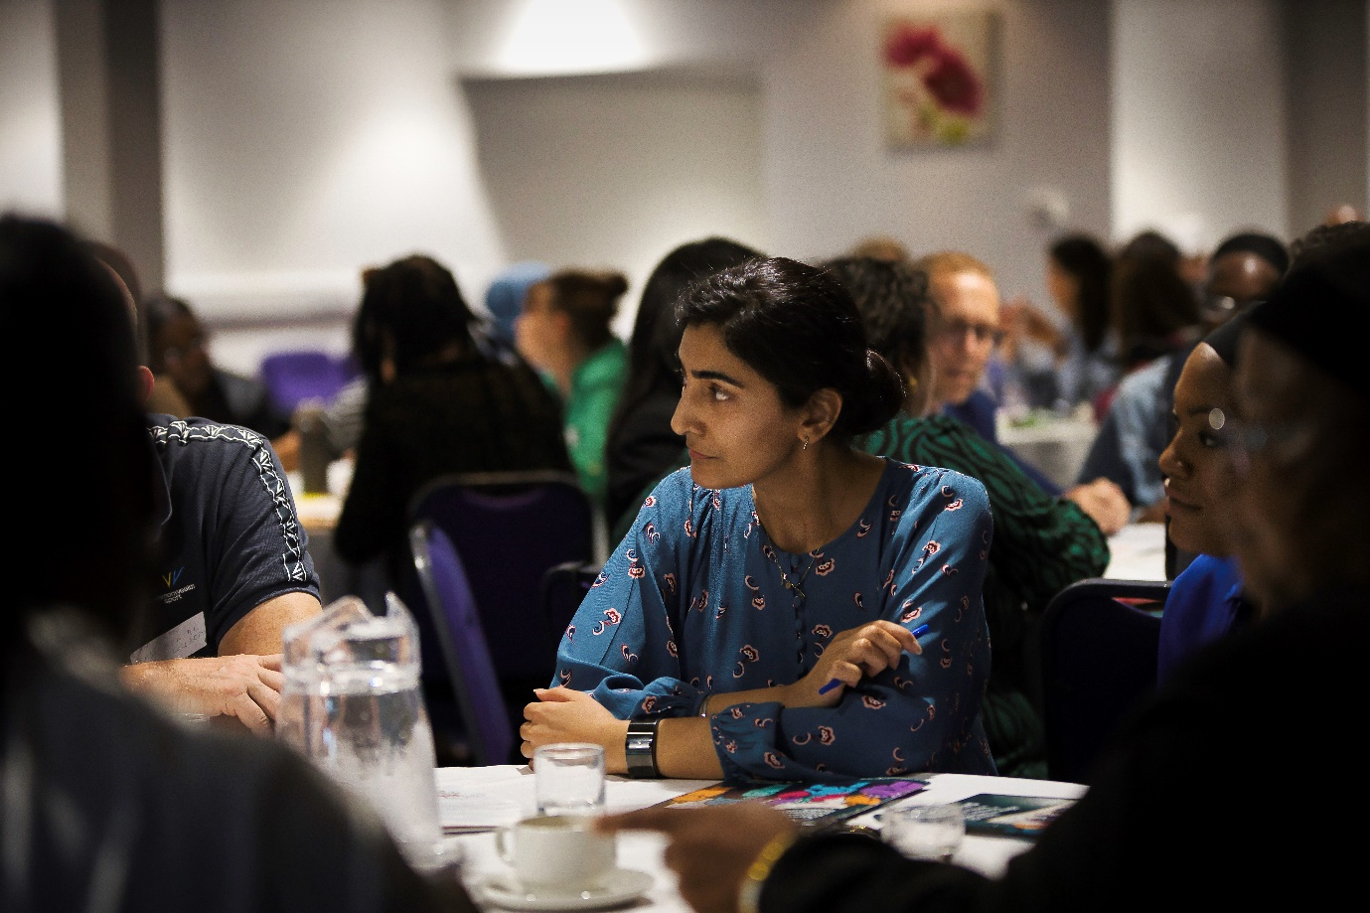
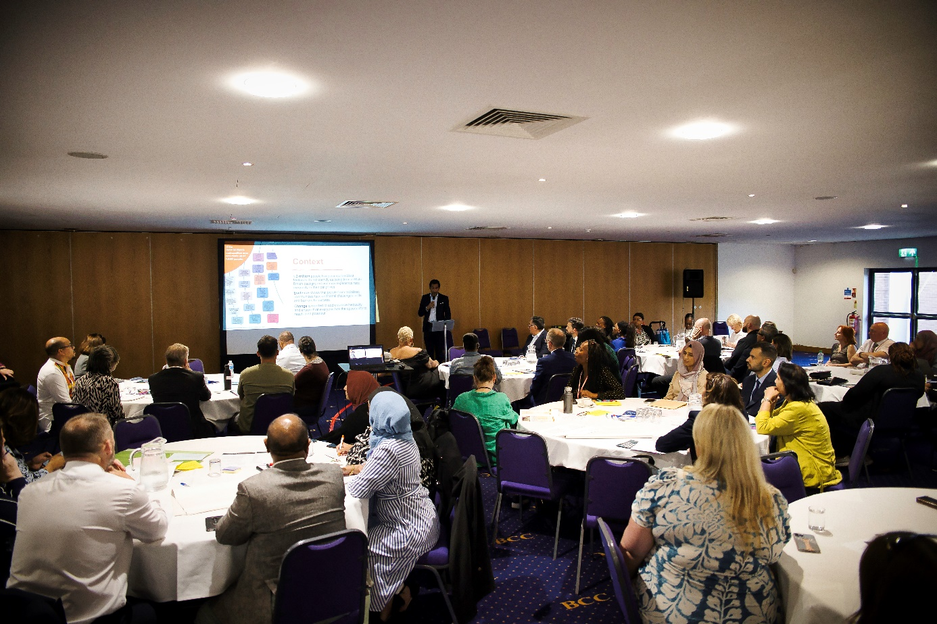
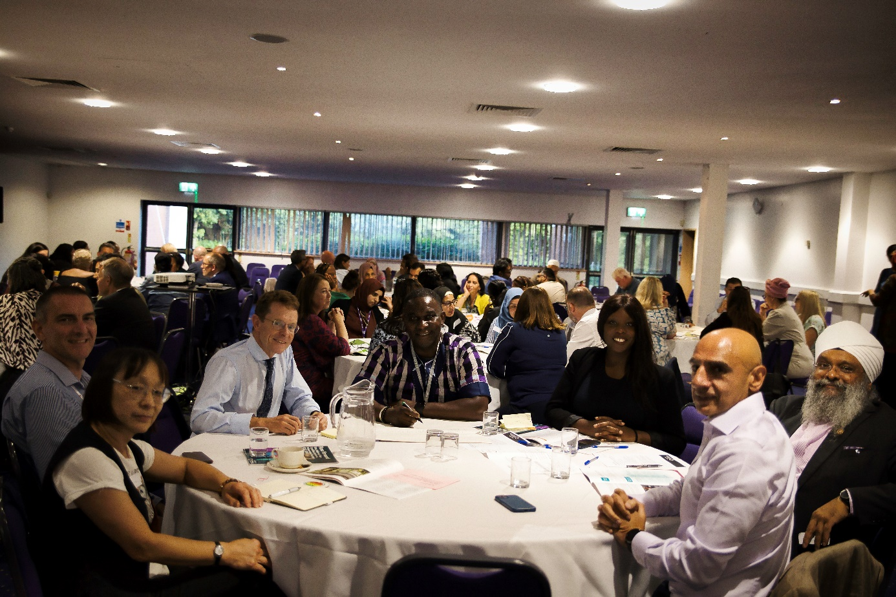

Enabling Change

The Taskforce cannot work alone. Our role is to work together with public services, businesses, and communities so that everyone is doing more to tackle race inequality. This year, we have worked hard to strengthen our partnerships and reach.

Progress in numbers:
1 | 1 Race Equalities Taskforce.  Led by an Independent Chair with 23 core members.
1 | 1 Members Advisory Group.  Chaired by the Leader of Sandwell Council with a councillor to represent each of the 7 constituent local authorities in the WMCA area.
7 | 7 work groups established.  These have held a total of 23 formal meetings held during this first year of delivery, plus additional project and preparatory activity. Our work groups include:  - Jobs and skills  - Housing and homelessness  - Transport  - Community hubs  - Education  - Criminal justice (which was paused in January 2024 and is being re-established)  - A West Midlands Universities EDI forum.  2 more work groups will be established by early 2025: health and civic leadership.
98 | 98 partners contributed to the Taskforce and its work groups.  This includes 11 independent members of the Taskforce, 42 public service partners, 8 education partners, 14 business leaders, 14 community leaders and 9 elected members.
200+ | 200+ organisations actively participated in Taskforce led or supported projects and events.  This includes:  - Community launch of the Taskforce (Sept 2023)  - Local Criminal Justice Board leadership summit (Nov 2023)  - Race Equality Skills Week (20, Feb 2024)  - Funders Roundtable with WMCA Faith Strategic Partnership Group (March 2024)  - WMCA Civic Leadership Fair (June 2024)  - YCA Race Equality Youth Summit (July 2024)  - Community Led Business Support Launch (July 2024)  - Mayor’s Stronger Together roundtable (August 2024)
4,600+ | 4,600+ hours given. This equates to more than 2,000 hours of local authority officer time and 2,600 hours of volunteer time dedicated to the Taskforce and our work group [estimated on an average of half a day per partner per month].
£500k+ | More than £500,000 of non-financial resource given to Taskforce activity - including staff time, room bookings, advisory and training activity.
£1.85m | £1.85 million of new funding achieved and invested into communities.
PLUS | We are also extending our reach and “ripple effect” through:  - Championing the race equality agenda at external events.  - Building strong strategic partnerships, e.g., with Birmingham Race Impact Group, BCON and Chambers of Commerce.  - Engaging in “quiet diplomacy”, the Taskforce Chair has been meeting senior leaders behind the scenes.

Example partnership event: Inspire Education Trust
“Inspire Education Trust is proud to be an independent contributor to the West Midlands Race Equalities Taskforce.
During the September 2023 Inspire Education Trust conference, the Taskforce Chair and Deputy Chair, addressed all staff in the Trust to raise awareness on race inequalities in the region. The conference comprised of over 700 education professionals working across Coventry and Warwickshire.
Importantly, the conference raised awareness about the West Midlands diverse demographics as well as shone a light on the challenges faced by individuals across the region as a result of racial disparities.
The address has raised important conversations across the Trust about equality, diversity and inclusion and allowed education professionals to reflect on the role they play in shaping young people’s lives with equality, diversity and inclusion at the forefront of this.”
Josh Smith, Head of HR at Inspire Education Trust and independent member of the West Midlands Race Equalities Taskforce.

Example partnership event: Race Equality Youth Summit
We helped the Young Combined Authority (YCA) to deliver their annual youth summit in July 2024.
The YCA is the WMCA's youth voice programme. It brings together young people aged 11 to 18 years to have a say on regional policy. The YCA chose to focus their summit this year on race equality.
More than 200 young people, policy makers and professionals joined the event. It included keynote speeches, including from the Mayor of the West Midlands and Taskforce member Josh Smith. It also had a networking marketplace and youth panel.
We played a key role in reaching young people. We drew on the Taskforce's networks to invite young people to the event - doubling the number of attendees.
To make sure that the event could lead to genuine change, Taskforce members also sponsored and helped to shape the 3 workshops. This means that the ideas young people shared can inform future action by the WMCA, Taskforce and our partners. The Taskforce members who led on this were:
- Annum Mahmood (Youth Futures Foundation) – career pathways.
- Josh Smith (Inspire Education Trust) – mental health.
- Alethea Fuller (Office of Police and Crime Commissioner) – youth justice.

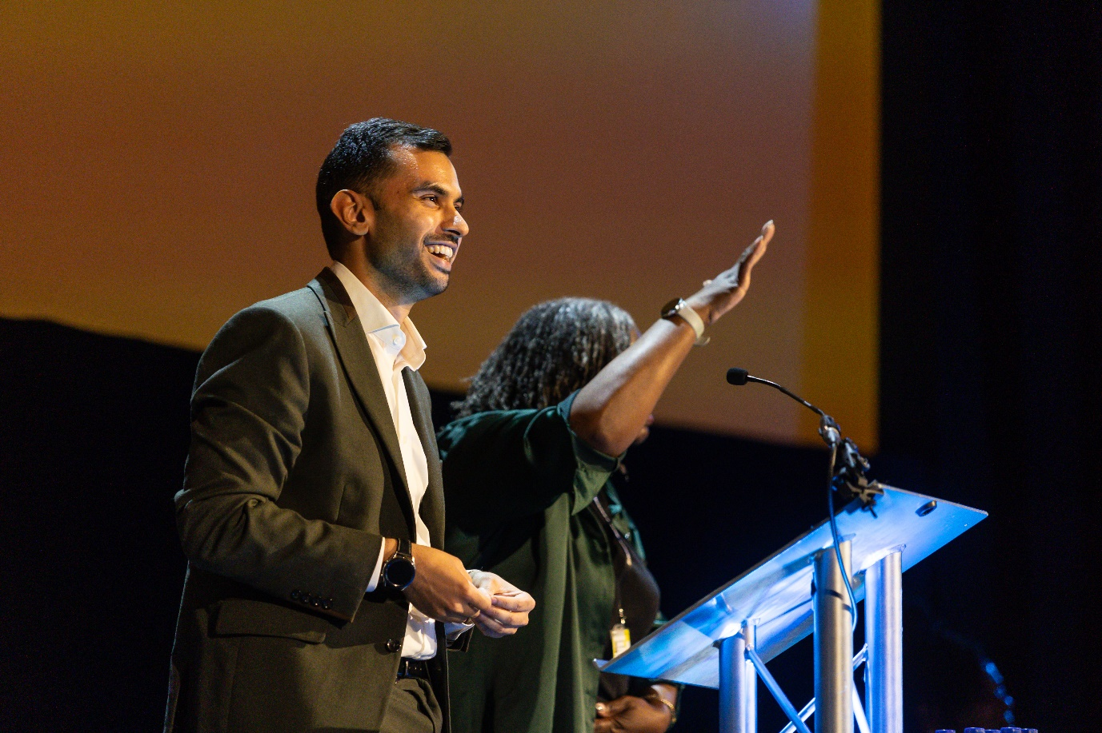
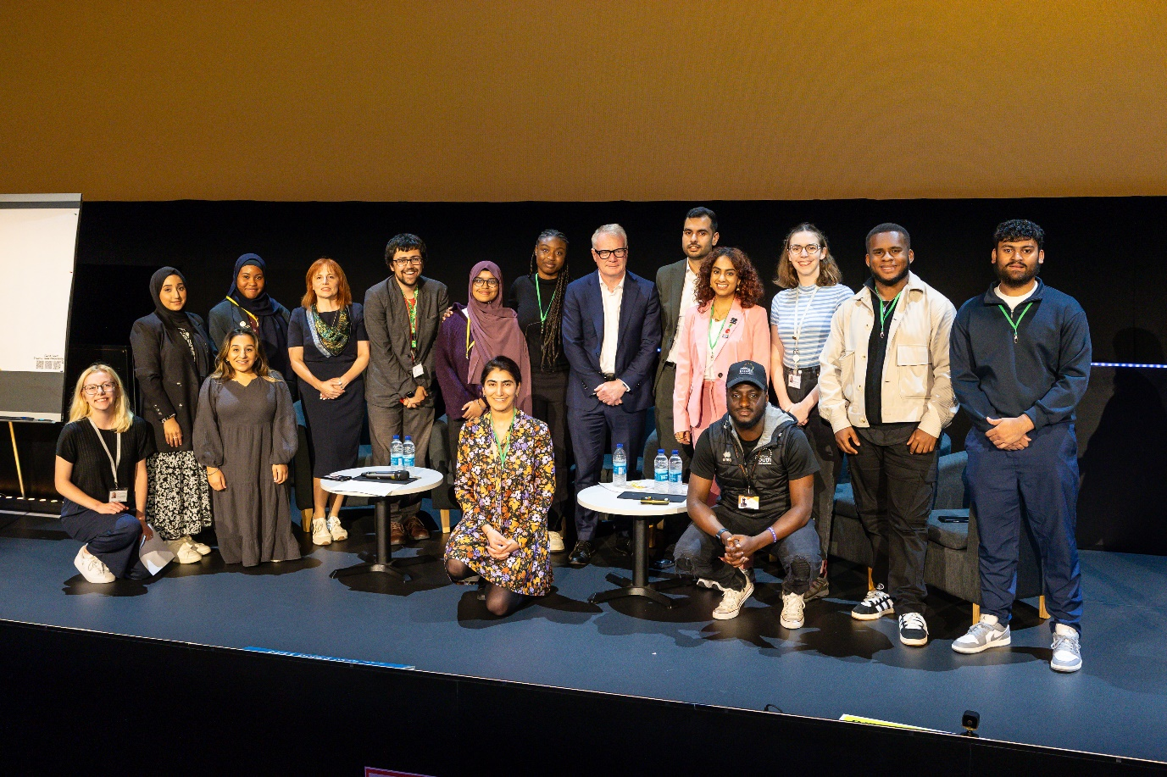
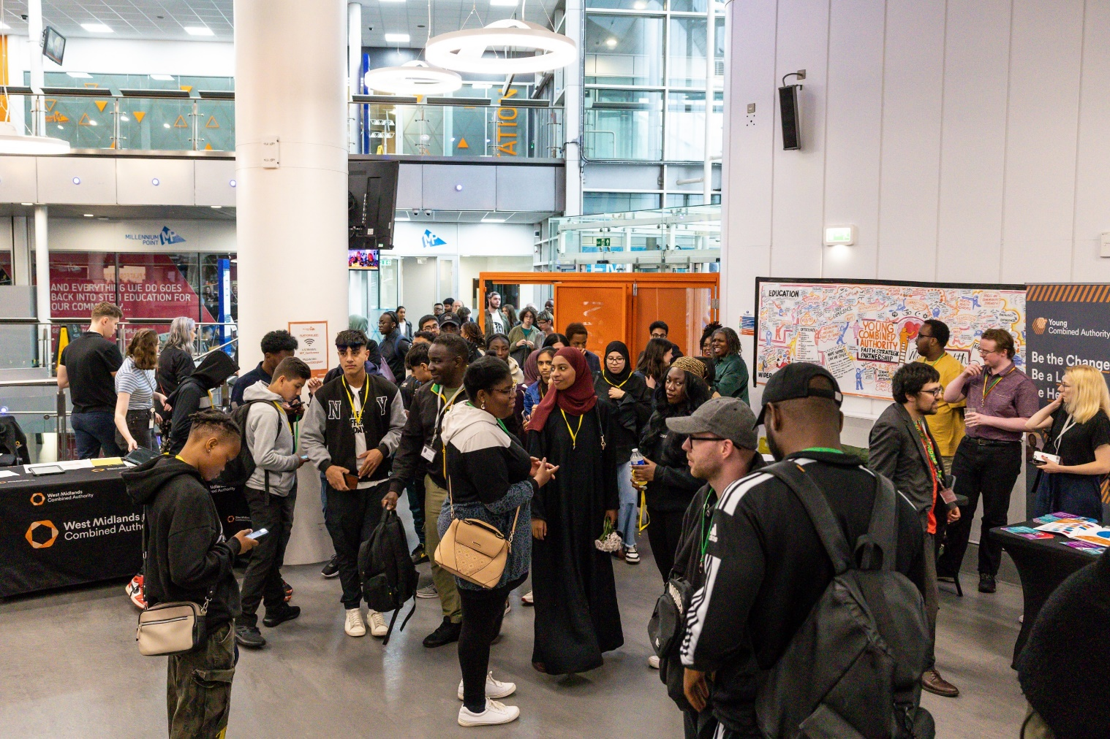

Influencing Change

Our aim as a Taskforce is to create lasting change on a regional scale. This means that we often focus on challenging and supporting the West Midlands Combined Authority and its partners to improve the way they work.

Key example: Bus passenger projects
Data shows that there is transport inequality in our region. People from racialised communities rely more on bus services than White British people. They also face more barriers to getting around.
Our transport group want to understand more about the experiences of passengers. We think this will help the WMCA and other partners to make better decisions about transport.
There was an opportunity to do this through the “Passenger Incentives Programme” (PIP). PIP is a programme funded as part of the region’s "Bus Service Improvement Plan" (BSIP).
Through PIP, £19.8m of funding is being provided to operators (in tranches) and in return Transport for West Midlands (TfWM) will leverage 770,000 weeks’ worth of bus travel to distribute to citizens. This is taking the form of vouchers for free and discounted tickets. These are being distributed with the primary objective of improving long-term bus patronage. There are a number of target groups (PIP’s cohorts) which fall under two primary groups:
- Excluded access cohorts – These are groups who suffer exclusion because they are unable to access transport. The premise of providing assistance for these groups would be to improve life chances which would in turn reduce the extent to which affordability of travel is a barrier.
- Modal shift cohorts – These are groups who travel frequently via car and offers are provided to determine how to successfully incentivise these people to use the bus more frequently.
The primary model of PIP delivery is for TfWM agents to establish contact with 3rd party organisations who then distribute voucher codes to their relevant contacts in the travelling public. Once on-boarded to PIP in this way, customers are required to create a Swift account to redeem their voucher (if they haven’t got one already) and further contact and distribution of additional vouchers is handled via automated emails from TfWM to the customer.
In early 2024, early in delivery of PIP, the Taskforce had a plan to use PIP to more directly engage with people from the outset and to give people free travel in exchange for them sharing their experiences with us.
It was difficult at first to find a suitable community to engage with. That was mostly because at the time the PIP team had limited connections to community groups of interest. However, even wider transport teams within WMCA and local authority partners struggled to assist.
In the end, we decided to focus on the refugee community, who could benefit greatly from the free travel that was on offer and were one of the excluded access cohorts for PIP.
Solihull Council helped us to connect with a group of refugees who were living in a local hotel.
Our plan was to visit the hotel to sign people up to the scheme, and then come back in three weeks to ask them about the journeys they take. It was a 3-month project starting in January 2024. It turned out to be very difficult. 3 separate in-person engagement events took place: sessions to try to distribute codes to the refugees; and a focus-group to discuss the refugees’ experiences with PIP for evaluation.
Lots of the men living in the hotel were very excited to be able to get the bus travel. They said it would make a big difference to their lives, such as helping them get to college for their English classes. We heard that some people at the time were walking all the way to Birmingham, a journey of around 8 miles or 3 hours by foot.
An overview of challenges faced included:
- Language barriers and lack of translation support – both an issue with live conversations at events and an issue for the refugees to understand the literature/correspondence associated with the scheme.
- Digital exclusion - the process for registration and the wider PIP scheme had been designed with a heavy reliance on access to smart phones / other computer.
- Poor access to technology – Specific issues were inability to scan QR codes on the devices the refugees had, and limited access to internet on devices (some refugees would be reliant on free Wi-Fi).
- Digital literacy – Specific issues were people remembering email addresses and passwords, and people not understanding the meaning of “GDPR” and as a result struggling to get past consent forms/fields.
As a result of these issues, it was very difficult to get them signed up to get the free travel. It took multiple attempts and three visits to get people registered.
The language barriers were a significant hurdle to overcome. Translation support had been sought to assist the engagement but had not been forthcoming. The refugees themselves played a really important role by translating for each other. Otherwise, the support of Jas (the refugee officer working at the hotel) and Eduardo (a TfWM officer who was multilingual, but not a translator) was critical to enabling people to access the PIP offers. In addition, although officers who attended the engagements faced challenges, their willing to put themselves into atypical situation (as compared to their routine work) was key to supporting the refugees.

Despite the hurdles, the engagement resulted in support for around 200 individuals. Half of these had not previously had a Swift account. Altogether they have collectively made around 52,000 journeys using the free travel offered to them. Of those that responded to the post-evaluation survey, 96% rated the offer as good/excellent and only 3.8% indicated they wouldn’t intend to buy a ticket after the offer ended.

The exercise has resulted in substantial learning and highlighted why it is important to think about different communities when setting up projects or making decisions. This includes learning to help with future engagements, and improvements to make to the wider PIP scheme.
An overview of some of the key actions taken since the engagement include:
- National Express sales team officers seconded into TfWM to support delivery of PIP – these officers have bought with them much stronger connections to organisations and communities across the West Midlands as well as broader engagement skillsets.
- Closer working with 3rd party organisations – The role that Jas played in supporting the engagement was critical and one of the learnings has been the important role 3rd party organisations play in helping us understand the needs of the communities they represent and communicate appropriately with them.
- Communication materials – to support PIP additional materials including videos and pictorials have been produced covering how to use PIP as well as basics like using the bus and planning journeys. This also included translation of materials into a number of locally prominent languages.
Since the engagements, PIP support has continued to be provided to more refugees as one of the PIP excluded access cohorts. This has been achieved through a number of campaigns via organisations with strong connections to refugees (with those organisations distributing vouchers on TfWM’s behalf). In total, PIP has supported around 3,200 refugees providing 39,000 free weeks’ worth of bus travel (£660,000) so far and enabling 450,000 journeys.
There are outstanding issues, particularly in PIP’s reliance on digital technologies and the exclusion of certain racialised communities who are more likely to be “digitally excluded”.
At the time of writing, TfWM is considering ways to use the BSIP funding for incentives differently to better connect communities, and a key consideration is how to overcome digital exclusion. In addition, there is an opportunity to overcome any systematic biases in how TfWM approaches community organisations. This represents a new opportunity for the Taskforce to work with TfWM.
The Taskforce is also continuing to work with TfWM to review the wider picture of how PIP is supporting racialised communities across the programme’s cohorts to identify opportunities to remove systematic exclusion that results from scheme design and delivery.

Other highlights: Fairer housing
Fairer housing has always been a top priority for us and the people we speak to.
Our housing and homelessness group have been looking for ways to influence change on a regional scale. The group brings together housing experts from the WMCA, local authorities and business. This helps us to think about challenges in new ways.
One of our most important partners is the WMCA Homelessness Taskforce. They bring together organisations, people and resources from across the region to tackle homelessness. Their central aim is to ‘design out homelessness’ by identifying the gaps that cause or fail to prevent homelessness. We are working together to support research by The Oak Foundation on race disparities in homelessness.
Advocacy and shaping housing policy is another priority. This is a growing area of work, particularly in the context of the policy changes the new Government may drive forward. The Taskforce housing and homelessness work group has responded to national consultation and is working with the WMCA to inform policy.
We are working closely with the WMCA housing, property and regeneration team to find ways to increase the number of homes that are available to and suitable for people from racialised communities.
The team have agreed to work with us over the coming year to:
- Inform the WMCA Affordable Homes Strategy. The strategy will shape how the region supports house building from 2026 onwards. We hope it will provide an opportunity to develop more social and/ or affordable homes that can meet the needs of racialised communities in our region, particularly larger families.
- Refresh the WMCA Design Charter. The Design Charter sets out the WMCA’s asks of developers when they build homes in our region. We are going to work together to explore how we can build a stronger focus on issues such as overcrowding and energy performance into future frameworks and approaches.
- Support community led development. As a first step, the team have agreed to hold a workshop for community led organisations who may be interested in building homes in the future.
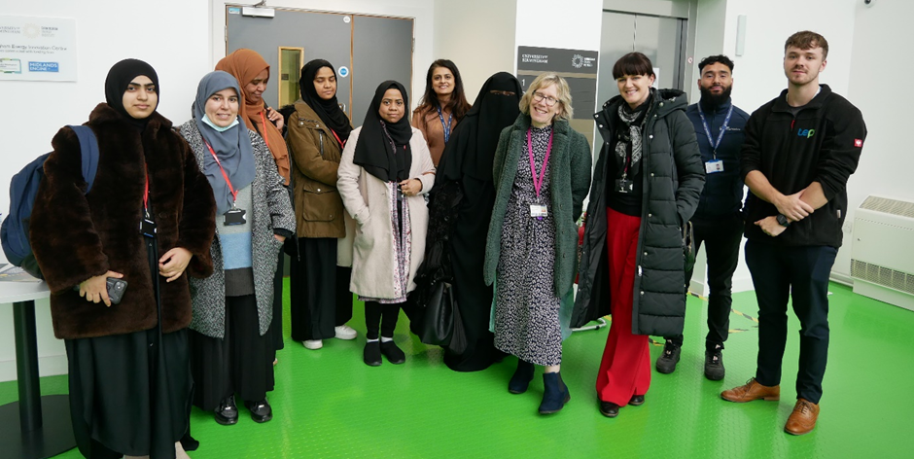
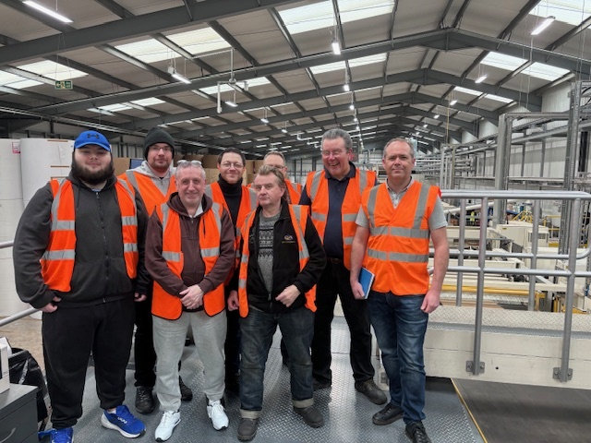
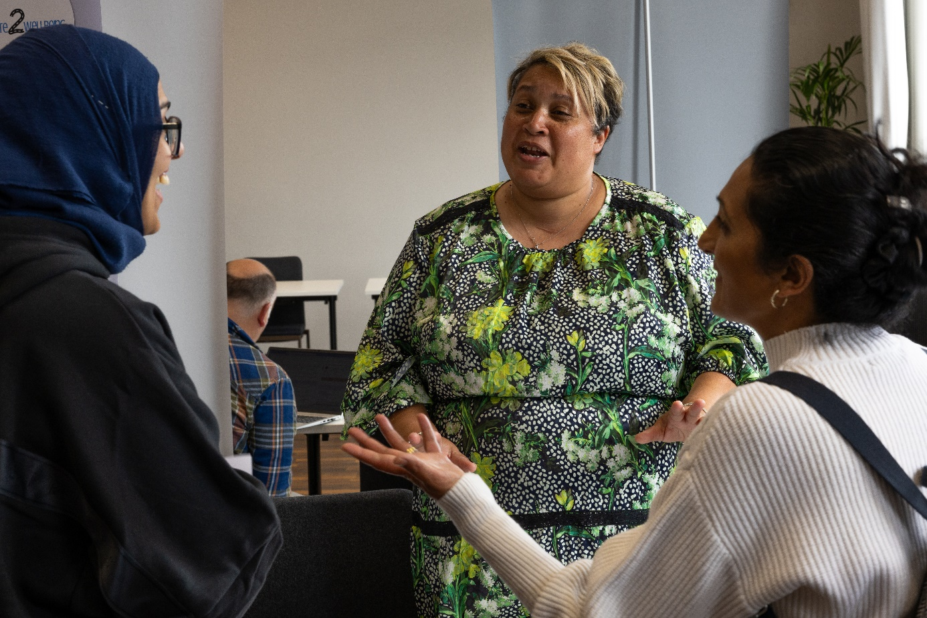

Mobilising Action

Race inequality is a complex and entrenched issue. It will not be easy to solve. But action is better than inaction, and the only way to learn is by testing new ideas. Our work groups bring together experts from different backgrounds and sectors to do this. Highlights include:

Race Equality Skills Week
We piloted a new project during national race equality week (5th February 2024). It aimed to connect employers with communities to help build inclusive career pathways.
The Taskforce invited to large employers, partners and community groups to take part.
We asked employers to run career insight and skills sessions for local adults who are looking for good jobs. We encouraged them to design sessions based on what already works for them, for example copying workshops they run for graduates.
14 employers agreed to take part. Accenture, Cadent, EY, Midlands Rail Alliance (Balfour Beatty, Mott MacDonald and Skanska), Transport for West Midlands, Schumacher Packaging, SSE and Weightmans LLP all delivered workshops during the week. The workshops included an introduction to their companies and an overview of different jobs they have. The employers also ran training sessions for attendees to develop skills, such as CV writing or practicing for interviews.
Some employers added their own unique twists. For example, Accenture led a workshop on artificial intelligence. Midlands Rail Alliance ran a mock assessment centre which included team activities such as building a marshmallow tower.
4 community organisations agreed to work with us and invited their members to the workshops. These were: Aspire and Succeed CIC (Lozells), Rights and Equality Sandwell (Smethwick), Aaina Community Hub (Caldmore) and Colebridge Enterprises (Chelmsley). Birmingham City University, Aston University and South and City College Birmingham also took some of their students to take part. Department for Work and Pensions shared the workshop details with adults they work with. We offered community organisations £600 to cover their costs of taking part.
The pilot was a great success. Feedback from participants has been very positive. All 13 employers are keen to take part next year.
We also learned lots along the way. Our lessons learned include:
- Employers wanted to make a positive difference. Together, we overcame hurdles that make it hard to host communities in their buildings. We did this by working with trusted partners who could come to the workshop with their participants, instead of advertising the events online for individuals to sign up to. We also made sure all attendees were adults and helped businesses to fill out risk assessments.
- We uncovered some challenges. Several community organisations could not take part due to short notice or limited capacity. Some people signed up but arrived late or did not attend. People said transport was a key barrier. Other participants needed to leave workshops early due to childcare. We had to cancel some of the events due to low registrations.
- A few participants told us that they were sceptical at the start of the workshop but felt very positive by the end of it. They said that they did not believe the employers were genuine about creating opportunities for people like them, but taking part in this project has changed their minds.
- Some participants told us how much they valued going into the employer's office. They said it helped them to imagine working there in the future.
- One employer decided to bring their workshop into the community. Schumacher Packaging held their workshop in Colebridge Enterprise's unit. This helped to reach people who had concerns about taking part.
We have encouraged employers and community groups to stay in touch. For example, workers at Colebridge Enterprises have now visited Schumacher Packaging's factory. This was brilliant to hear!
The Taskforce will continue to work together with employers, partners and community groups to create opportunities. Our jobs and skills work group are planning to deliver this project again in February 2025.

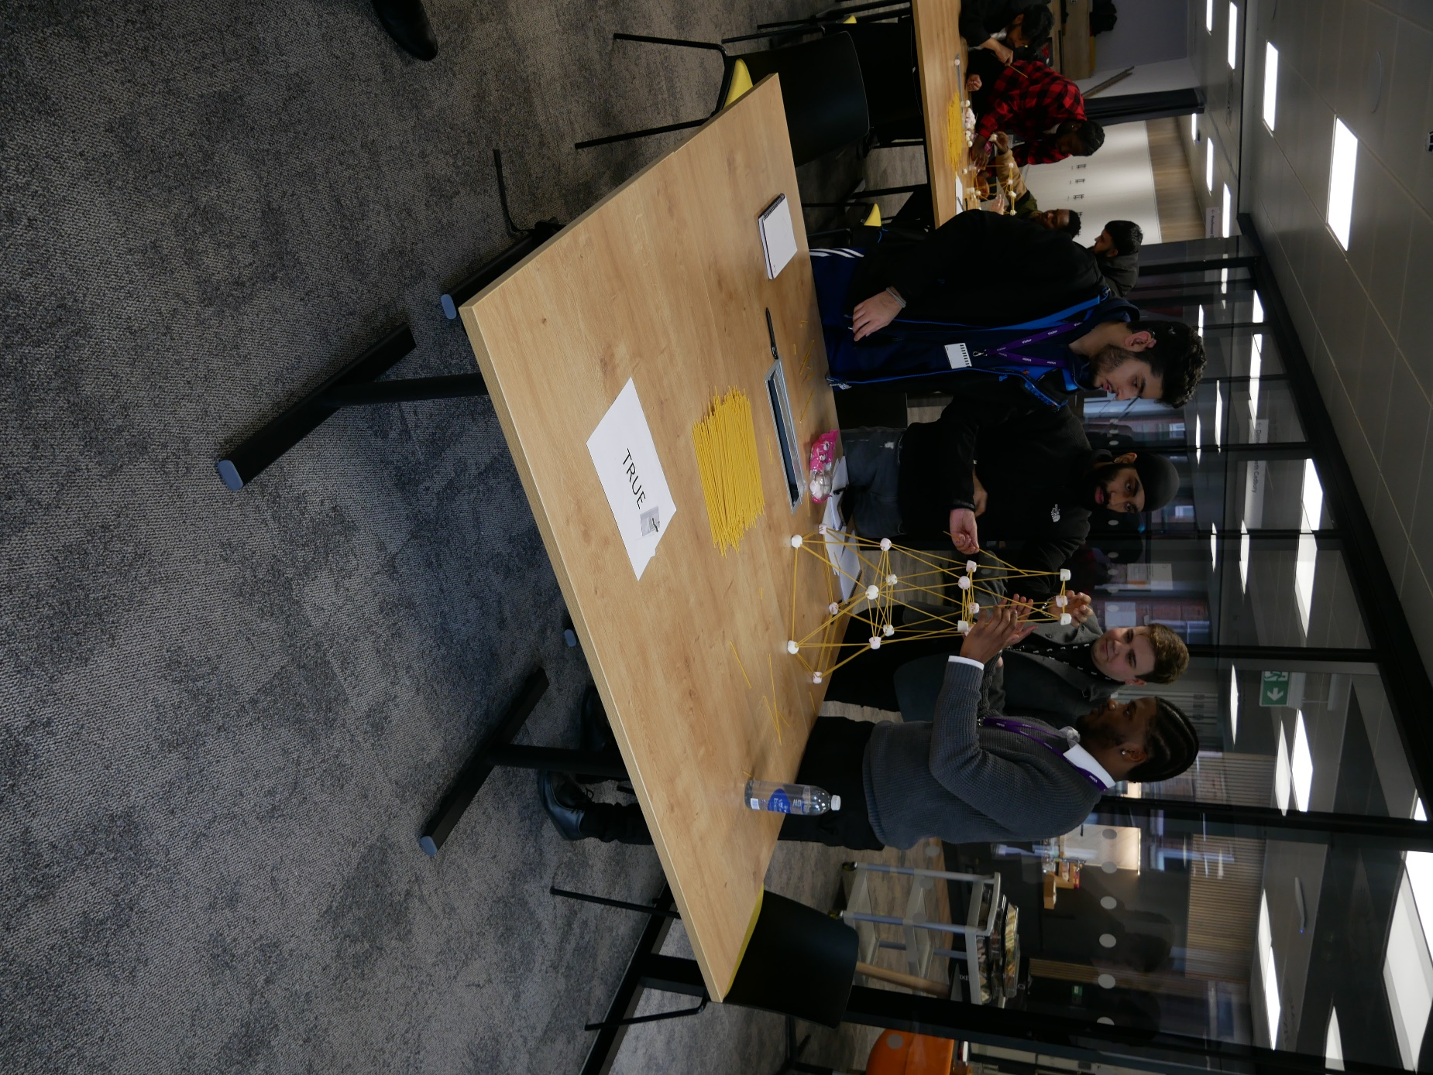
Community Led Business Support
In July 2024, we launched a community led business support pilot.
The West Midlands is diverse and enterprising. However, evidence shows that race inequality is a barrier to growth. People from racialised communities are significantly more likely to start a business, yet these businesses are less likely to grow and be successful.
Leading studies from the Centre for Research in Ethnic Minority Entrepreneurship (CREME) at Aston University has found:
- People from ethnic minority communities are more likely to start a business than the population generally. These businesses are also more likely to provide employment opportunities to marginalised groups and revitalised deprived neighbourhoods.
- Ethnic minority led businesses are also less likely to grow and be successful. Despite being twice as likely to start a business, just 43% of ethnic minority businesses go on beyond the crucial 42-month mark (at which point a business usually becomes income generating), while for white-owned companies that figure is 67%.
- Removing the barriers to success (e.g., difficulties in accessing finance) that ethnic minority businesses face could enable them to quadruple their national contribution to GVA, from £25bn to £100bn annually.
The Race Equalities Taskforce’s own Race Forward report recognised the additional barriers to success that people from racialised communities face. It highlights the need to invest in community hubs as an accessible source of skills and enterprise support.
Our ambition is to tackle the barriers that ethnic minority led businesses face. We can do this by helping more businesses from diverse communities to get the growth support they need at the right time. This can help them to be more productive, profitable and sustainable.
To test this, the Taskforce is working with Business Growth West Midlands (BGWM, part of the WMCA) to pilot community led business support.
The pilot has invested £270,000 into five community organisations. These hubs will work with the Taskforce, BGWM and commercial partners to connect local businesses to support. The pilot is funded by the UK Shared Prosperity Fund.
By partnering with community organisations that ethnic minority entrepreneurs can trust, we can connect more businesses to available support. This could include advice, funding, growth programmes and opportunities for businesses to diversify into new and emerging sectors. Working together will also help us to understand how we can make the best use of our resources.
Our investment will also enable our partner community hubs to boost their reach, resilience and impact, and secure further investment. We hope that it will enable the hubs to build on their existing work and explore opportunities for future partnerships.
The five community organisations taking part in this pilot will work closely with their local authority BGWM teams. They all have a strong track record of supporting marginalised communities to succeed.

Our partner hubs are:
- The Highlife Centre in Ball Hill, Coventry
- iSE Women’s Hub in Sparkbrook, Birmingham
- Legacy Centre of Excellence in Newtown, Birmingham
- SWEDA in West Bromwich, Sandwell
- Access to Business, with Wolverhampton Black Business Network.
Press release: https://www.wmca.org.uk/news/community-led-business-support-to-drive-economic-growth-in-diverse-neighbourhoods/
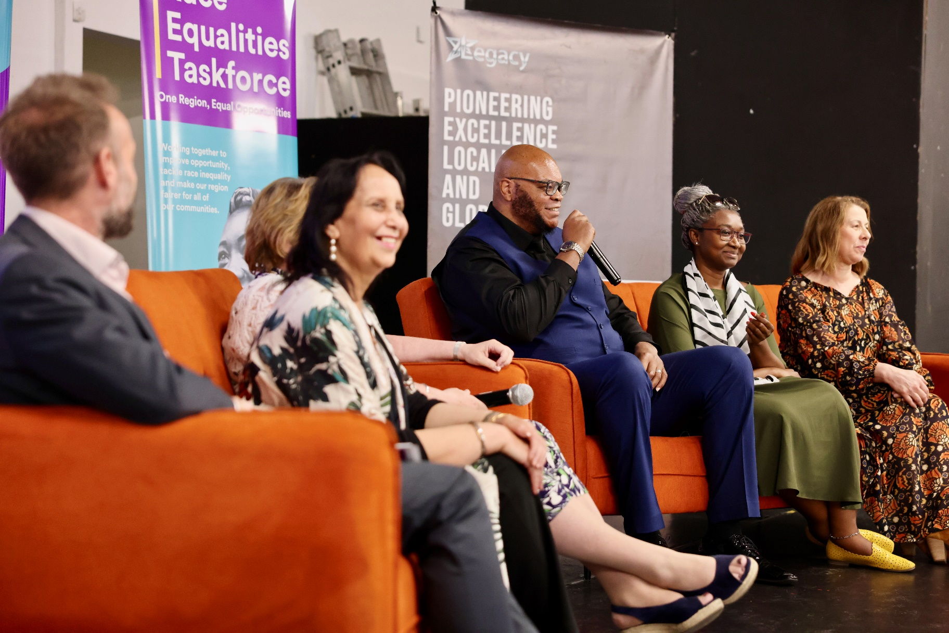
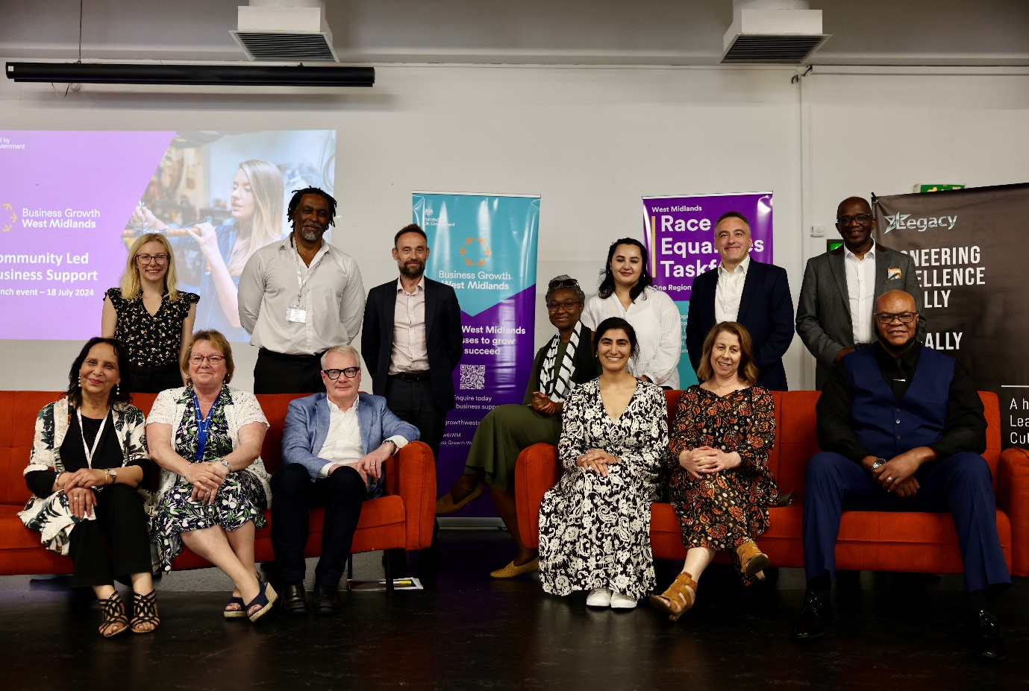
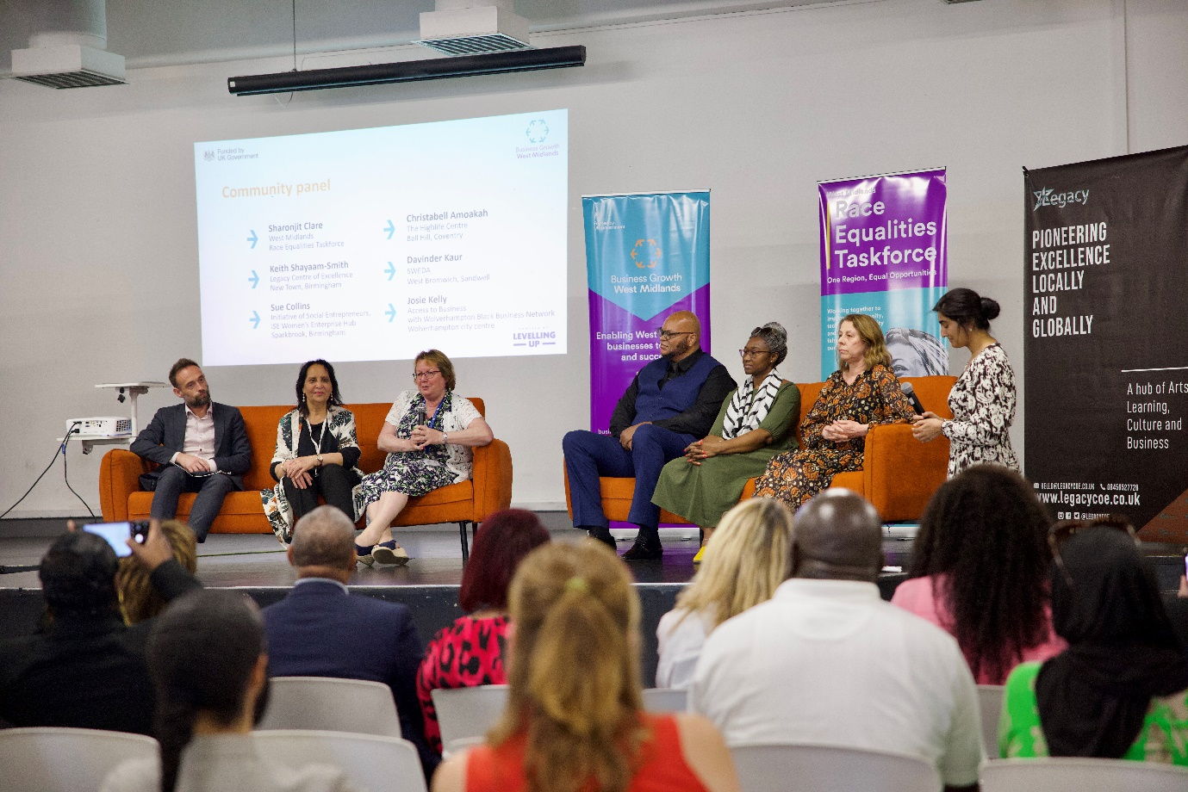
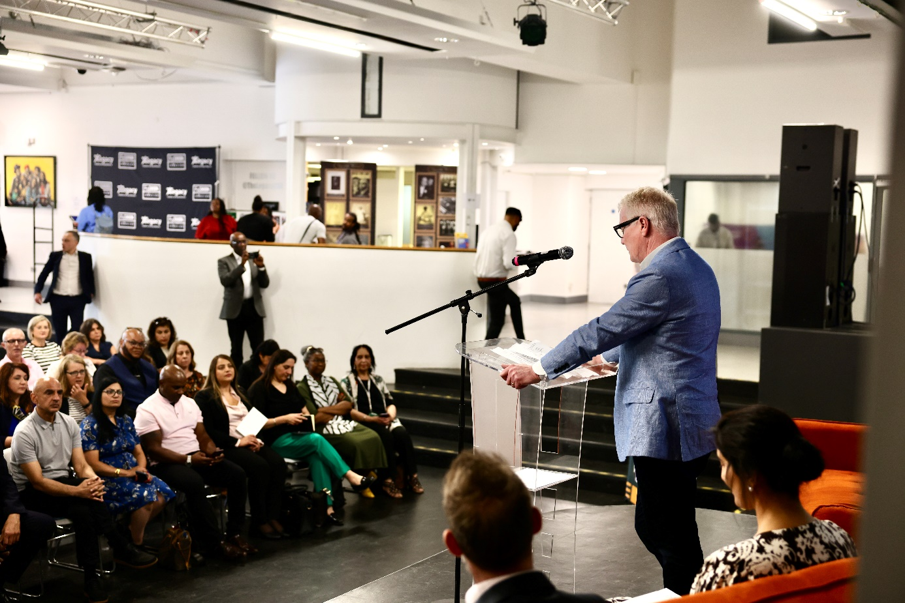

Unlocking Investment

Community leaders at our launch event told us that they feel undervalued and under resourced. People asked the Taskforce to work with public service partners to “build on what’s already there”, by supporting community organisations to build their capacity and secure further investment. Highlights include:

Capacity Building Investment
The Taskforce and WMCA have given a £100,000 capacity building grant to Aaina Community Hub in Walsall (February 2024).
Based in Caldmore, Aaina was set up in 1997 and engages with more than 2000 people each year. It focuses on Pakistani and Bangladeshi women and their families. The hub specialises in providing culturally sensitive training and wellbeing support. It helps local people to upskill and connect with jobs and training opportunities that they would otherwise be unable to access.
Aaina will use our grant funding to extend their English language and digital training courses to more people. It will also create a new enterprise offer for local businesses and entrepreneurs.
Our grant will enable Aaina to build its capacity and resilience, so the hub can secure further external funding in the future. We hope to use this grant to learn how community organisations can be supported to grow.
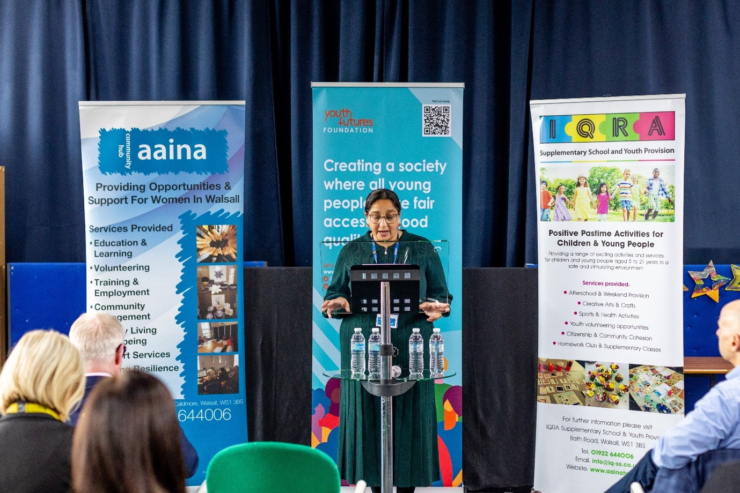
Direct impact:
"The impact of the capacity building grant has been quite significant.
Since February 2024, we have engaged 244 women, an increase of 100%, in upskilling opportunities at the Aaina Community Hub. The number of women participating in ESOL, Digital Literacy, progression courses has doubled due to the increased capacity provided through the grant funding.
The number of women receiving support with employment skills has also increased with over 84 women actively seeking employment and participating in employment skills workshops, with 12 women securing employment in in areas such as community projects, cleaning, social care and support and warehouse operative.
We have appointed two additional staff from the locality and are working with Walsall College to provide a pathway into progression for learners around vocational and enterprise related courses, and employment skills. We are promoting the WM Business Growth Hub to local women and their families to support home grown businesses through our Comms team.

The grant has also attracted significant funding to provide growth and stability to the organisation and partner organisations based at the Hub. £1.5 million in funding has been secured for the next 5 years. Aaina have secured £1 million in grant funding from Youth Futures Foundation for a four-year project focused on addressing inequalities in accessing employment for Bangladeshi and Pakistani youth aged 16 to 24 years, and over £50,000.00 NHS funding for health and mental wellbeing projects to address inequalities in the locality.
Iqra Supplementary School & Youth Provision has secured a large National Lottery Funding for 3 years to deliver positive past time activities for children and young people.
The Organisation has committed to appointing a Funding Officer to ensure continued growth and access to short and long-term income streams that meet the needs of local people around employment, education, enterprise and health and wellbeing."
A'isha Khan, chief executive of Aaina Community Hub

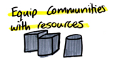
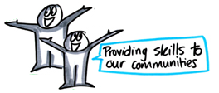



Aaina partnership with Youth Futures Foundation
“Young people with Bangladeshi and Pakistani heritage in Walsall will benefit from a £1m grant to help tackle youth unemployment in the region.
A partnership of Walsall-based organisations, led by Aaina Community Hub, was announced as the latest to join Youth Futures Foundation’s flagship place-based programme, Connected Futures, during a visit by Richard Parker, Mayor of the West Midlands.
Launched in 2022, the multi-million-pound fund seeks to change the journey from education to employment for young people through pioneering local partnerships. The programme aims to develop and test new approaches to breaking down systemic barriers and improving access to employment for young people from marginalised backgrounds.
Youth Futures Foundation’s seven-figure investment follows a £100,000 grant into Aaina from the West Midlands Combined Authority (WMCA), in support of the region’s Race Equalities Taskforce.
The Taskforce and WMCA are looking to actively support this partnership between Aaina and Youth Futures Foundation, helping to connect young people from racialised communities to employment and training opportunities.
Through the Connected Futures programme, Aaina hopes to increase Walsall’s employment rate for young people aged 16-24 with Bangladeshi and Pakistani heritage, by increasing access to skills and training opportunities and creating an employer-led momentum for change.
The partnership follows the publication of a report in March 2024 by Youth Futures Foundation which revealed that half of young people (48%) from an ethnic minority background face discrimination in the workplace.
Young people with Bangladeshi and Pakistani heritage face some of the largest disparities in finding and retaining good jobs. The funding will help Aaina tackle the employment gap in the area by supporting young people to upskill and connect with jobs and training opportunities that they would otherwise be unable to access.
By building relationships with employers, the partnership will broker direct engagement between young people and local firms, increasing access to opportunities and unleashing the potential of young people from ethnic minorities, who make up 25% of the UK’s future workforce.
Aaina will work alongside Iqra Supplementary School, which provides activities for Pakistani and Bangladeshi young people aged 5 to 24 from low-income families in South and Central Walsall.”
Youth Futures Foundation (press release) https://youthfuturesfoundation.org/news/aaina-connected-futures/

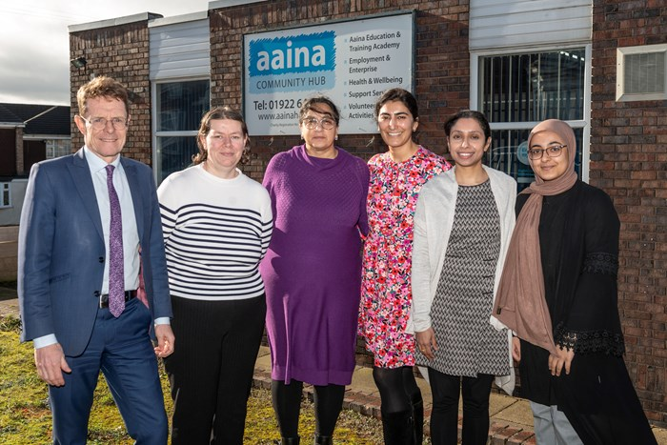
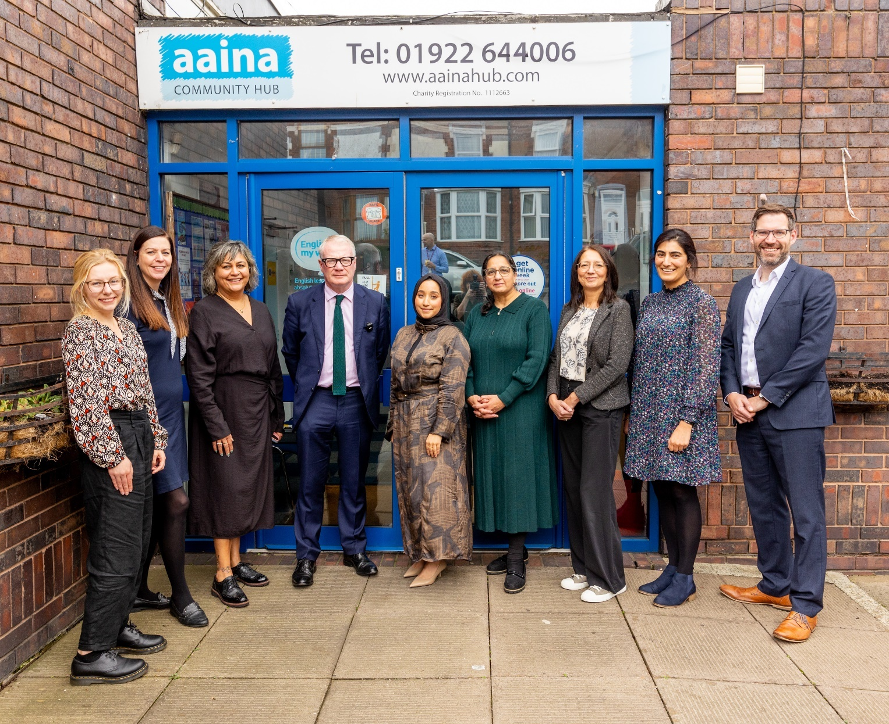

Looking Forward

The Taskforce has made good progress over the last 12 months. We have got partners to commit their time and resources to finding new ways to tackle race inequality. This has included practical action to engage with and invest in communities. We plan to build on this good start.
Looking forward, we will continue to:
- Strengthen the Taskforce and our partnerships. We will continue to extend our work groups and build support for change. This includes securing more resources to help our mission. We will use the findings of the independent review that is being done on the Taskforce to improve how we work.
- Deliver on our Race Forward priorities. Most of our work this year has focused on bringing partners together to enable change. This gives us a strong foundation to work from. Now, we are ready to push forward and influence more regional policy and mobilise further pilot activity.
- Champion our community priorities. We will continue to build our networks with communities across the region, to engage with them and find ways for the region to support their work.
- Support and shape work towards the Mayor’s priorities. These are to invest in jobs for everyone, build social and affordable homes, help businesses to grow and make travel easier and more affordable. These issues all matter to us and are areas where we are already working to bring about change.

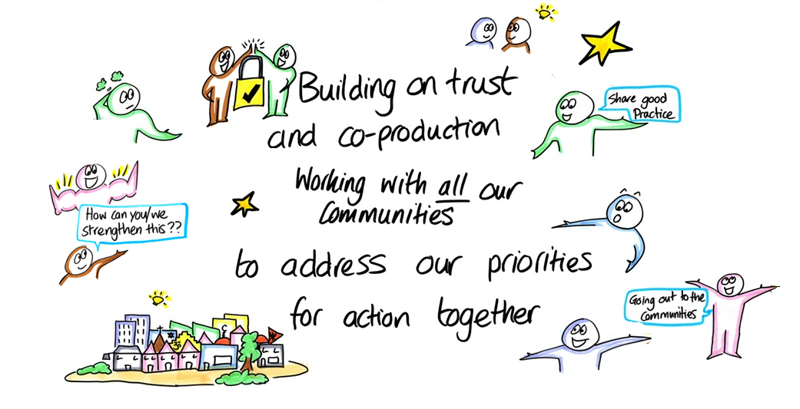
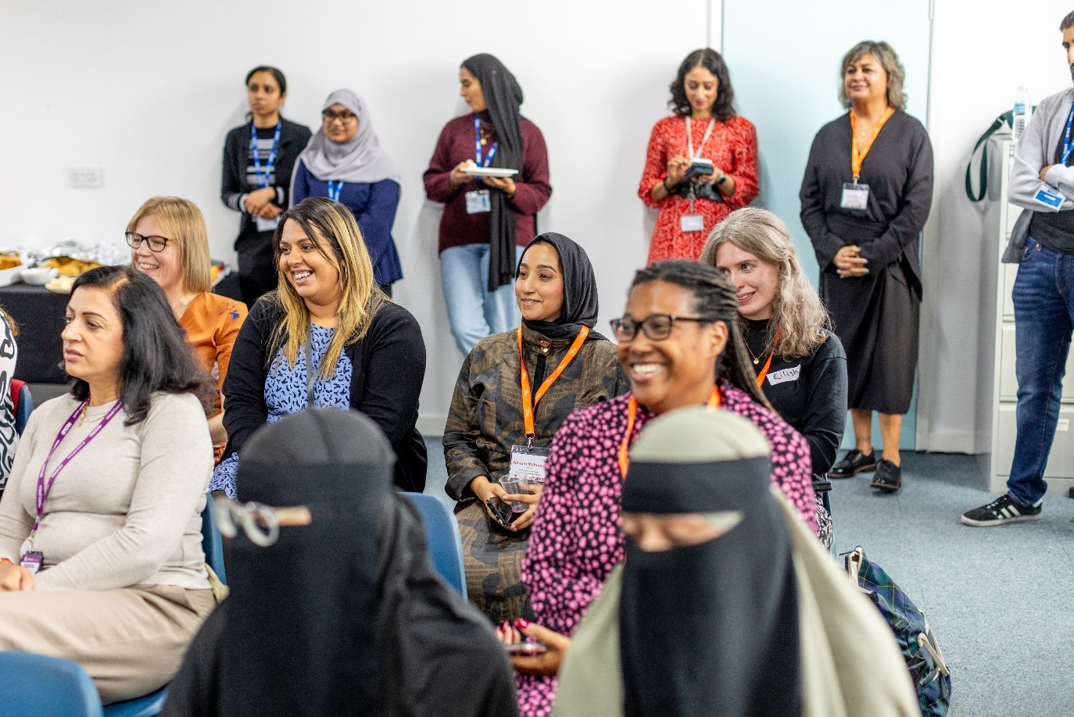
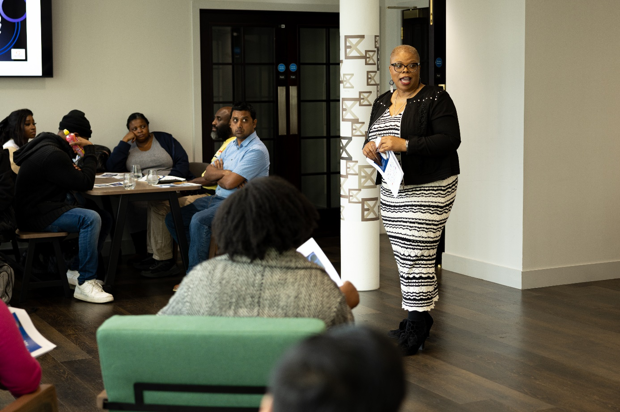
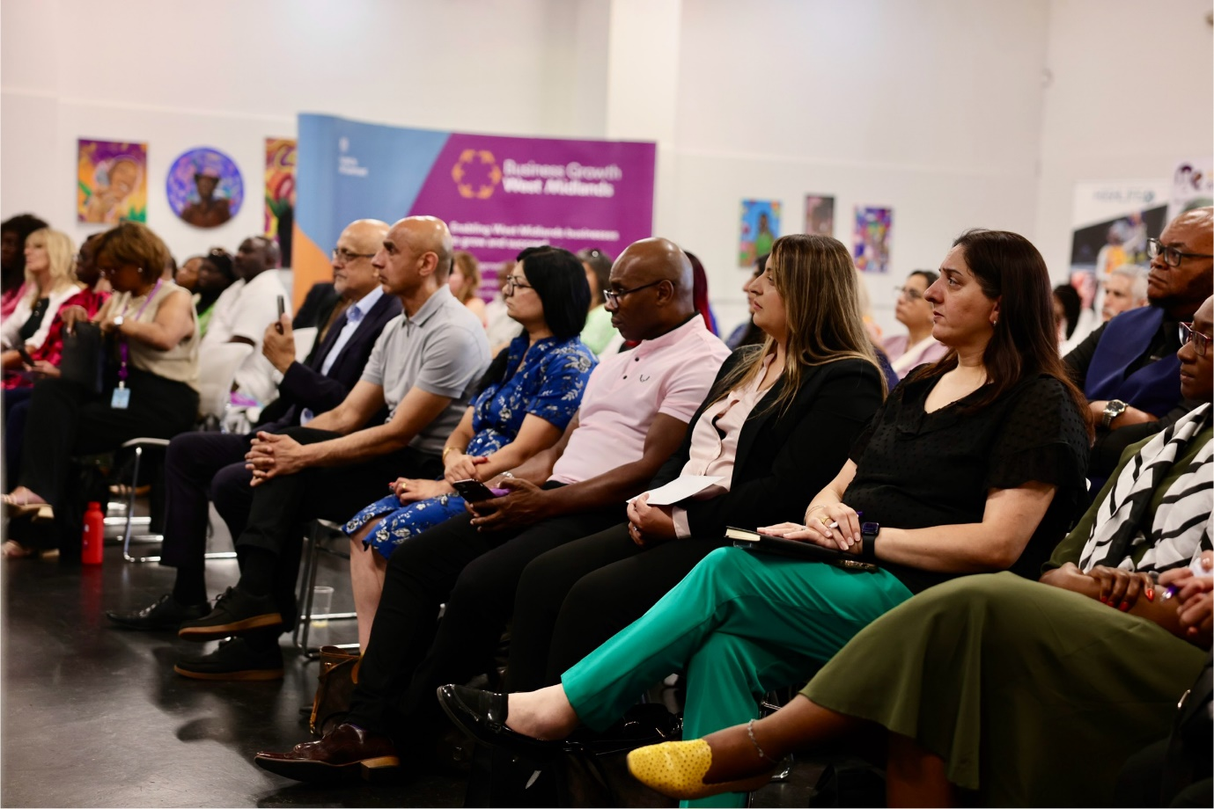

Appendix: summary of progress

This table offers a high-level overview of the progress towards the Race Equalities Taskforce’s Race Forward priorities. It is not an exhaustive log of activity nor a robust evaluation of impact, but rather a fair reflection of the Taskforce’s activity to date which will be built upon further as the partnership matures.
Progress is mapped on our social innovation spiral (see page 5):
- Better data and community engagement.  - Generate ideas through workshops, reports and learning.  - Enable change by bringing together partners to take action.  - Directly influence WMCA and our partners.  - Indirectly influence wider partners. | - Develop and test ways to tackle issues.  - Demonstrate what works for longer term change.  - Deliver and implement what works.  - Grow and scale progress.  - Embed change into the system.
Key: grey (not started), yellow (developing), light green (active), dark green (delivering tangible impact).

Jobs, Living Standards, Skills and Education
Action idea | Activity | Progress on the social innovation spiral
JS1: develop inclusive career pathways | Established a multi-sector jobs and skills work group, which has met regularly since Autumn 2023. | (3) Enable change by brining partners together.
 | Delivered the “Race Equality Skills Week” pilot, where employers offered career insight and skills development workshops to local adults. February 2024. |  |  | (6) Mobilise change by testing ways to tackle issues.
 | Convened a senior leaders roundtable as part of Race Equality Skills Week, securing commitment from large employers to dedicate non-financial resource to supporting the Taskforce to test practical ways to improve career pathways. February 2024. | (3) Enable change by brining partners together.
JS2: invest in community hubs | Invested £100k into Aaina Community Hub to enable them to extend their offer to racialised communities and build their capacity (February 2024). Aaina have leveraged this to secure a £1m investment from Youth Futures Foundation, a partnership supported by Annum Mahmood and Sharonjit Clare (RET member, RET Chair.) |  |  | (6) Mobilise change by testing ways to tackle issues.
 | Partnered with Business Growth West Midlands to launch a £270k pilot to fund 5 community led organisations to connect local businesses to regional support. Launched in July 2024. We are influencing policy through this pilot by creating an audit trail of ‘what works’ for supporting ethnic minority businesses. This interventionist approach has secured the interest of the Department for Business and Trade. |  | (4) Directly influence the WMCA and our partners.  AND: | (6) Mobilise change by testing ways to tackle issues.
JS3: tackle under-employment | Worked with the WMCA skills team to commission WM REDI to research under-employment in the region. The research was completed in Spring 2024 and evidenced that people from racialised communities are more often overqualified for their jobs. A summary of the research will be brought to the RET jobs and skills work group in October 2024. | (2) Enable change by generating ideas from workshops, reports and learning from what works.
JS4: shape good work | Not started activity, are waiting for clarity on the direction of policy from WMCA and Government. | (0) No RET activity.
JS5: promote cultural intelligence in schools | Presented to Inspire Education Trust staff conference in September 2024. This has influenced activity at the Trust and Josh Smith (RET member) is engaging with other academies in Coventry. | (3) Enable change by brining partners together.
 | Convened a West Midlands Universities EDI Forum, who have agreed to continue to work together around ways to advance workforce and student diversity. Initial meeting held in October 2024 by Daniel Smith (RET member). | (3) Enable change by brining partners together.
 | Building links with key partners to develop an education work group, e.g., Herminder Channa of Oasis Trust. | (3) Enable change by brining partners together.
XX
Health and Wellbeing
Action idea | Activity | Progress on the social innovation spiral
HW1: address disparities in life expectancy and access to care. | The Taskforce’s activity around health was paused for its first year of delivery on the advice of the WMCA, due to a lack of clarity or consensus around how the Taskforce can navigate and add value to the work of system partners. Other policy areas were prioritised.  Despite this, community organisations we have spoken to over the year have identified improving health as a key priority. As such, the Taskforce is now looking to establish a health and wellbeing workstream at pace.  Initial preparations have included the RET Chair writing to the leaders of Integrated Care Systems via the West Midlands Health Equity Advisory Board (Summer 2024). As part of the letter, we have offered to commission community listening with ethnic minority women, with the view to support the development of activity around race disparities in maternal care and child mortality. | (3) Enable change by bringing together partners to take action.
HW2: support practitioner awareness of what works. | As per HW1 above. The Taskforce has additionally sparked the WMCA to commit to piloting Birmingham City Council’s BLACHIR cultural intelligence resources (see CQ below). The Taskforce has been consulted on this as it developed. | (0) No RET activity.
HW3: improve community awareness. | As per HW1 above. | (0) No RET activity.
X
Housing and Homelessness
Action idea | Activity | Progress on the social innovation spiral
HH0: establish a work group | Established a multi-sector housing and homelessness work group, which has met regularly since Autumn 2023. | (3) Enable change by bringing together partners to take action.
HH1: navigate housing choices. | The RET housing and homelessness work group have not started activity towards this action. The group are focusing on other priorities at present. | (0) No RET activity.
HH2: explore the potential for regional guidance on housing allocations | Extending social and affordable housing is a priority for the RET housing and homelessness work group. They are writing a ‘call of evidence’ to social landlords to understand the equalities insights they have for their residents and how this shapes service delivery. The work group have also requested support from the Taskforce/ WMCA to reconvene a regional forum to explore the best use of social housing stock. | (3) Enable change by bringing together partners to take action.
HH3: investigate race inequality in homelessness | The WMCA Homelessness Taskforce has secured research by the Oak Foundation to investigate race disparities in homelessness. The research began in Summer 2024. | (2) Enable change by generating ideas through reports.
HH4: increase the supply of homes for communities | Community organisations have the potential to develop housing that meets the needs of local people – Witton Lodge Community Association is a fantastic example of this. The RET housing and homelessness work group are looking to find a route to supporting more community led development. As a first step, the WMCA has agreed to deliver a workshop with interested community organisations, to learn about available funding and application processes. | (2) Enable change by generating ideas through workshops.
HH4: increase the supply of homes for communities | The WMCA has agreed to engage the RET housing and homelessness work group on the development of the WMCA’s Affordable Homes Strategy. This is a key policy which will inform the region’s approach to the development of homes, following the receipt of additional powers from Homes England. The WMCA lead is due to present to the group in Autumn 2024. |  | (4) Directly influence the WMCA and our partners.
HH5: update the WMCA Design Charter | The RET housing and homelessness work group are currently working to review and inform a refresh of the WMCA Design Charter. |  | (4) Directly influence the WMCA and our partners.
HH6: identify other opportunities for action | The RET housing and homelessness work group are currently preparing a series of position statements to highlight opportunities and inform WMCA activity. An example is recognising the risk of EPC compliance leading to future pressure on social stock. |  | (4) Directly influence the WMCA and our partners.
 | Responded to the British Homes for British Workers consultation, outlining the racist undertones of this proposal and its potential to drive further divisions (March 2024). This was not published, on the recommendation the Members Advisory Group. |  | (5) Indirectly influence wider partners.
X
Transport
Action idea | Activity | Progress on the social innovation spiral
T0: establish a work group | Established a multi-sector transport work group, which has met regularly since Autumn 2023. | (3) Enable change by bringing together partners to take action.
T1: strengthen equalities and community voice in decision making, | Transport for West Midlands colleagues have undertaken an analysis of their data to better understand race inequality in transport. Data has found that people from racialised communities are more likely to be reliant on public transport services to get around (particularly bus services) and are also less likely to be satisfied with these services. | (1) Enable change by identifying challenges and opportunities through better data and community engagement.
 | Identified an opportunity to strengthen TfWM’s “personas.” There are currently 14 data driven personas which represent different transport users in different stages of their lives and different levels of wealth. As “generic” personas, these do not currently prompt transport planners to think about race inequality when making decisions. The RET transport group is exploring the potential to redress this. | (1) Enable change by identifying challenges through better data.
 | Delivered a project to offer a group of refugees free bus travel through the BSIP scheme (January 2024). This was challenging and highlighted barriers that some communities face to getting around – including language barriers and digital deprivation. The project highlighted why it is important to think about different communities when setting up projects or making decisions. This project directly supported 200 people to access the free bus travel available to them, and has informed tangible action from the Transport for West Midlands team. |  | (4) Directly influence the WMCA and our partners.
 | Strengthening equality impact assessments (EQIAs) has consistently been a top priority within Race Forward and the RET transport work group. The group are planning a work programme to address this, including to track/ support EQIAs on a policy, programme and commissioned piece of work, and look for opportunities to upskill transport planners on completing EQIAs.  The RET Chair has also contributed to a WMCA review on EQIAs which was commissioned by the WMCA corporate equalities team. We are awaiting findings from this (September 2024). |  | (4) Directly influence the WMCA and our partners.
T2: explore race budgeting | This activity has not started. We are awaiting outputs of the national implementation of the Violence Against Women and Girls report, which includes the development of a gender-sensitive budgeting. This will inform next steps. | (0) No RET activity.
T3: experiment with better transport for all. | This activity has not started and/or is currently being progressed through the above actions. | (0) No RET activity.
X
Criminal Justice
Action idea | Activity | Progress on the social innovation spiral
CJ1: strengthen EQIAs with community voice | The West Midlands Office of the Police and Crime Commissioner (OPCC) has been leading its own activity. The OPCC have agreed to reestablish and lead/ sponsor a RET criminal justice work group, as per the initial report to the WMCA Board in July 2021. This will meet in late 2024. | (0) No RET activity.
CJ2: help to build trust | As per CJ1 above. | (0) No RET activity.
CJ3: tackle disproportionality in youth justice. | The RET Chair and PCC wrote a joint letter to Youth Justice Services in late 2023, and these partners will be re-engaged in the coming months. The RET also supported a criminal justice workshop at the Race Equality Youth Summit, which was sponsored by Alethea Fuller (RET member and Deputy Chief Executive at OPCC). Next steps are to be confirmed. | (2) Enable change by generating ideas through workshops, reports and learning from what works.
CJ4: improve data sharing. | Initial exploration of this took place in the run up and during the Local Criminal Justice Board workshop with the Taskforce in November (see CJ8 below). This highlighted challenges and tensions around collecting and sharing workforce equalities data. | (2) Enable change by generating ideas through workshops, reports and learning from what works.
CJ5: implement race recommendations | The OPCC have produced a summary report of existing recommendations for tackling race inequality in criminal justice. This will be explored further once the work group is convened. | (2) Enable change by generating ideas through workshops, reports and learning from what works.
CJ6: prevent race hate crime | Initial exploration of this has identified that collecting or accessing data on race hate crime is not easy and will require joint work across local authority and police partners. Community partners have also raised the role they could play in encouraging the reporting of hate crime at the Mayor’s stronger together roundtable in August 2024. Next steps to be identified. | (1) Enable change by identifying challenges through better data.
CJ7: target efforts to reduce reoffending | As per CJ1 above. | (0) No RET activity.
CJ8: cross cutting priority - leadership | Convened a special workshop with the Local Criminal Justice Board (LCJB) in November 2023, on leadership diversity and representation across the criminal justice system. Three themes were explored: improving and sharing data insights on race diversity, sharing and strengthening interventions to improve diversity, and engaging more communities in civic leadership. Findings have been shared with the LCJB to integrate into their action plan. | (3) Enable change by bringing together partners to take action.
X
Cross cutting priorities
Action idea | Activity | Progress on the social innovation spiral
DATA: better data | In all our engagements/ policy areas, the Taskforce routinely asks partners where their data on race equality sits – working to build a stronger picture and strengthen the collection and use of EDI data. | (1) Enable change by identifying challenges through better data.
LEAD1: advancing diversity in senior leadership | Senior leadership (shadowing): the RET Chair asked the WMCA Board to create shadowing positions for members from underrepresented groups (February 2024). This has been backed by the Leader of Sandwell Council and Wolverhampton City Councils and the previous Mayor. The RET Chair will write to the new Mayor to pick this action up. |  | (4) Directly influence the WMCA and our partners.
 | Senior leadership (WMCA and partners): the Taskforce has prompted the WMCA to strengthen its race action plan. For example, the WMCA has created an internal dashboard for monitoring our workforce diversity against the region’s economically active population.  The RET Chair has also directly supported the recruitment process for senior leaders at the WMCA and a close partner. |  | (4) Directly influence the WMCA and our partners.
 | Employers: the RET Chair has been engaging employers to understand their receptiveness to setting ethnicity targets for their workforces and asking challenging questions around representation at mid-to-senior levels. This activity will be strengthened by and connected to a RET response to the Government’s new proposals on equal pay. | (3) Enable change by bringing together partners to act.
 | The Taskforce has played its own leadership role as a navigator and mediator in complex, senior discussions across the West Midlands. We have played a key role in building bridges between organisations, teams, people, sectors – and this is ongoing work. We have dedicated time and energies to building trusted relationships across all partners and ‘winning hearts and minds.’  The RET Chair has modelled inclusive leadership, connecting with different independent chairs of other taskforces and boards across the region, to influence their activity on a partnership basis. E.g., WMCA Innovation Board’s innovation accelerator programme – the RET Chair has informed the frameworks that participants are applying to ensure inclusion. This also involved working with Innovate UK, where we have quietly encouraged a change in policy in how they monitor some of the programmes they fund. | (3) Enable change by bringing together partners to act.
LEAD2: advancing diversity in civic leadership | Supported the WMCA’s civic leadership project to understand the barriers to good representation across key roles such as school governors, magistrates and charity trustees. This included supporting 3 roundtables and an ‘opportunities fair’ event, where organisations could promote their vacancies to people from underrepresented groups (February, June 2024). | (2) Enable change by generating ideas through workshops.
CQ: cultural intelligence | Following the Race Forward report, the WMCA has agreed to pilot Birmingham City Council’s BLACHIR cultural intelligence framework. This will support officers to gain an understanding of different communities, to improve their decision making and approach to engagement. The programme is being developed, ready for a January 2025 start to training. Our target is for 10% of staff to participate in the pilot – this is in addition to the WMCA’s existing mandatory training around equalities and anti-racism. |  | (4) Directly influence the WMCA and our partners.
COMM1: community engagement | Held the Taskforce’s community launch event in Sandwell in September 2024. This has resulted in clear actions and a prioritisation of Race Forward recommendations by communities, which the Taskforce is continuing to deliver against. The event has also enabled the Taskforce to build connects to multiple community led organisation, which the Taskforce is continually building upon. | (2) Enable change by generating ideas through workshops.
 | Championing stronger community engagement – the Taskforce has taken action to build deeper relationships with community led organisations who can act as a portal to communities. The Taskforce is continually building its stakeholder map and identifying opportunities to support or commission community listening activity. An upcoming opportunity is the WMCA’s development of an inclusive communities approach. | (1) Enable change by identifying challenges through better community engagement.
 | Helped to deliver the Mayor’s “stronger together” roundtable with communities (August 2024). The purpose was to understand how the WMCA can support and add value to the work of communities, recognising the important role they play in supporting communities through crisis – such as the racist riots this summer. Next steps are currently being formulated by the WMCA. | (2) Enable change by generating ideas through workshops.
COMM2: capacity building | Funders roundtable – the Taskforce partnered with the WMCA Faith Strategic Partnership Group to convene a roundtable of funders (April 2024). The purpose was to explore why racialised and faith communities are less likely to secure funding, and how we could work together to build the capacity of these organisations and maximise our resources. All partners were keen to meet again. We are planning a second roundtable for Autumn 2024. | (3) Enable change by bringing together partners to act.
 | Supporting WMCA activity around capacity building for communities, including working with the WMCA wellbeing team to inform their advisory offer for organisations who were unsuccessful in securing Commonwealth Games Legacy Grants and the WMCA skills team in developing a leadership training offer for the non-for-profit sector. Both activities are ongoing. |  | (4) Directly influence the WMCA and our partners.
NEW – Supply chains and procurement | Started to explore opportunities to influence how the WMCA can diversify its supply chains and explore this as a tool to influence the wider ecosystem, e.g., the weightings that might be set up around social value.  We were led to this through our experience of securing funds through the WMCA Strategic Assurance Framework. The Taskforce is looking to understand and strengthen processes. |  | (4) Directly influence the WMCA and our partners.
X

Appendix: thanks to partners

Thank you to the below partners who have participated in meetings of the Taskforce and its work groups. Thank you also to the community organisations who have dedicated their time, energy, and trust into working with us over the past 12 months. This list is not exhaustive – huge thanks to everyone else who has played a role in our progress to date, including multiple officers across the West Midlands Combined Authority who have embraced our mission as central to their roles.

Taskforce members (Sept 2023/24)
Independent members:  - Sharonjit Clare  - Annum Mahmood  - Daniel Cash  - Bishop Desmond Jaddoo  - Hannah Buckley  - Josh Smith  - Julie Blake  - Manny Sandhu  - Mary Osuagwu  - Ridhi Kalaria  - Alex Cole (resigned in Spring 2024 with our thanks) | Public service partners:  - Alethea Fuller, Office of the West Midlands Police and Crime Commissioner  - Allison Duggal, Coventry City Council  - David Pattinson, City of Wolverhampton Council  - Irena Hergottova, Walsall Council  - Jin Takhar, City of Wolverhampton Council  - Dr Justin Varney, West Midlands Association of Public Health Directors  - Koser Shaheen, Sandwell Council  - Mark Whitehouse, Department of Work and Pensions  - Mary Morrissey, Solihull Council  - Michelle Ugwueze, West Midlands Police  - Valerie De Souza, Coventry City Council  - Claire Dhami, Kwabena Osayande, Lucy Gosling, West Midlands Combined Authority


Taskforce work group members (Sept 2023/24, in addition to the above):
Jobs and skills:  - Julie Obada, City of Wolverhampton Council  - Kevin Davies, The Vine Trust  - Kristy Rowlett, Lisa Perkins, Wesleyan  - Martin Barret, Lloyds  - Sam Tredgett, Bally Bains, Bally Chahal, Keiran Philly, Accenture  - Satinder Bains, Irwin Mitchell  - Shaun Hall, Mahfia Watkinson, WMCA  Community enterprise hubs:  - A'isha Khan, Aaina Community Hub  - Christabell Amoakoh, Roze Navaab, Highlife Centre  - Davinder Kaur, SWEDA  - Josie Kelly, Paul Tabor, Access to Business  - Kasim Choudhry, Sue Collins, iSE  - Keith Shayaam-Smith, Legacy Centre of Excellence  - Lynne Avery, Ian McLaughlin, Paul Edwards, WMCA  - Sharniya Ferdinand, NatWest  Criminal Justice (paused in January 2024, to be resumed early 2025):  - Claire Martin, Sandwell Children's Trust  - Hannah Pawley, City of Wolverhampton Council  - Sal Naseem, strategic leader  Universities EDI forum:  - Hannah Bartlett, Aston University  - Imogeen Denton, Birmingham City University  - Joanne Oguzie, University College Birmingham  - Kulbir Shergill, Warwick University  - Mehrunnisa Lalani, Coventry University  - Monique Myers, University of Birmingham  - Sukhvinder Singh, Wolverhampton University | Housing and homelessness:  - Damini Sharma, OM Group  - Jane Kemp, Addecure  - Joanna Lee Mills, Shoosmiths LLP  - Michelle Garbett, City of Wolverhampton Council  - Anthony Walker, City of Wolverhampton Council  - Rashida Hussain, Walsall Council  - Leo Pollock and Mia Higgins, WMCA  - Thanks to Jean Templeton and Neelam Sunder, WMCA Homelessness Taskforce  Transport:  - Adam Tranter, Mayors Cycling and Walking Commissioner  - Giles Perkins, WSP  - Kester Sleeman, City of Wolverhampton Council  - Marianne Page, City of Wolverhampton Council  - Jas Sandhu, David Balme, Solihull Council  - Tim Fawcett, Mott MacDonald  - David Harris, Helen Davies, Ed Fusi, WMCA  Health (to commence early 2025):  - Pooja Ahluwalia, Mubasshir Ajaz, WMCA  Education (to commence early 2025):  - Herminder Channa, Oasis Trust  - Brenda Wile, City of Wolverhampton Council  Civic leadership (to commence early 2025):  - Miriam Aslam, Kashmire Hawker, Timon Burford, WMCA  - Work with Amrick Singh Ubhi and Steve Botham, WMCA Strategic Faith Partnership Group on the funding roundtable.
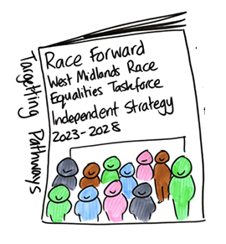
Members of the Taskforce Members Advisory Group (Sept 2023/24):
- Councillor Kerrie Carmichael, Leader of Sandwell Metropolitan Borough Council
- Councillor Abdul Khan, Coventry City Council
- Councillor Amandeep Garcha, Walsall Metropolitan Borough Council
- Councillor Nicky Brennan, Birmingham City Council
- Councillor Karen Grinsell, Solihull Metropolitan Borough Council
- Councillor Paula Brookfield, City of Wolverhampton Council
- Councillor Steve Clark, Dudley Metropolitan Borough Council
- Councillor Syeda Khatun, Sandwell Metropolitan Borough Council
- Councillor Wazma Qais, Solihull Metropolitan Borough Council.
Race Equality Skills Week participants:
Aaina Community Hub, Accenture, Aspire and Succeed CIC, Aston University, Birmingham City University, Black Country NHS Foundation Trust, Cadent, Colebridge Enterprises, DWP, EY, Midlands Rail Alliance (Balfour Beatty, Mott MacDonald and Skanska), Schumacher Packaging, Severn Trent, Shakespeare Martineau LLP, South and City College Birmingham, Rights and Equality Sandwell, SSE, Transport for West Midlands, Trowers and Hamlins LLP, Weightmans LLP, West Midlands Combined Authority.
Core community partners:
Thank you to the below community partners who have most directly participated in the Taskforce’s pilot activity:
- Aaina Community Hub, Caldmore, Walsall: https://aainahub.com/
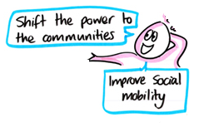
- Access to Business, Wolverhampton: https://access2business.co.uk/
- Aspire and Succeed CIC, Lozells, Birmingham: https://aspireandsucceed.org/
- Colebridge Enterprises, Chelmsley, Solihull: https://colent.org/
- The Highlife Centre, Coventry: https://www.thehighlife.org/
- iSE Women’s Hub, Sparkbrook, Birmingham: https://www.i-se.co.uk/
- Legacy Centre of Excellence, New Town, Birmingham: https://www.legacycoe.co.uk/
- Rights and Equality Sandwell, Smethwick, Sandwell: https://rightsandequalitysandwell.co.uk/
- SWEDA, West Bromwich, Sandwell: https://sweda.org.uk/
- Wolverhampton Black Business Network, Wolverhampton: https://www.wbbn.co.uk/

Organisations attending the Taskforce's launch workshop:
Balaji Temple, Bangladeshi Women's Association, Bangladeshi Islamic Centre, European Welfare Association CIC, Rights and Equality Sandwell Limited, Sandwell African Caribbean Mental Health Foundation, Skills Work Enterprise Development Agency, Yemeni Community Association Sandwell. Birmingham City Council, City of Wolverhampton Council, Coventry City Council, Department for Work and Pensions, West Midlands Office of the Police Crime Commissioner, Sandwell Council, Walsall Council, Solihull Council, West Midlands Combined Authority. Aston University, Bourneville Village Trust, Inspire Education Trust, Oxfam, TIN Ventures Ltd, WMCS, Accenture, Accenture Song, Allies Network C.I.C, Birmingham Hippodrome, Black Country Innovate CIC, Chinese Community Centre-Birmingham, DRNET, Evenfields Careers Ltd, Faith Strategic Partnership Group, Health Companion Ltd (Trading as Health Fabric), Irwin Mitchell LLP, Lloyds Banking Group, Macca Tree Holdings Ltd, Maokwo, Mental Health Collective, Midven, NatWest, Nishkam Civic Association, One Walsall, Push On Wellbeing CIC, Reach For A Star, Sandwell and West Birmingham NHS Trust, Shakespeare Martineau, Spectra, St Bartholomew's Church Edgbaston, TAG Network Midlands Limited, Teacheractive, UNITE, University of Leicester, Wesleyan Assurance, William Wilson Turner Foundation.

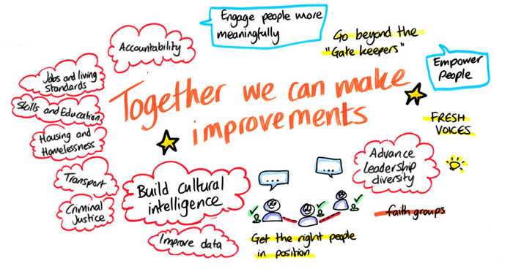
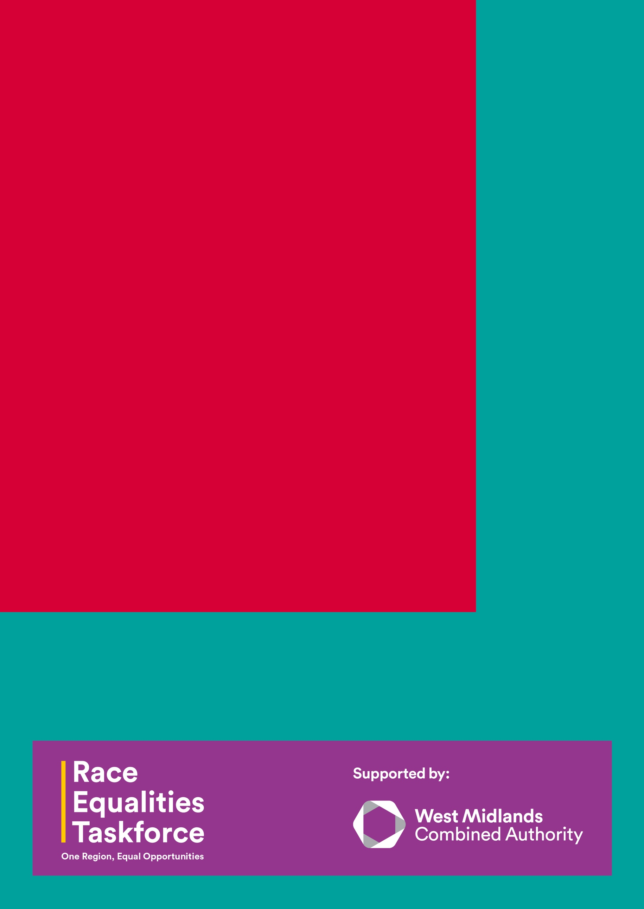



In marketing referred to as the West Midlands Bus Scheme.
A voucher of free travel for a week would consume twice the amount of overall bus travel to distribute through PIP as a voucher for 50% discount for a week.
As of 8 October 2024
For those that are currently actively receiving offers, if they continue to claim the offered rewards they could continue to benefit from a further 77,000 weeks of free travel.
See: https://www.aston.ac.uk/research/bss/abs/centres-hubs/creme/time-to-change

