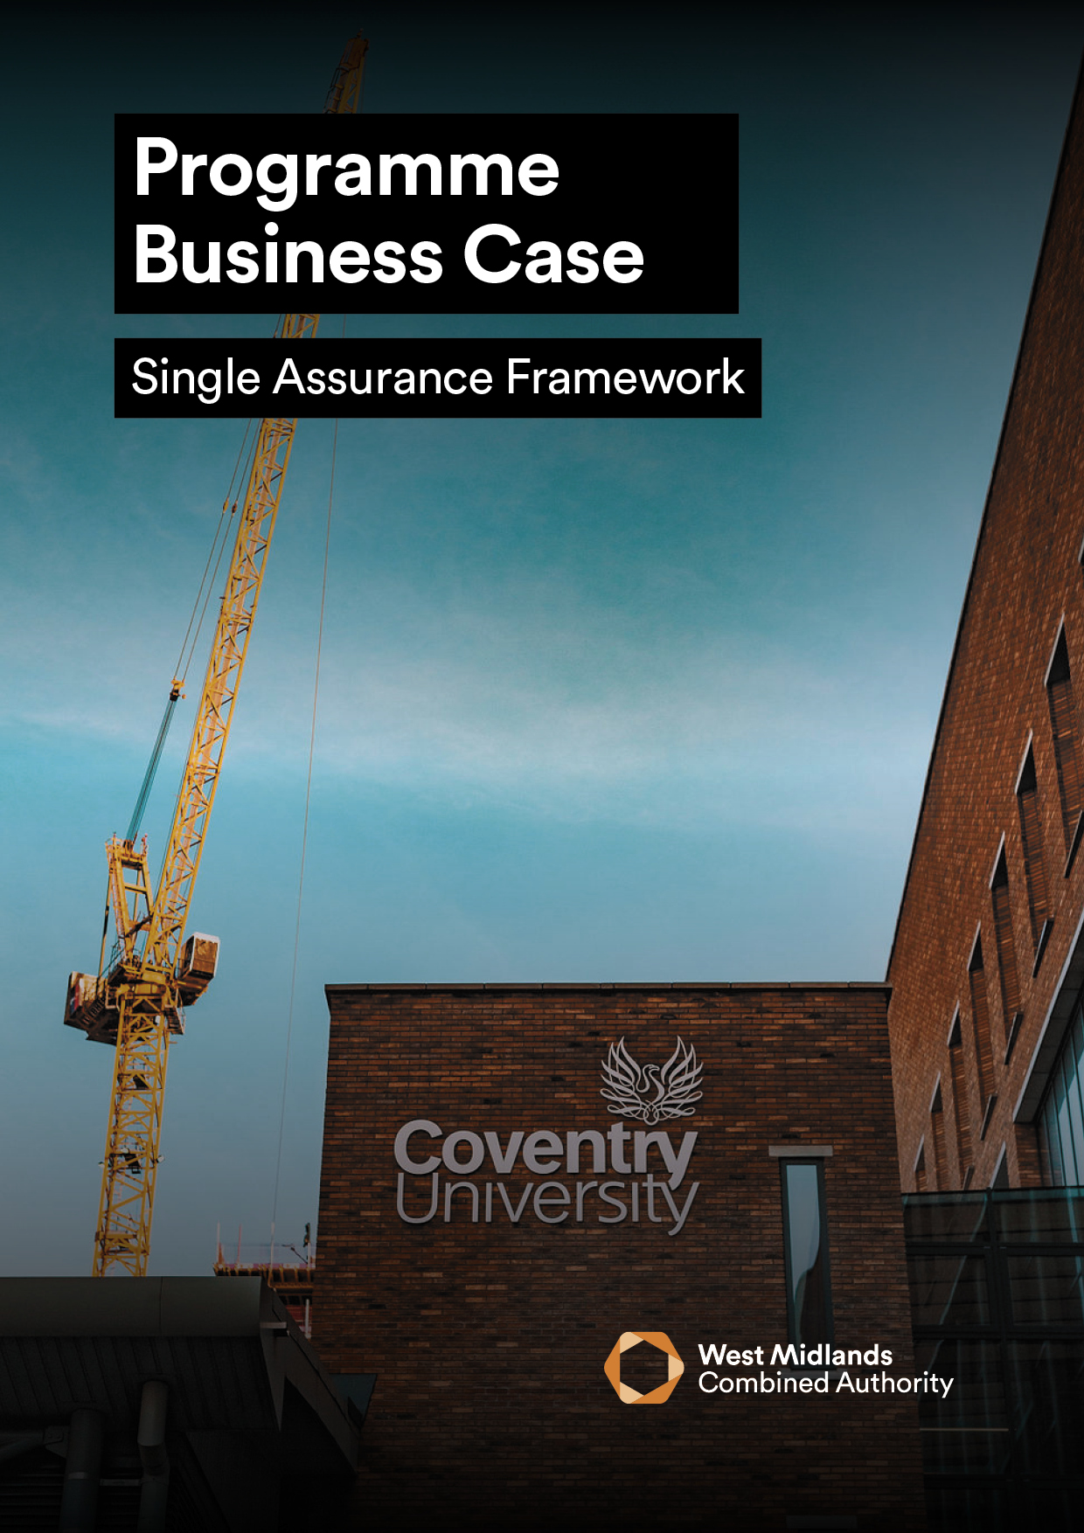
<INSERT PROJECT NAME>

PROGRAMME BUSINESS CASE VERSION 5.1
The purpose of the Programme Business Case (PBC) is to define the selection of projects and activities required to deliver the programme’s objectives in support of the agreed strategy for the delivery of policy objectives.
A PBC should be used where several linked projects contribute to the same outcomes and cannot be treated separately. Developing a PBC means that individual business cases for those linked projects can be proportionate, because they can refer and signpost to detail contained in this submission.

GUIDANCE

The PBC should be treated as a working document. It must be revisited and updated upon completion of each tranche of the programme, prior to obtaining approval to commence a further tranche.
- This PBC should be developed using the WMCA guidance document.
- All business cases submitted to WMCA are informed by and based upon guidance contained within HM Treasury Green Book and supporting information.
- Input of key stakeholders and subject matter experts in the development of this PBC is a mandatory requirement and the extent of this engagement/input must be detailed within Table 2a or 2b. Without evidence of this engagement and input, the Single Assurance Framework (SAF) process cannot commence.
- Mandatory appendices listed in Table 3 must be submitted as supplementary documents.

LIST OF TABLES

1 | Programme Details
2 | Stakeholder Involvement
3 | Mandatory Appendices
4 | Finance Summary
5 | Objectives and Alignment to WMCA Aims
6 | Alignment to Inclusive Growth Fundamentals
7 | Key Risks
8 | Main Benefits
9 | Critical Success Factors
10 | Long-List of Options
11 | Short-Listed Options
12 | Summary of Programme Expenditure
13 | Capital and Revenue Funding Statement
14 | Summary of Programme Funding
15 | Programme Borrowing Summary (Where necessary)
16 | Programme Milestones
17 | Programme Delivery Roles and Responsibilities

Table 1
PROGRAMME DETAIL
Programme Name:
WMCA Directorate:
Delivery Team (if WMCA internal):
Organisation (if WMCA external):
WMCA programme Code:
GOVERNANCE
If external to WMCA, when was this programme approved by your internal governance?
VERSION CONTROL
Version: |  |  | Date:
PBC Prepared by: |  |  | Organisation and Job Title:

(Table 2a) WMCA Internal Business Cases ONLY
(e.g., WMCA Directorates)
Stakeholder | Name | Status | Date | Requirement
WMCA Senior Responsible Owner | Enter Name | Select Status | Enter Date | Mandatory
WMCA  Legal | Enter Name | Select Status | Enter Date | Mandatory  (WMCA Legal to be instructed by WMCA SRO only)
WMCA Procurement | Enter Name | Select Status | Enter Date | Mandatory
WMCA Contract Compliance Team | Enter Name | Select Status | Enter Date | Mandatory
WMCA  Finance | Enter Name | Select Status | Enter Date | Mandatory  (if NOT Investment Programme funded)
WMCA Major Programme Returns | Enter Name | Select Status | Enter Date | Mandatory  (if Investment Programme funded)
WMCA Inclusive Growth Team | Enter Name | Select Status | Enter Date | Mandatory
WMCA Monitoring & Evaluation Team | Enter Name | Select Status | Enter Date | Mandatory
WMCA Transport Planning | Enter Name | Select Status | Enter Date | Mandatory  (If there are transport implications)
WMCA Active Travel Team | Enter Name | Select Status | Enter Date | Mandatory  (for Active Travel schemes)
Travel Demand Management Schemes | Enter Name | Select Status | Enter Date | If there are transport implications
WMCA  Risk Team | Enter Name | Select Status | Enter Date | for any risk management queries
WMCA Insurance Team | Enter Name | Select Status | Enter Date | for activities outside WMCA usual scope or when acquiring new property/assets
Digital and Data Engagement and Delivery | Enter Name | Select Status | Enter Date | if there is a Digital & Data element
HR Business Partner | Enter Name | Select Status | Enter Date | if there are HR implications, e.g. recruitment
Property & Strategic Assets* | Enter Name | Select Status | Enter Date | For any land/property transactions.

(Table 2b) WMCA External Business Cases ONLY
(e.g., Constituent LAs, WMCA Arm’s Length Bodies, etc.)
Stakeholder | Name & Email | Status | Date | Requirement
External  Programme Senior Responsible Owner | Enter Name & Email | Select Status | Enter Date | Mandatory
External  Legal Lead | Enter Name & Email | Select Status | Enter Date | Mandatory
External  Finance Lead | Enter Name & Email | Select Status | Enter Date | Mandatory
External  Procurement Lead | Enter Name & Email | Select Status | Enter Date | Mandatory
WMCA Senior Responsible Owner | Enter Name | Select Status | Enter Date | Mandatory
WMCA  Legal | Enter Name | Select Status | Enter Date | Mandatory  (WMCA Legal to be instructed by WMCA SRO only)
WMCA Finance | Enter Name | Select Status | Enter Date | Mandatory  (if it’s NOT CRSTS/  Investment Programme funded)
WMCA Major Programme Returns | Enter Name | Select Status | Enter Date | Mandatory  (if CRSTS/ Investment Programme funded)
WMCA Inclusive Growth Team | Enter Name | Select Status | Enter Date | Mandatory
WMCA Transport Planning | Enter Name | Select Status | Enter Date | Mandatory  (If there are transport implications)
WMCA Active Travel Team | Enter Name | Select Status | Enter Date | Mandatory  (for Active Travel schemes)
Travel Demand Management Schemes | Enter Name | Select Status | Enter Date | (If there are transport implications)

MANDATORY APPENDICES
Provide each of the mandatory appendices listed below as separate documents (do not embed documents within the business case and ideally avoid the use of PDFs).
Any missing appendices risk delays in your business case being submitted into the SAF process.

Table 3
Mandatory Appendices |  | Included  (Y/N)
A | Health and Equity Impact Assessment - HEIA
B | Risk Register and Issue Log
C | Logic Model  (may be contained within MEP)
D | Benefits Register  (may be contained within MEP)
E | NPSV/BCR/RPSC/VfM calculations  (may be in the form of a workbook)
F | Written Confirmation(s) of Confirmed Funding  (including funding award letter)
G | Programme Schedule
H | Risk Management Strategy
I | Benefits Realisation Plan
J | Monitoring and Evaluation Plan - MEP
K | Stakeholder and Communications Strategy
L | Whole Life Carbon Assessment (WLCA)  (for Transport projects costing £10m or more)
M | Whole Life Carbon Assessment (WLCA)  (for Transport projects costing £10m or more)

If you are unable to submit the appendices listed above, please provide your justification for non-submission below:
- <If applicable, add justification>

EXECUTIVE SUMMARY
Provide a one-page standalone summary of the proposed programme to include (max 500 words):
- A brief programme description and why it is necessary
- Programme Objectives
- Associated Outcomes

Table 4
Finance Summary | PBC
Total programme cost | £
WMCA funds subject to this business case | £
WMCA funding source(s)
Funds already secured | £
Identified but unsecured funding | £
Funding deficit yet to be identified | £

1 - STRATEGIC CASE

PROVIDING STRATEGIC FIT SUPPORTED BY A COMPELLING CASE FOR CHANGE

1.1 ORGANISATIONAL OVERVIEW
Provide a brief overview of the organisation(s) making the case for intervention and change.

1.2 STRATEGY AND POLICY ALIGNMENT
Explain how the programme supports the WMCA Strategic Planning Framework and other programmes and projects within the strategic portfolio. In addition, comment on how Local, Regional, and National policy and other organisations’ strategies (relevant to the programme) are supported. Attach relevant documents, if applicable.

1.3 PROGRAMME OBJECTIVES AND ALIGNMENT TO WMCA AIMS
Outline the objectives of the programme and how they will be measured within the table below. Objectives should focus on the desired outcomes that support the WMCA’s Strategic Planning Framework.
Refer to the supplementary guidance document which contains detailed information regarding how to develop and articulate programme objectives to ensure they are SMART and effectively address the need for change.

Note: All programmes should clearly align to WMCA Outcomes and Strategic Planning Frameworks.

Table 5
# | Objective | Baseline  Outputs / Outcomes  (Quantitative) | Target Outputs  (Quantitative) | Target Outcomes (including reference from the agreed WMCA outcomes framework) | Target Date | Alignment to WMCA Aims and Objectives
1. |  |  |  |  |  | Choose an item.
2. |  |  |  |  |  | Choose an item.
3. |  |  |  |  |  | Choose an item.
4. |  |  |  |  |  | Choose an item.
5. |  |  |  |  |  | Choose an item.

1.4 HEALTH AND EQUITY IMPACT ASSESSMENT (HEIA)
Provide details of the HEIA conducted for this programme, including the likely impact on:

- Protected characteristics as guided by the Equality Act 2010
- Health inequalities
- Place (socio-economic and environment)

Note: A HEIA framework and template has been developed by WMCA to help ensure the likely impact of policy changes (including the development of programmes and projects) is effectively considered. Details of how to access this framework/template can be found in the supplementary guidance. Where external delivery partners have their own templates for conducting this assessment, they do not need to use the WMCA version.

1.5 INCLUSIVE GROWTH
Explain how this programme will contribute to West Midlands Combined Authority Inclusive Growth fundamentals using the table below:

Table 6
Inclusive Growth Fundamental | Mission | Impact and Actions to support each Fundamental
Climate and environment | Carbon emissions decoupled from economic growth and reduced to net zero by 2041.
Inclusive economy | People experience an increase in their household incomes and a better standard of living.
Power and participation | People can fully participate in influencing and exercising agency in the things that matter to them
Affordable and safe places | Ensuring that everyone in the West Midlands has affordable, safe and secure housing which meets their needs and aspirations. To do this, we must design out homelessness, create good quality homes and address housing decency and living standards across the different housing sectors.
Connected communities | People live in connected communities which enable everyone to interact with the world around them, both physically and digitally, fostering a sense of belonging.
Education and learning | Improved levels of skills for all to flourish and realise their potential.
Health and wellbeing | Avoidable differences in health outcomes are reduced so that everyone can live longer, healthier, and happier lives.

Note to Internal programme leads Only:
Complete the Inclusive Growth Implementation Toolkit which can be found here and include a screenshot of you results in this section for review as shown in the example below:
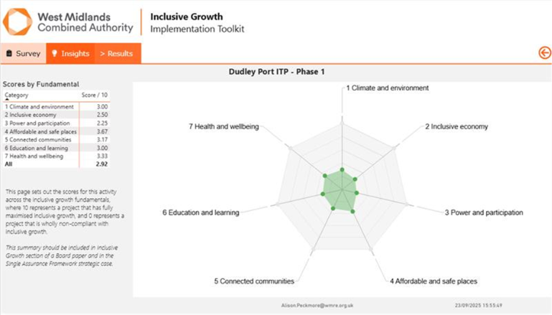
Sample (replace with your programme)
Implementation Toolkit Total Score
Delete as appropriate:
Non-compliant 0-2
Compliant 2-4
Aspirational 4-8
Transformational 8-10

Note to external programme leads only:
Use the Inclusive Growth Framework to complete Table 6 above and demonstrate how you will contribute to Inclusive Growth fundamentals.

Contact details for the WMCA Inclusive Growth Team are available within the supplementary guidance document.

1.6 EXISTING ARRANGEMENTS AND BUSINESS NEEDS
Provide a clear Case for Change for this programme.
This should include a complete summary of the current service model and ‘Business as Usual’ (BAU) offer, including any elements of services provided externally, where appropriate.
In addition, state the deficiencies associated with the current provision and the implications if the programme does not proceed.

1.7 KEY RISKS
Use the programme Risk Register, and latest assessment of programme risks, to complete the table below. Capture the programme’s (top 5) highest rated risks associated with the achievement of its objectives and outcomes, along with the key activity aimed at either managing the cause or mitigating the effects of each risk.
Note: The information provided should be an extract from the Risk Register and Issue Log attached with this PBC.
Table 7
ID | Risk | Impact  (1-5) | Probability  (1-5) | RAG  Rating | Risk  Owner | Mitigation

1.8 MAIN BENEFITS
Include the main benefits associated with achievement of the programme objectives/outcomes. These should be aligned with a preliminary Benefits Realisation Plan and Benefits Register (or MEP) appended to this PBC.
Notes:
- The approach to benefits identification should focus on the 20% of benefits likely to provide 80% of the programme’s benefit value.
- Outcomes and outputs should not be included in this table. Ensure that the benefits listed here match those included in the Economic Case, including monetizable benefits within the BCR calculations.

Table 8
# | Benefit | Benefit category (type) | Beneficiary(s) | Benefit class | Value (if quantifiable) OR Size (is qualitative)
1. |  | Choose an item. |  | Choose an item.
2. |  | Choose an item. |  | Choose an item.
3. |  | Choose an item. |  | Choose an item.
4. |  | Choose an item. |  | Choose an item.
5. |  | Choose an item. |  | Choose an item.

1.9 LOGIC MODEL
Provide the programme Logic Model and summarise your engagement with the relevant WMCA Monitoring & Evaluation Team in its development.

Note:
For CRSTS/TCR funded schemes, please contact Transport.Evaluation@tfwm.org.uk
WMCA corporate M&E team CorporateMonitoringEvaluation@wmca.org.uk
Additional guidance is contained within the supplementary guidance document.

:
.

1.10 CONSTRAINTS
Specify any constraints that have been placed on the programme.
Note: Any risks arising from the constraints identified in this section should be included in the Risk Register, alongside any mitigating actions.

1.11 DEPENDENCIES
Specify any dependencies outside the scope of the programme upon which the success of the programme is dependent.
Note: Any risks arising from the dependencies identified in this section should be included in the Risk Register, alongside any mitigating actions.

2 - ECONOMIC CASE

MAXIMISE PUBLIC VALUE TO SOCIETY THROUGH THE SELECTION OF THE OPTIMAL COMBINATION OF SCOPE, COSTS AND OUTCOMES
Note: Where the programme is Transport based with total costs of £10m or more, the Whole Life Carbon Assessment (WLCA) Appendix M is to be prepared in conjunction with this business case and submitted as a mandatory appendix.

2.1 CRITICAL SUCCESS FACTORS (CSFs)
List the Critical Success Factors (CSFs) associated with this programme i.e., what must this programme achieve to be successful?
Notes:
- These are not outcomes or objectives; they are the attributes essential for successful delivery of the programme.
- A table of five basic CSFs that apply to all proposals, is given in Table 9 below. At most the number should not exceed seven. Additional guidance is available within the supplementary guidance document.
- Align your responses to the individual project(s) that will contribute to the delivery of each CSF.
Table 9
# | Critical Success Factor (CSF)
1. | Strategic: Strategic fit and meets business needs
2. | Economic: Potential Value for Money
3. | Commercial: Supplier capacity and capability
4. | Financial: Potential affordability
5. | Management: Potential achievability
6. | [Additional CSF if required – delete if not required]
7. | [Additional CSF if required – delete if not required]

2.2 LONG-LIST OF OPTIONS
Determine the long-list of options and undertake a SWOT (strengths, weaknesses, opportunities, threats) analysis to complete the table below. All supporting evidence informing the long-list should be made available if requested for reference and/or Assurance and Appraisal purposes.
Note: Some of the long-list of options detailed in Table 10 should also feature the short-listed options taken forward.

Table 10
# | Option Description | Advantages  (Benefits) | Disadvantages  (Disbenefits) | Meets the Objectives and CSFs of this programme?  (Y/N) | Option Short-listed?  (Y/N)
1
2
3
4
5
6
7
8
9
10

2.3 SHORT-LISTED OPTIONS
Describe how proposals for delivering the programme objectives (via projects) have been short-listed. State the Preferred Option which will progress through to the development of future project business case stages.
Table 11
Option Label | Business as  Usual  (baseline) | Do-minimum  Option | Preferred  Option  (If not Do-  Minimum) | More/Less ambitious Preferred Option
Description of Option
Indicative Present Value Benefits (PVB)
Indicative Present Value public sector Cost (PVC)
Residual risk and optimism bias included in PVC (%)
Indicative Net Present Social Value (NPSV)
(PVB-PVC)
Indicative Benefit Cost Ratio (BCR)
(PVB/PVC)
Indicative Return on Public Sector Costs (RPSC)

PVB-PVC non public
_______________

PVC
Significant unquantifiable and/or un-monetisable Benefits
(Qualitative)
Lifespan of option (in years)

2.4 VALUE FOR MONEY
Provide your rationale for choosing the preferred option, based upon your options analysis and appraisal above.
Note: PVB, PVC, NPSV, BCR and VfM calculations for each option should be provided and attached as a mandatory appendix to this business case (Appendix M).

3 - COMMERCIAL CASE

COMMERCIALLY VIABLE AND ATTRACTIVE TO THE SUPPLY SIDE
At PBC stage, the Commercial Case is not expected to be matured. However, the nature of work required to sound out the market and inform the procurement process of the future project business case submissions, should be identified.
Note: The Legal Appendix is to be prepared in conjunction with this business case and submitted as a mandatory appendix.

3.1 OVERVIEW OF COMMERCIAL CASE IN SUPPORT OF THE PREFERRED OPTION
State the ability of the marketplace to provide the required goods or services and the attractiveness of this proposal to potential service providers.

3.2 OVERVIEW OF THE COMMERCIAL STRATEGY
References the programme’s Commercial Strategy and how public value will be achieved through economies of scale.

3.3 SUBSIDY CONTROL
A summary of the findings from a Subsidy Control Assessment should be included here - if applicable at this stage.

4 - FINANCIAL CASE

AFFORDABLE AND FUNDABLE OVER TIME
Note: Seek support from your Finance rep, WMCA Finance Business Partner and/or WMCA Accountant when providing information for the Financial Case.

4.1 TOTAL PROGRAMME ESTIMATED EXPENDITURE
Provide a list of projects and estimated gross expenditure for the programme (where applicable/known) within Table 12 below:

Table 12 (£000s/£m)
# | Expenditure Stream (£)  Note: add/delete line items as applicable to your programme | Capital/  Revenue | Total | % of Grand Total
 | Example: Early programme Investigation Works
 | Example - Project A
 | Example -Project B
 | Example -Project C
 | Example -Project D
 | Example – programme Management Costs
 | Example – Monitoring & Evaluation
 | Example – Future Projects not yet scoped/subject to further Investigation
TOTAL PROGRAMME ESTIMATED EXPENDITURE

Notes re Programme Expenditure:
- Associated Revenue Expenditure (Non-Capital Costs): A summary and explanation of any revenue expenditure associated with the programme/Project, not included in Table 12, should be provided with an explanation regarding how this will be funded. (For example, ongoing annual maintenance expenditure for the useful life of the asset).
- Where possible, demonstrate how benchmarking has been used to ensure reasonable cost estimates (e.g. cost/unit targets).
- Explain any key assumptions used to derive the cost estimates provided (such as inflation indices used).
- Describe any sources of cost uncertainty, and the methodology used to derive estimates for contingency/remaining optimism bias.
- Where applicable, provide a reference to appendices which contain a detailed breakdown of the expenditure summarised above at Table 12.
- Provide any other narrative/explanation in respect of programme expenditure considered relevant.
- Include any ongoing revenue costs for the whole life of an asset.

4.2 CAPITAL AND REVENUE FUNDING STATEMENT
Explain the status of the funding and any issues, conditions, constraints or risks relevant to any of the funding sources underpinning the programme. Where any funding proposed is “TBC” or “Unidentified this should include narrative explaining the work being undertaken to address this.
Where applicable, provide a reference to appendices which contain evidence demonstrating the status of funding stated in Table 13.
Complete Table 13 as appropriate and include where funding is needed to develop individual project business cases. Include any remaining funding gap, where applicable.
Notes:
- Where funding is being requested to develop individual projects, the Terms and Conditions of the funding source should be checked to ensure they allow this
- All secured funding identified below should be verified by a written confirmation (Mandatory Appendix F), with details of any conditions.
- Any funding requested via this PBC is considered ‘unsecured’ until approval of any associated Project Business Case (as appropriate for the project).
Table 13
 | Status  (Secured/Un- Secured) | Amount  £000/£M
Revenue
Capital
Total
Development Funding within the above
(funding required for individual business cases)

Table 14 should detail how the expenditure set out at Table 13 will be funded (by individual funding source).
Note: The total should agree with the total at Table 13. This table is designed to show how the funding will be applied and does not represent the cash in-flows. Any borrowing should be detailed in Section 4.3.
Add/delete line/column items as applicable to your project.
Table 14 (£000s/£m)
# | Funding Source  (for the funding requested from this submission) | Secured (Yes/No) | Type  Capital/  Revenue | Previous Year | Year 1  xx-xx | Year 2  xx-xx | Year 3  xx-xx | Total | % of Grand Total
Funding Source (subject to approval of this business case)
 | e.g. CRSTS1/TCR /Integrated Settlement/ Land Fund)
Subtotal – Funding Requested for Approval from this Submission
Funding Source (Not subject to approval of this business case) include sources of match funding
 | Example: Previous Funding Awarded – WMCA (Insert Fund)
 | Example: Future Funding to be Requested – WMCA (Insert Fund)
 | Example: Central Government (MHCLG/DfT/BEIS etc.)
 | Example: Local Authority Borrowing
 | Example: Private Sector
 | Section 106 Contributions
 | Unidentified/To Be Confirmed
Subtotal - (Not subject to approval of this business case)
Grand Total (All programme Funding)

4.3 BORROWING SUMMARY
State if any element of the programme costs are to be financed by borrowing. (Yes/No).
If Yes, complete the following table and provide an explanation of the borrowing required:

Table 15
Principle expected to be Borrowed | £XX
Source of Finance | (PWLB, Private, LA to LA, etc.)
Loan Type | (Annuity, Equality Instalment of Principal, Maturity, Other)
Interest Rate Assumed | X.X%
Loan Term | XX Years
Expected Loan Draw Down Date | DD/MM/YYYY
Repayment Source | (E.g., Future Customer Revenues)
Other costs Associated with Borrowing | £XX

4.4 CASHFLOW
Summarise (where applicable) any material cashflow challenges the programme is likely to face.
Where there are material challenges, provide a cashflow summary statement and incorporate any cashflow risks (with mitigating actions) within the programme Risk Register.

4.5 AFFORDABILITY & DUE DILIGENCE
Provide a summary of any financial due diligence that has been completed regarding the financial position of all major organisations involved in the delivery of the programme.
Where risks exist regarding the financial security of the programme, arising from this due diligence activity, include these in the programme Risk Register with appropriate mitigating actions.

5 - MANAGEMENT CASE

CAN BE DELIVERED SUCCESSFULLY BY THE ORGANISATION AND ITS PARTNERS

5.1 MANAGEMENT AND GOVERNANCE
Provide an overview of the necessary management and governance arrangements both in the delivery phase and in operation i.e., include detail of:
- Governance and decision-making arrangements
- Change management arrangements (including compliance with the WMCA Change Control process alongside any directorate, organisational or funder change control requirements).
- Benefits realisation arrangements and plans, including benefits register/MEP.
- Contract management arrangements.
- Post evaluation arrangements.

5.2 PROGRAMME SCHEDULE FOR DELIVERY
List key programme milestones below including start and end dates. The information provided should align with, and is a summary of, the Programme Schedule, which must be appended to this PBC.
Include dates for future business case submissions (i.e. component projects) and a longstop date by which all monies for this programme will be drawn.
Table 16
# | Milestone | Start Date | End Date
1
2
3
4
5
6
7
8
9
10

5.3 PROGRAMME TEAM ORGANOGRAM
Insert a programme Organogram which includes the staff who will work full-time, part-time and fixed term on this programme. The programme Sponsor and programme Senior Responsible Owner (SRO) should be appointed and identified in the Organogram.

5.4 PROGRAMME DELIVERY ROLES AND RESPONSIBILITES
Classify the roles and tasks detailed within the Organogram to determine who is Responsible (R), Accountable (A), who needs to be Consulted (C) and Informed (I).
Table 17
 | <Insert Role> | <Insert Role> | <Insert Role> | <Insert Role> | <Insert Role>
<Insert Task> | Choose an item. | Choose an item. | Choose an item. | Choose an item. | Choose an item.
<Insert Task> | Choose an item. | Choose an item. | Choose an item. | Choose an item. | Choose an item.
<Insert Task> | Choose an item. | Choose an item. | Choose an item. | Choose an item. | Choose an item.
<Insert Task> | Choose an item. | Choose an item. | Choose an item. | Choose an item. | Choose an item.
<Insert Task> | Choose an item. | Choose an item. | Choose an item. | Choose an item. | Choose an item.

5.5 USE OF SPECIALIST ADVISERS
Specify what support and subject matter expertise/advice is required by the programme team. Include both internal resources (e.g. key enabling services and Business Partners within Legal, Finance and Procurement teams) and external resources (e.g. technical consultants)

5.6 CHANGE AND CONTRACT MANAGEMENT ARRANGEMENTS
Detail how supplier contracts, at a programme and Project level will be monitored and managed to ensure the WMCA Change Control Process is effectively implemented. Include detail of how exceptions to acceptable tolerances in performance will be applied.

5.7 RISK AND ISSUE MANAGMENT
Detail how risk management will be implemented across the programme, including the relevant roles and responsibilities that are assigned for managing this activity.
This should include detail regarding how programme risks are identified, reviewed and reported, including responsibility for undertaking this activity.
The mechanism for escalating programme risks should also be included within this section, including when issues materialise from known risks.

5.8 INSURANCE IMPLICATIONS
Are there any insurance implications/exposures arising from this programme? (Yes/No) [delete as appropriate]
Note: If you have any doubts as to whether the activity you are proposing is covered by existing insurance or for additional insurance guidance and support, please contact the WMCA Insurance team: insuranceteam@wmca.org.uk
If Yes, please articulate these here:

For external programme leads only:
Where the programme is being led by an external partner/LA, clarify whether insurance implications are fully covered under existing arrangements or whether WMCA has any insurable interest

5.9 PROGRAMME ASSURANCE
Set out the arrangements for programme assurance, including the use of Cabinet Office Gateway Reviews. Other sources of assurance should be considered including technical, quality, security etc.
Specify the probable timescales for undertaking programme implementation and post evaluation reviews.
Note: There is no requirement to add detail of the Single Assurance Framework (SAF) process specifically.

5.10 CONTINGENCY ARRANGEMENTS
Detail the programme contingency plans in the event of any delays or disruptions to anticipated services.

5.11 LESSONS LEARNT
Detail how Lessons Learnt have been considered during the development of this proposal and plans for capturing and implementing improvements following Lessons Learnt activity during the programme’s lifecycle.
Note: This activity should include the use of a Lessons Learnt Log and planned Lessons Learnt Workshops.

5.12 MONITORING AND EVALUATION
Summarise Monitoring and Evaluation arrangements for the programme including milestones leading to evaluation. This should include the completion of component project business cases.
Include detail, by providing responses to the questions within section 5.12 of the PBC guidance.
For additional M&E support please contact the WMCA M&E team email: CorporateMonitoringEvaluation@wmca.org.uk
For additional M&E support for Transport programmes please contact the TfWM M&E team email: Transport.Evaluation@tfwm.org.uk

Excludes grant funding for developers unless WMCA is acquiring any of the land. For Property & Strategic Assets please also ensure you refer to the Land and Property Protocol contained within WMCAs Constitution

