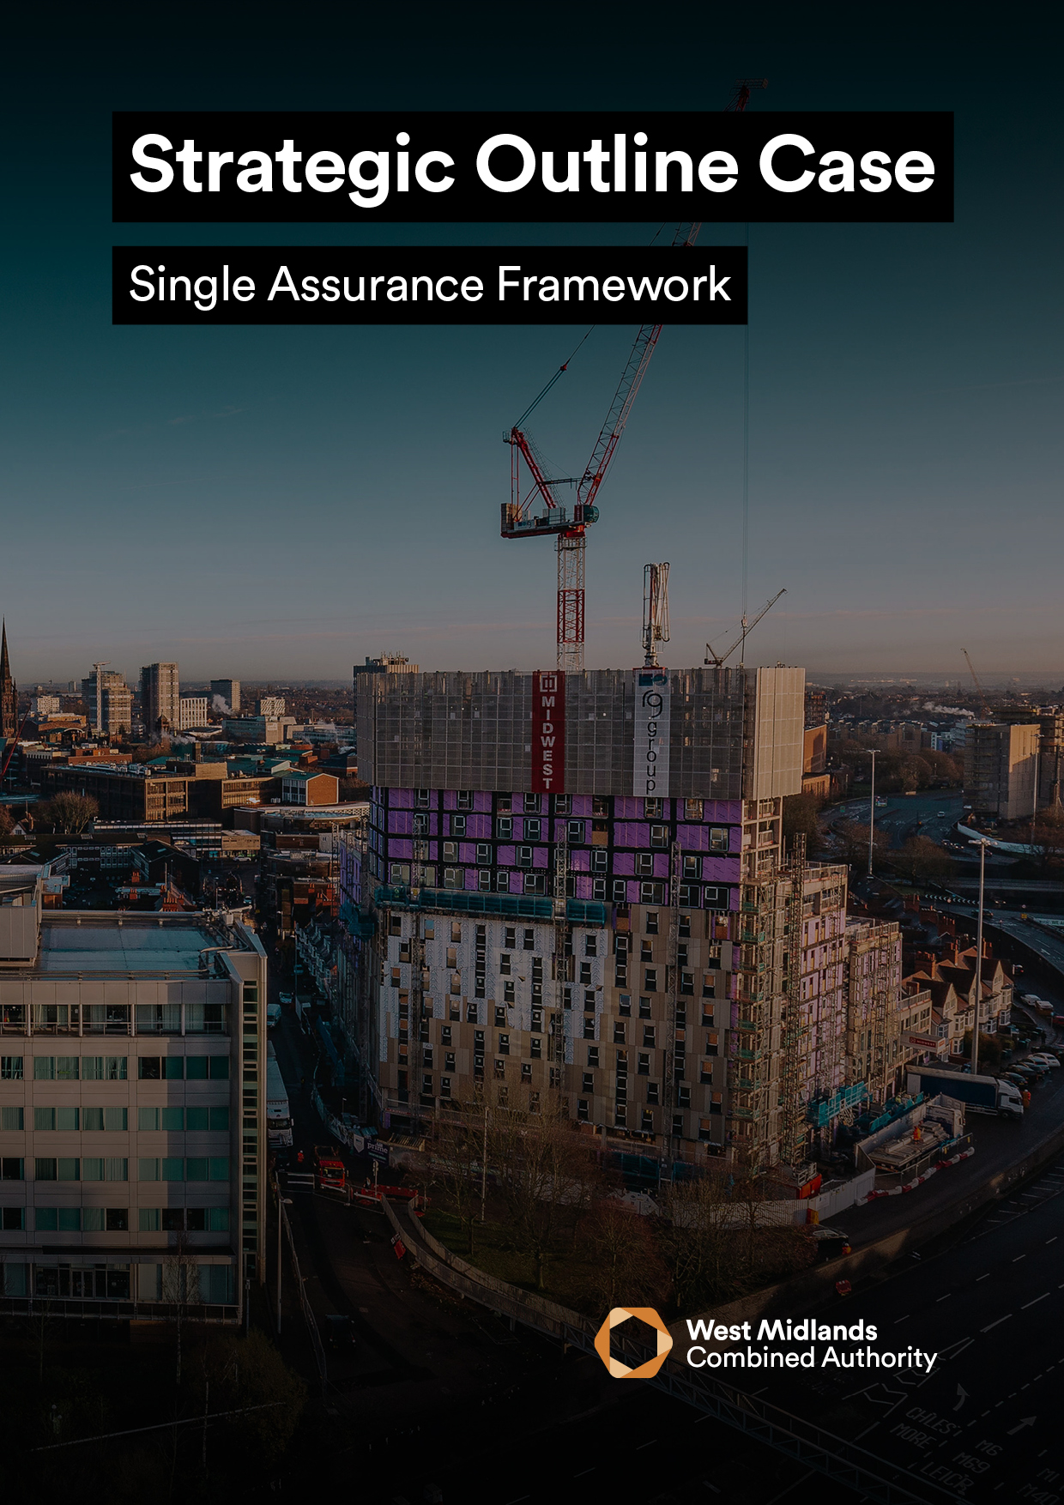
Serena Dhanoa
Centro

STRATEGIC OUTLINE CASE
______________________________________________________________________

[Insert Project Name]

Version |  | Date
Prepared By |  | Job Title

Lead WMCA Directorate
Lead WMCA Executive Director

Has BCAT been submitted to Assurance & Appraisal? | Yes | No
Has this OBC been approved by Lead WMCA Executive Director? | Yes | No

Approved By
Signature
Date

Please refer to the WMCA SOC Guidance Document and HM Treasury Green Book / Blue Book for assistance when completing this template.

APPLICANT DETAILS
Project Name: |  | WMCA Project Code:
Lead Organisation:
Lead Contact: |  | Job Title:
Phone Number: |  | Email:
Address:
Local Authority Area  (lead organisation) |  | Ward:
Other Organisations involved in project bid:

FACTUAL SUMMARY
SOC (£M)
Total Project Cost
WMCA Funding Required
Funds Secured
Funds Not Secured

To support better spending, investment decisions and better procurement, this Strategic Outline Case should be written using guidance from the WMCA. In addition, it is a requirement that all bids for public funds submitted to WMCA are guided and based around the HM Treasury’s Green Book 2020 and supporting information which can be found here.

1 | EXECUTIVE SUMMARY

1 | EXECUTIVE SUMMARY
Summary
Please provide a one-page stand-alone summary of the proposed project which includes a brief project description, strategic alignment with WMCA policies, project objectives, costs and expected outputs.

2 | STRATEGIC CASE

2A - Project Objectives – Outline the objectives of the project and how they will be measured within the table below. In defining your objectives, please consider whether these can defines in such a way that progress towards meeting them can be monitored as SMART objectives (Specific, Measureable, Achievable, Relevant and Time-bound). Please ensure the information below is aligned with the Plan on a Page (POAP) submitted for the project.

Objective | WMCA Strategic Alignment

2B – Strategic Objectives – Outline how the proposed project will contribute to each of the key elements that relate to the WMCA’s Strategic Objectives

Policy Aim | Alignment with Proposed Project
A healthier West Midlands, increasing healthy life expectancy and tackling health inequalities
A happier West Midlands, improving mental health and driving inclusion for all our communities
A better-connected West Midlands, where transport connects all communities to opportunities
A more prosperous West Midlands, where everyone can contribute to and benefit from a globally competitive regional economy
A greener West Midlands, where we reduce carbon emissions to address the climate crisis
A fairer West Midlands, where we support marginalised and vulnerable groups

2C – Inclusive Growth – Please outline how the proposed project will align with the WMCA’s Inclusive Growth Objectives. Refer to guidance for Inclusive Growth definition.

2D – COVID-19 Recovery – Please outline any specific measures included within the proposed project to support COVID-19 recovery?

2E – Benefits and Outputs – Specify the main benefits and outputs associated with the achievement of the projects objectives?

2F – Key Risks – Specify the risks (circa 3-5) associated with the achievement of the project’s objectives and the proposed counter measures for avoidance, mitigation and management

Please complete the questions listed below within the SOC Context Appendix to support the Strategic Case:

Strategic Case Supporting Questions
2G | Organisational Overview (Guidance – Page 5)
2H | Constraints (Guidance – Page 6)
2I | Organisation Business Needs / Services Gaps (Guidance – Page 6)
2J | Full Risk Register (Guidance – Page 6)

3 | ECONOMIC CASE

3A – Key Deliverables and Critical Success Factors – Set out the intended key deliverables and critical success factors of the project that will contribute towards delivery of the strategic objectives

Objective | CSF | Measure of success | Date required by | WMCA Strategic Alignment | Baseline Measure | Start Date

3B – Shortlisted Options – Describe the shortlisted options to be examined in further detail at the next business case stage i.e. OBC

Please complete the questions listed below within the SOC Context Appendix to support the Economic Case:

Economic Case Supporting Questions
3C | Long List of Options (Guidance – Page 7)
3D | NPSC/NPSV Findings (Guidance – Page 7)

4 | COMMERCIAL CASE

At SOC stage, the Commercial Case is not expected to be matured. However, the nature of work required to sound out the market and inform the procurement process of the next business case submission i.e. OBC, should be identified. With this in mind, please complete the questions listed below within the SOC Context Appendix to support the Commercial Case:

Commercial Case Supporting Questions
4A | Overview of Commercial Case (Guidance – Page 7)
4B | Overview of Commercial Strategy (Guidance – Page 8)

5 | FINANCIAL CASE

5A - Capital Funding - Provide an overview of the proposed funding package to deliver the project within the table below. Please provide written confirmation of all confirmed funding with details of any conditions etc.
Funder | Amount | % of Total | Status  (Confirmed/ Pending Approval) | Details of Funding Status / Timing / Conditions etc.
Total

5B – Revenue Funding – If applicable, outline any on-going revenue funding required in support of the project and the source of this funding

Please complete the questions listed below within the SOC Context Appendix to support the Financial Case:

Financial Case Supporting Questions
5C | Overview of Financial Model (Guidance – Page 8)

6 | MANAGEMENT CASE

6A – Management and Governance – Provide an overview of the necessary management and governance arrangements both in the delivery phase and in operation

6B – Monitoring and Evaluation – Set out a summary of the initial Monitoring Evaluation
arrangements for the project and milestones to progress towards completion of the next
business case stage i.e. OBC

Please complete the questions listed below within the SOC Context Appendix to support the Management Case:

Management Case Supporting Questions
6C | Project Organogram (Guidance – Page 9)
6D | Project Delivery – Roles & Responsibilities (Guidance – Page 9)
6E | Initial Stakeholder & Communication Strategy (Guidance – Page 9)

