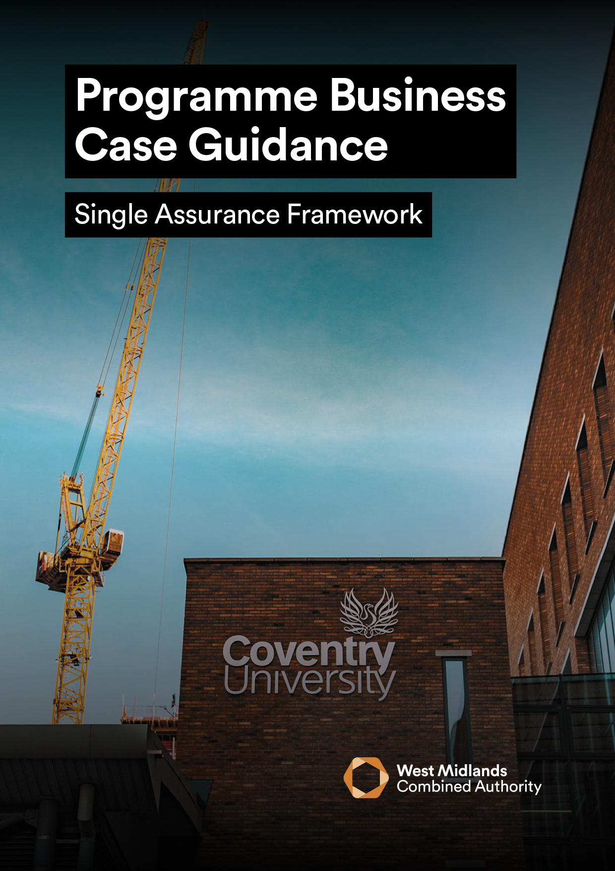

**PROGRAMME BUSINESS CASE**

**______________________________________________________________________**

[Insert Programme Name]

|  |  |  |  |
| --- | --- | --- | --- |
| **Version** |  | **Date** |  |
| **Prepared By** |  | **Job Title** |  |

|  |  |
| --- | --- |
| **Lead WMCA Directorate** |  |
| **Lead WMCA Executive Director** |  |

|  |  |  |
| --- | --- | --- |
| **Has a BCAT been submitted to the Assurance & Appraisal Team?** | Yes | No |
| **Has this PBC been approved by Lead WMCA Executive Director?** | Yes | No |

|  |  |
| --- | --- |
| **Approved By** |  |
| **Signature** |  |
| **Date** |  |

|  |  |
| --- | --- |
|  |  |

|  |  |  |  |  |
| --- | --- | --- | --- | --- |
| **APPLICANT DETAILS** | | | | |
| Programme Name: |  | WMCA Finance Code: |  | |
| Lead Organisation: |  | | | |
| Lead Contact: |  | Job Title: | |  |
| Phone Number: |  | Email: | |  |
| Address: |  | | | |
| Local Authority Area  (lead organisation) |  | Ward: | |  |
| Other Organisations/ key stakeholders involved in programme: |  | | | |

|  |  |
| --- | --- |
| **FACTUAL SUMMARY** | |
|  | PBC (£M) |
| Total Programme Costs |  |
| WMCA Funding |  |
| Funds Secured |  |
| Funds Not Secured |  |

|  |  |
| --- | --- |
|  |  |

***To support better spending, investment decisions and better procurement, this Programme Business Case should be written using guidance from the Finance & Business Hub. If you require any further information or support, please email*** [***saf@wmca.org.uk***](mailto:saf@wmca.org.uk) ***In addition, it is a requirement that all business cases submitted to WMCA are guided and based around HM Treasury’s Green Book together with its Business Case guidance for programmes which can be found*** [***here.***](https://www.gov.uk/government/publications/the-green-book-appraisal-and-evaluation-in-central-governent)

|  |  |
| --- | --- |
| 1 | **EXECUTIVE SUMMARY** |

Please provide a one-page summary of the proposed programme to include:

* a brief description of the programme
* how it aligns to WMCA strategic objectives and policies
* the programme objectives
* known/estimated costs
* funding source(s)
* expected outputs
* a summary of proposed projects to be included within the programme
* any known interdependencies with other Projects/Programmes.

|  |
| --- |
|  |

|  |  |
| --- | --- |
| 2 | **STRATEGIC CASE** |

**2A - Programme Objectives** – Outline the **SMART** (**S**pecific, **M**easurable, **A**chievable, **R**elevant and **T**ime-bound) objectives of the programme and how they will be measured within the table below. .

|  |  |
| --- | --- |
| **Programme Objective inclusive of quantitative measurement** | **WMCA Strategic Alignment** |
|  |  |
|  |  |
|  |  |
|  |  |
|  |  |

**2B – Strategic Objectives** – Outline how the proposed programme will contribute to WMCA’s Strategic Objective(s). Please ensure that specific proposed projects within the programme are referenced where applicable

|  |  |
| --- | --- |
| **Policy Aim** | **Alignment with Proposed Programme (and associated projects)** |
| Promote inclusive economic growth in every corner of the region |  |
| Ensure everyone has the opportunity to benefit |  |
| Connect our communities by delivering transport and unlocking housing and regeneration schemes |  |
| Reduce carbon emissions to net zero and enhance the environment |  |
| Secure new powers and resources from central government |  |
| Develop our organisation and be a good regional partner |  |

**2C – Inclusive Growth –** Outline how the proposed programme will align with the WMCA’s Inclusive Growth Objectives. Please ensure that specific proposed projects within the programme are referenced where applicable[1]

|  |
| --- |
|  |

**2D – COVID-19 Recovery** – Please outline any specific measures included within the proposed programme to support COVID-19 recovery? Please ensure that specific proposed projects within the programme are referenced where applicable

|  |
| --- |
|  |

**2E – Benefits and Outputs –** Specify the main benefits / outputs associated with the achievements of the programme and component projects within the programme’s objectives

|  |
| --- |
|  |

**2F – Key Risks –** Specify the top risks (circa 3-5) associated with the achievement of the programme’s objectives and the proposed counter measures for avoidance, mitigation and management

|  |
| --- |
|  |

Please complete the sections listed below within the PBC Appendix to support the Strategic Case:

|  |  |
| --- | --- |
| **Strategic Case Supporting Questions** | |
| **2G** | Organisational Overview (Guidance – Page 6) |
| **2H** | Constraints (Guidance – Page 7) |
| **2I** | Organisation Business Needs / Services Gaps (Guidance – Page 7) |
| **2J** | Full Risk Register (Guidance – Page 7) |

|  |  |
| --- | --- |
| 3 | **ECONOMIC CASE** |

**3A – Key Deliverables and Critical Success Factors** – Set out the intended key deliverables and critical success factors of the programme that will contribute towards delivery of the strategic objectives

|  |  |  |  |  |  |  |  |
| --- | --- | --- | --- | --- | --- | --- | --- |
| **Objective** | **Related Project(s)** | **CSF** | **Measure of success** | **Date required by** | **WMCA Strategic Alignment** | **Baseline Measure** | **Start Date** |
|  |  |  |  |  |  |  |  |
|  |  |  |  |  |  |  |  |
|  |  |  |  |  |  |  |  |
|  |  |  |  |  |  |  |  |
|  |  |  |  |  |  |  |  |

**3B – Shortlisted Options –** Describe how proposals for delivering the Programme objectives (projects) have been shortlisted together with the preferred way forward which will progress through to the development of future project Business Case Stages.

|  |
| --- |
|  |

Please complete the sections listed below within the PBC Appendix to support the Economic Case:

|  |  |
| --- | --- |
| **Economic Case Supporting Questions** | |
| **3C** | Long List of Options (Guidance – Page 8) |
| **3D** | NPSC/NPSV Findings (Guidance – Page 8) |

|  |  |
| --- | --- |
| **4** | **COMMERCIAL CASE** |

At PBCstage, the Commercial Case is not expected to be matured. However, the nature of work required to sound out the market and inform the procurement process of the future project business case submissions, should be identified. With this in mind, please complete the sections listed below within the PBC Appendices to support the Commercial Case:

|  |  |
| --- | --- |
| **Commercial Case Supporting Questions** | |
| **4A** | Overview of Commercial Case (Guidance – Page 9) |
| **4B** | Overview of Commercial Strategy (Guidance – Page 9) |

|  |  |
| --- | --- |
| **5** | **FINANCIAL CASE** |

**5A - Capital Funding** - Provide an overview of the proposed funding package to deliver the programme within the table below. Please provide written confirmation of all confirmed funding with details of any conditions etc.

|  |  |  |  |  |
| --- | --- | --- | --- | --- |
| **Funder** | **Amount** | **% of Total** | **Status**  *(Confirmed/ Pending Approval)* | **Details of Funding Status / Timing / Conditions etc.** |
|  |  |  |  |  |
|  |  |  |  |  |
|  |  |  |  |  |
|  |  |  |  |  |
| **Total** |  |  |  |  |

**5B – Revenue Funding – If applicable, outline any ongoing revenue funding required in support of the programme and the source of this funding**

|  |
| --- |
|  |

Please complete the sections listed below within the PBC Appendix to support the Financial Case:

|  |  |
| --- | --- |
| **Financial Case Supporting Questions** | |
| **5C** | Overview of Financial Model (Guidance – Page 9) |

|  |  |
| --- | --- |
| 6 | **MANAGEMENT CASE** |

**6A – Management and Governance** – Provide an overview of the necessary management and governance arrangements that will be established/are in place for development and oversight of the Programme and proposed Business Cases, through to delivery and operation/project closure

|  |
| --- |
|  |

**6B – Monitoring and Evaluation** – Set out a summary of how success of the proposed programme will be measured, monitored and evaluated in delivering towards WMCA strategic objectives

|  |
| --- |
|  |

Please complete the sections listed below within the PBC Appendix to support the Management Case:

|  |  |
| --- | --- |
| **Management Case Supporting Questions** | |
| **6C** | Programme Organogram (Guidance – Page 10) |
| **6D** | Programme Delivery – Roles & Responsibilities (Guidance – Page 10) |
| **6E** | Initial Stakeholder & Communication Strategy (Guidance – Page 11) |

1. Refer to guidance for Inclusive Growth definition